UNITED STATES

SECURITIES AND EXCHANGE COMMISSION

Washington, D.C. 20549

______________________________________________

FORM 10-Q

__________________________________

- QUARTERLY REPORT PURSUANT TO SECTION 13 OR 15(d) OF THE SECURITIES EXCHANGE ACT OF 1934

For the quarterly period ended June 30, 2019

OR

- TRANSITION REPORT PURSUANT TO SECTION 13 OR 15(d) OF THE SECURITIES EXCHANGE ACT OF 1934

For the transition period from to

Commission File Number: 001-38285

Bandwidth Inc.

(Exact name of registrant as specified in its charter)

______________________________________________

Delaware

56-2242657

(State or other jurisdiction of

incorporation or organization)

(I.R.S. Employer
Identification Number)

900 Main Campus Drive

Raleigh, NC 27606

(Address of principal executive offices) (Zip Code)

(800) 808-5150

(Registrant’s telephone number, including area code)

_____________________________________________

Securities registered pursuant to Section 12(b) of the Act:

Title of each class

Trading Symbol(s)

Name of each exchange on which registered

Class A Common Stock, par value $0.001 per share

BAND

NASDAQ Global Select Market

_____________________________________________

Indicate by check mark whether the registrant (1) has filed all reports required to be filed by Section 13 or 15(d) of the Securities Exchange Act of 1934 during the preceding 12 months (or for such shorter period that the registrant was required to file such reports), and (2) has been subject to such filing requirements for the past 90 days. Yes x No ☐

Indicate by check mark whether the registrant has submitted electronically every Interactive Data File required to be submitted pursuant to Rule 405 of Regulation S-T (§232.405 of this chapter) during the preceding 12 months (or for such shorter period that the registrant was required to submit such files). Yes x No ☐

Indicate by check mark whether the registrant is a large accelerated filer, an accelerated filer, a non-accelerated filer, a smaller reporting company, or an emerging growth company. See the definitions of “large accelerated filer,” “accelerated filer,” “smaller reporting company,” and “emerging growth company” in Rule 12b-2 of the Exchange Act.

Large accelerated filer | ☐ | Accelerated filer | ☐
Non-accelerated filer | ☒ | Smaller reporting company | ☐
 |  | Emerging growth company | ☒

If an emerging growth company, indicate by check mark if the registrant has elected not to use the extended transition period for complying with any new or revised financial accounting standards provided pursuant to Section 13(a) of the Exchange Act. ☐

Indicate by check mark whether the registrant is a shell company (as defined in Rule 12b-2 of the Exchange Act). Yes ☐ No ☒

As of July 31, 2019, 17,762,688 shares of the registrant’s Class A common stock and 5,627,060 shares of registrant’s Class B common stock were outstanding, respectively.

Table of Contents

Bandwidth Inc.

Quarterly Report on Form 10-Q

For the Three Months Ended June 30, 2019

Table of Contents

 |  |  |  |  |  |  |  |  |  |  |  |  |  |  |  |  |  |  |  |  |  | Page
Special Note Regarding Forward Looking Statement |  |  |  |  |  |  |  |  |  |  |  |  |  |  |  |  |  |  |  |  |  | 2
 |  |  |  |  |  |  |  |  |  |  | PART I - FINANCIAL INFORMATION
Item 1. |  |  | Financial Statements |  |  |  |  |  |  |  |  |  |  |  |  |  |  |  |  |  |  | 4
 |  |  | Unaudited Condensed Consolidated Balance Sheets as of December 31, 2018 and June 30, 2019 |  |  |  |  |  |  |  |  |  |  |  |  |  |  |  |  |  |  |  |  |  | 5
 |  |  | Unaudited Condensed Consolidated Statements of Operations for the Three and Six Months Ended June 30, 2018 and 2019 |  |  |  |  |  |  |  |  |  |  |  |  |  |  |  |  |  |  |  |  |  | 6
 |  |  | Unaudited Condensed Consolidated Statements of Comprehensive Income for the Three and Six Months Ended June 30, 2018 and 2019 |  |  |  |  |  |  |  |  |  |  |  |  |  |  |  |  |  |  |  |  |  | 7
 |  |  | Unaudited Condensed Consolidated Statements of Changes in Stockholders’ Equity |  |  |  |  |  |  |  |  |  |  |  |  |  |  |  |  |  |  | 8
 |  |  | Unaudited Condensed Consolidated Statements of Cash Flows for the Six Months Ended June 30, 2018 and 2019 |  |  |  |  |  |  |  |  |  |  |  |  |  |  |  |  |  |  | 10
 |  |  | Notes to Unaudited Condensed Consolidated Financial Statements |  |  |  |  |  |  |  |  |  |  |  |  |  |  |  |  |  |  |  | 11
Item 2. |  |  | Management’s Discussion and Analysis of Financial Condition and Results of Operations |  |  |  |  |  |  |  |  |  |  |  |  |  |  |  |  |  |  | 30
Item 3. |  |  | Quantitative and Qualitative Disclosures About Market Risk |  |  |  |  |  |  |  |  |  |  |  |  |  |  |  |  |  |  | 47
Item 4. |  |  | Controls and Procedures |  |  |  |  |  |  |  |  |  |  |  |  |  |  |  |  |  |  | 48
 |  |  |  |  |  |  |  |  |  |  |  | PART II - OTHER INFORMATION
Item 1. |  |  | Legal Proceedings |  |  |  |  |  |  |  |  |  |  |  |  |  |  |  |  |  |  | 49
Item 1A. |  |  | Risk Factors |  |  |  |  |  |  |  |  |  |  |  |  |  |  |  |  |  |  | 50
Item 2. |  |  | Unregistered Sales of Equity Securities and Use of Proceeds |  |  |  |  |  |  |  |  |  |  |  |  |  |  |  |  |  |  | 83
Item 6. |  |  | Exhibits |  |  |  |  |  |  |  |  |  |  |  |  |  |  |  |  |  |  | 83
 |  |  | Signatures |  |  |  |  |  |  |  |  |  |  |  |  |  |  |  |  |  |  |  | 85
 |  |  | 1

Table of Contents

Special Note Regarding Forward-Looking Statements

This Quarterly Report on Form 10-Q contains forward-looking statements within the meaning of Section 27A of the Securities Act of 1933, as amended (the “Securities Act”) and Section 21E of the Securities Exchange Act of 1934, as amended (the “Exchange Act”). All statements contained in this Quarterly Report on Form 10-Q, other than statements of historical fact, are forward-looking statements. Forward-looking statements generally can be identified by the words “may,” “will,” “expect,” “believe,” “anticipate,” “intend,” “could,” “would,” “project,” “plan,” “estimate,” or “continue,” or the negative of these words or other similar terms or expressions that concern our expectations, strategy, plans or intentions. Forward looking statements contained in this Quarterly Report on Form 10-Q include, but are not limited to, statements about:

- our ability to attract and retain customers, including large enterprises;

- our approach to identifying, attracting and keeping new and existing customers, as well as our expectations regarding customer turnover;

- our beliefs regarding network traffic growth and other trends related to the usage of our products and services;

- our expectations regarding revenue, costs, expenses, gross margin, dollar based net retention rate, adjusted EBITDA, other non-generally accepted accounting principles in the United States of America (“GAAP”) net income and capital expenditures; our beliefs regarding the growth of our business and how that impacts our liquidity and capital resources requirements;

- the sufficiency of our cash and cash equivalents to meet our liquidity needs;

- our ability to attract, train, and retain qualified employees and key personnel;

- our beliefs regarding the expense and productivity of, and competition for, our sales force;

- our expectations regarding headcount;

- our ability to maintain and benefit from our corporate culture;

- our plans to further invest in and grow our business, and our ability to effectively manage our growth and associated investments;

- our ability to introduce new products and services and enhance existing products and services;

- our ability to compete successfully against current and future competitors;

- the evolution of technology affecting our products, services and markets;

- the impact of certain new accounting standards and guidance, as well as the time and cost of continued compliance with existing rules and standards;

- our beliefs regarding the use of non-GAAP financial measures;

- our ability to maintain, protect and enhance our intellectual property;

- our expectations regarding litigation and other pending or potential disputes;

- our ability to comply with modified or new laws and regulations; and

- the increased expenses associated with being a public company.

We caution you that the foregoing list may not contain all the forward-looking statements made in this Quarterly Report on Form 10-Q.

2

Table of Contents

You should not rely upon forward-looking statements as predictions of future events. We have based the forward-looking statements contained in this Quarterly Report on Form 10-Q primarily on our current expectations and projections about future events and trends that we believe may affect our business, financial condition, results of operations and prospects. The outcome of the events described in these forward-looking statements is subject to risks, uncertainties and other factors described in the section titled “Risk Factors” and elsewhere in this Quarterly Report on Form 10-Q. Moreover, we operate in a very competitive and rapidly changing environment. New risks and uncertainties emerge from time to time and it is not possible for us to predict all risks and uncertainties that could have an impact on the forward-looking statements contained in this Quarterly Report on Form 10-Q. We cannot assure you that the results, events and circumstances reflected in the forward-looking statements will be achieved or occur, and actual results, events or circumstances could differ materially from those described in the forward-looking statements.

The forward-looking statements made in this Quarterly Report on Form 10-Q relate only to events as of the date on which the statements are made. We undertake no obligation to update any forward-looking statements made in this Quarterly Report on Form 10-Q to reflect events or circumstances after the date of this Quarterly Report on Form 10-Q or to reflect new information or the occurrence of unanticipated events, except as required by law. We may not actually achieve the plans, intentions or expectations disclosed in our forward-looking statements and you should not place undue reliance on our forward-looking statements. Our forward-looking statements do not reflect the potential impact of any future acquisitions, mergers, dispositions, joint ventures or investments we may make.

3

Table of Contents

PART I - FINANCIAL INFORMATION

Item 1. Financial Statements

4

Table of Contents

Bandwidth Inc.

Condensed Consolidated Balance Sheets

(In thousands)

(Unaudited)

 |  | December 31, |  |  | June 30,
 |  | 2018 |  |  | 2019
Assets
Current assets:
Cash and cash equivalents | $ | 41,261 |  | $ | 140,091
Marketable securities |  | 17,400 |  |  | 55,839
Accounts receivable, net of allowance for doubtful accounts |  | 24,009 |  |  | 26,695
Prepaid expenses and other current assets |  | 6,114 |  |  | 8,541
Deferred costs |  | 2,630 |  |  | 2,053
Total current assets |  | 91,414 |  |  | 233,219
Property and equipment, net |  | 25,136 |  |  | 31,799
Intangible assets, net |  | 7,089 |  |  | 6,829
Deferred costs, non-current |  | 1,828 |  |  | 1,038
Other long-term assets |  | 727 |  |  | 2,128
Goodwill |  | 6,867 |  |  | 6,867
Deferred tax asset |  | 17,359 |  |  | 31,615
Total assets | $ | 150,420 |  | $ | 313,495
Liabilities and stockholders’ equity
Current liabilities:
Accounts payable | $ | 3,418 |  | $ | 3,089
Accrued expenses and other current liabilities |  | 21,393 |  |  | 24,120
Current portion of deferred revenue |  | 5,324 |  |  | 4,887
Advanced billings |  | 2,588 |  |  | 2,676
Total current liabilities |  | 32,723 |  |  | 34,772
Deferred rent, net of current portion |  | 2,503 |  |  | 3,698
Deferred revenue, net of current portion |  | 6,424 |  |  | 5,900
Total liabilities |  | 41,650 |  |  | 44,370
Stockholders’ equity:
Class A and Class B common stock |  | 19 |  |  | 23
Additional paid-in capital |  | 116,600 |  |  | 271,628
Accumulated deficit |  | (7,848) |  |  | (2,558)
Accumulated other comprehensive (loss) income |  | (1) |  |  | 32
Total stockholders’ equity |  | 108,770 |  |  | 269,125
Total liabilities and stockholders’ equity | $ | 150,420 |  | $ | 313,495

The accompanying notes are an integral part of these unaudited condensed consolidated financial statements.

5

Table of Contents

Bandwidth Inc.

Condensed Consolidated Statements of Operations

(In thousands, except share and per share amounts)

(Unaudited)

 |  | Three months ended June 30, |  |  |  |  |  | Six months ended June 30,
 |  | 2018 |  |  | 2019 |  |  | 2018 |  |  | 2019
Revenue | $ | 48,304 |  | $ | 56,779 |  | $ | 101,316 |  | $ | 110,100
Cost of revenue |  | 26,566 |  |  | 30,110 |  |  | 51,930 |  |  | 58,876
Gross profit |  | 21,738 |  |  | 26,669 |  |  | 49,386 |  |  | 51,224
Operating expenses:
Research and development |  | 4,435 |  |  | 7,656 |  |  | 8,216 |  |  | 15,373
Sales and marketing |  | 4,654 |  |  | 8,514 |  |  | 9,176 |  |  | 16,863
General and administrative |  | 11,490 |  |  | 14,282 |  |  | 22,059 |  |  | 28,615
Total operating expenses |  | 20,579 |  |  | 30,452 |  |  | 39,451 |  |  | 60,851
Operating income (loss) |  | 1,159 |  |  | (3,783) |  |  | 9,935 |  |  | (9,627)
Other income, net |  | 90 |  |  | 729 |  |  | 139 |  |  | 930
Income (loss) before income taxes |  | 1,249 |  |  | (3,054) |  |  | 10,074 |  |  | (8,697)
Income tax benefit |  | 9,263 |  |  | 6,526 |  |  | 6,629 |  |  | 14,161
Net income | $ | 10,512 |  | $ | 3,472 |  | $ | 16,703 |  | $ | 5,464
Net income per share:
Basic | $ | 0.58 |  | $ | 0.15 |  | $ | 0.93 |  | $ | 0.25
Diluted | $ | 0.50 |  | $ | 0.14 |  | $ | 0.80 |  | $ | 0.23
Weighted average number of common shares outstanding:
Basic |  | 18,154,964 |  |  | 23,102,553 |  |  | 17,908,159 |  |  | 21,807,523
Diluted |  | 20,893,653 |  |  | 24,447,417 |  |  | 20,866,777 |  |  | 23,262,496

The accompanying notes are an integral part of these unaudited condensed consolidated financial statements.

6

Table of Contents

Bandwidth Inc.

Condensed Consolidated Statements of Comprehensive Income

Net income

Other comprehensive income

Unrealized gain (loss) on marketable securities, net of income taxes Foreign currency translation
Total comprehensive income

(In thousands)

(Unaudited)

Three months ended June 30, |  |  |  |  |  |  | Six months ended June 30,
2018 |  |  | 2019 |  |  |  | 2018 |  |  | 2019
$ | 10,512 |  | $ | 3,472 |  | $ | 16,703 |  | $ | 5,464
 | 4 |  |  | 13 |  |  | (2) |  |  | 21
 | — |  |  | 12 |  |  | — |  |  | 12
$ | 10,516 |  | $ | 3,497 |  | $ | 16,701 |  | $ | 5,497

The accompanying notes are an integral part of these unaudited condensed consolidated financial statements.

7

Table of Contents

Bandwidth Inc.

Condensed Consolidated Statements of Changes in Stockholders’ Equity

(In thousands, except share amounts)

(Unaudited)

 | Class A voting |  |  |  | Class B voting |  |  |  |  |  |  |  | Accumulated
 | common Stock |  |  |  | common Stock |  |  |  |  |  |  |  | other |  |  |  |  |  | Total
 |  |  |  |  |  |  |  |  |  | Additional paid-in |  |  | comprehensive |  |  | Accumulated |  |  | stockholders’
 | Shares | Amount |  |  | Shares |  | Amount |  |  | capital |  |  | (loss) income |  |  | deficit |  |  | equity
Balance at December 31, 2017 | 4,197,831 | $ | 4 |  | 13,440,725 | $ | 13 |  | $ | 102,465 |  | $ | — $ |  |  | (25,771) |  | $ | 76,711
Exercises of vested stock options | 5,000 |  | 1 |  | — |  | — |  |  | 34 |  |  | — |  |  | — |  |  | 35
Exercise of warrants to purchase common stock | — |  | — |  | 48,904 |  | — |  |  | 36 |  |  | — |  |  | — |  |  | 36
Costs in connection with initial public offering | — |  | — |  | — |  | — |  |  | (285) |  |  | — |  |  | — |  |  | (285)
Unrealized loss on marketable securities | — |  | — |  | — |  | — |  |  | — |  |  | (6) |  |  | — |  |  | (6)
Stock based compensation | — |  | — |  | — |  | — |  |  | 493 |  |  | — |  |  | — |  |  | 493
Net income | — |  | — |  | — |  | — |  |  | — |  |  | — |  |  | 6,191 |  |  | 6,191
Balance at March 31, 2018 | 4,202,831 |  | 5 |  | 13,489,629 |  | 13 |  |  | 102,743 |  |  | (6) |  |  | (19,580) |  |  | 83,175
Exercises of vested stock options | 1,112,646 |  | 1 |  | — |  | — |  |  | 6,932 |  |  | — |  |  | — |  |  | 6,933
Vesting of restricted stock units | 6,512 |  | — |  | — |  | — |  |  | — |  |  | — |  |  | — |  |  | —
Conversion of Class B voting common stock to Class A voting common stock | 6,052,910 |  | 6 |  | (6,052,910) |  | (6) |  |  | — |  |  | — |  |  | — |  |  | —
Issuance of Class A voting common stock | 330 |  | — |  | — |  | — |  |  | — |  |  | — |  |  | — |  |  | —
Unrealized gain on marketable securities | — |  | — |  | — |  | — |  |  | — |  |  | 4 |  |  | — |  |  | 4
Stock based compensation | — |  | — |  | — |  | — |  |  | 762 |  |  | — |  |  | — |  |  | 762
Net income | — |  | — |  | — |  | — |  |  | — |  |  | — |  |  | 10,512 |  |  | 10,512
Balance at June 30, 2018 | 11,375,229 |  | 12 |  | 7,436,719 |  | 7 |  |  | 110,437 |  |  | (2) |  |  | (9,068) |  |  | 101,386
Exercises of vested stock options | 534,474 |  | — |  | — |  | — |  |  | 3,579 |  |  | — |  |  | — |  |  | 3,579
Vesting of restricted stock units | 2,466 |  | — |  | — |  | — |  |  | — |  |  | — |  |  | — |  |  | —
Conversion of Class B voting common stock to Class A voting common stock | 435,313 |  | — |  | (435,313) |  | — |  |  | — |  |  | — |  |  | — |  |  | —
Unrealized loss on marketable securities | — |  | — |  | — |  | — |  |  | — |  |  | (1) |  |  | — |  |  | (1)
Stock based compensation | — |  | — |  | — |  | — |  |  | 762 |  |  | — |  |  | — |  |  | 762
Net income | — |  | — |  | — |  | — |  |  | — |  |  | — |  |  | 2,510 |  |  | 2,510
Balance at September 30, 2018 | 12,347,482 |  | 12 |  | 7,001,406 |  | 7 |  |  | 114,778 |  |  | (3) |  |  | (6,558) |  |  | 108,236
Exercises of vested stock options | 72,569 |  | — |  | — |  | — |  |  | 500 |  |  | — |  |  | — |  |  | 500
Vesting of restricted stock units | 2,022 |  | — |  | — |  | — |  |  | — |  |  | — |  |  | — |  |  | —
Conversion of Class B voting common stock to Class A voting common stock | 490,674 |  | 1 |  | (490,674) |  | (1) |  |  | — |  |  | — |  |  | — |  |  | —
Unrealized gain on marketable securities | — |  | — |  | — |  | — |  |  | — |  |  | 2 |  |  | — |  |  | 2

8

Table of Contents

Bandwidth Inc.

Condensed Consolidated Statements of Changes in Stockholders’ Equity

(In thousands, except share amounts)

(Unaudited)

Stock based compensation | — |  | — |  | — |  | — |  |  | 1,322 |  |  | — |  |  | — |  |  | 1,322
Net loss | — |  | — |  | — |  | — |  |  | — |  |  | — |  |  | (1,290) |  |  | (1,290)
Balance at December 31, 2018 | 12,912,747 |  | 13 |  | 6,510,732 |  | 6 |  |  | 116,600 |  |  | (1) |  |  | (7,848) |  |  | 108,770
Issuance of common stock in connection with follow on public offering, net of underwriting discounts | 2,875,000 |  | 3 |  | — |  | — |  |  | 147,388 |  |  | — |  |  | — |  |  | 147,391
Costs in connection with public offering | — |  | — |  | — |  | — |  |  | (785) |  |  | — |  |  | — |  |  | (785)
Exercises of vested stock options | 589,510 |  | 1 |  | — |  | — |  |  | 3,934 |  |  | — |  |  | — |  |  | 3,935
Vesting of restricted stock units | 105,367 |  | — |  | — |  | — |  |  | — |  |  | — |  |  | — |  |  | —
Equity awards withheld for tax liability | (16,585) |  | — |  | — |  | — |  |  | (938) |  |  | — |  |  | — |  |  | (938)
Conversion of Class B voting common stock to Class A voting common stock | 57,230 |  | — |  | (57,230) |  | — |  |  | — |  |  | — |  |  | — |  |  | —
Adjustment to opening retained earnings due to adoption of ASC 606 | — |  | — |  | — |  | — |  |  | — |  |  | — |  |  | (174) |  |  | (174)
Unrealized gain on marketable securities | — |  | — |  | — |  | — |  |  | — |  |  | 8 |  |  | — |  |  | 8
Stock based compensation | — |  | — |  | — |  | — |  |  | 1,676 |  |  | — |  |  | — |  |  | 1,676
Net income | — |  | — |  | — |  | — |  |  | — |  |  | — |  |  | 1,992 |  |  | 1,992
Balance at March 31, 2019 | 16,523,269 |  | 17 |  | 6,453,502 |  | 6 |  |  | 267,875 |  |  | 7 |  |  | (6,030) |  |  | 261,875
Costs in connection with public offering | — |  | — |  | — |  | — |  |  | (49) |  |  | — |  |  | — |  |  | (49)
Exercises of vested stock options | 366,405 |  | — |  | — |  | — |  |  | 2,446 |  |  | — |  |  | — |  |  | 2,446
Vesting of restricted stock units | 20,003 |  | — |  | — |  | — |  |  | — |  |  | — |  |  | — |  |  | —
Equity awards withheld for tax liability | (3,665) |  | — |  | — |  | — |  |  | (274) |  |  | — |  |  | — |  |  | (274)
Conversion of Class B voting common stock to Class A voting common stock | 826,441 |  | 1 |  | (826,441) |  | (1) |  |  | — |  |  | — |  |  | — |  |  | —
Unrealized gain on marketable securities | — |  | — |  | — |  | — |  |  | — |  |  | 13 |  |  | — |  |  | 13
Foreign currency translation | — |  | — |  | — |  | — |  |  | — |  |  | 12 |  |  | — |  |  | 12
Stock based compensation | — |  | — |  | — |  | — |  |  | 1,630 |  |  | — |  |  | — |  |  | 1,630
Net income | — |  | — |  | — |  | — |  |  | — |  |  | — |  |  | 3,472 |  |  | 3,472
Balance at June 30, 2019 | 17,732,453 | $ | 18 |  | 5,627,061 | $ | 5 |  | $ | 271,628 |  | $ | 32 |  | $ | (2,558) |  | $ | 269,125

The accompanying notes are an integral part of these unaudited condensed consolidated financial statements.

9

Table of Contents

Bandwidth Inc.

Condensed Consolidated Statements of Cash Flows

(In thousands)

(Unaudited)

 | Six months ended June 30,
 | 2018 |  |  | 2019
Operating activities
Net income | $ | 16,703 |  | $ | 5,464
Adjustments to reconcile net income to net cash provided by (used in) operating activities:
Depreciation and amortization |  | 2,683 |  |  | 4,321
Accretion of bond discount |  | (26) |  |  | (478)
Amortization of debt issuance costs |  | 32 |  |  | 139
Stock-based compensation |  | 1,255 |  |  | 3,306
Deferred taxes |  | (6,677) |  |  | (14,263)
Loss on disposal of property and equipment |  | 10 |  |  | 351
Changes in operating assets and liabilities:
Accounts receivable |  | (1,776) |  |  | (2,683)
Prepaid expenses and other assets |  | (620) |  |  | (3,586)
Deferred costs |  | 225 |  |  | 1,290
Accounts payable |  | (2,375) |  |  | (95)
Accrued expenses and other liabilities |  | 2,517 |  |  | 1,584
Deferred revenue and advanced billings |  | 4,141 |  |  | (1,047)
Deferred rent |  | 1,025 |  |  | 285
Net cash provided by (used in) operating activities |  | 17,117 |  |  | (5,412)
Investing activities
Purchase of property and equipment |  | (3,113) |  |  | (7,844)
Capitalized software development costs |  | (1,547) |  |  | (1,675)
Proceeds from sale of property and equipment |  | 3 |  |  | —
Purchase of marketable securities |  | (13,995) |  |  | (55,933)
Maturities of marketable securities |  | 3,000 |  |  | 18,000
Net cash used in investing activities |  | (15,652) |  |  | (47,452)
Financing activities
Proceeds from the follow-on public offering, net of underwriting discounts |  | — |  |  | 147,391
Payment of costs related to the follow-on public offering |  | — |  |  | (755)
Payment of costs related to the initial public offering |  | (285) |  |  | —
Payments on capital leases |  | (50) |  |  | —
Payment of debt issuance costs |  | — |  |  | (125)
Proceeds from exercises of stock options |  | 6,967 |  |  | 6,381
Proceeds from exercises of warrants |  | 37 |  |  | —
Equity awards withheld and paid for tax liabilities |  | — |  |  | (945)
Net cash provided by financing activities |  | 6,669 |  |  | 151,947
Effect of exchange rate changes on cash, cash equivalents and restricted cash |  | — |  |  | (1)
Net increase in cash, cash equivalents, and restricted cash |  | 8,134 |  |  | 99,082
Cash, cash equivalents, and restricted cash, beginning of period |  | 37,870 |  |  | 41,501
Cash, cash equivalents, and restricted cash, end of period | $ | 46,004 |  | $ | 140,583
Supplemental disclosure of cash flow information
Cash paid during the period for interest | $ | 45 |  | $ | 96
Cash paid for taxes | $ | 155 |  | $ | 157
Supplemental disclosure of noncash investing and financing activities
Purchase of property and equipment, accrued but not paid | $ | 2,126 |  | $ | 2,725
Equity awards withheld for tax liabilities, accrued but not paid | $ | — |  | $ | 267

The accompanying notes are an integral part of these unaudited condensed consolidated financial statements.

10

Table of Contents

Bandwidth Inc.

Notes to Condensed Consolidated Financial Statements

(In thousands, except share and per share amounts)

(Unaudited)

1. Organization and Description of Business

Bandwidth Inc. (together with its subsidiaries, “Bandwidth” or the “Company”) was founded in July 2000 and incorporated in Delaware on March 29, 2001. The Company’s headquarters are located in Raleigh, North Carolina. The Company is a cloud-based, software-powered communications platform-as-a-service (“CPaaS”) provider that enables enterprises to create, scale and operate voice or text communications services across any mobile application or connected device.

The Company has two operating and reportable segments, CPaaS and Other. CPaaS revenue is derived from usage and monthly services fees charged for usage of Voice, Messaging, 911 and Phone Numbers solutions through the Company’s proprietary CPaaS software application programming interfaces. Other revenue consists of fees charged for services provided such as: SIP trunking, data resale, and a hosted Voice-over Internet Protocol (“VoIP”). The Other segment also includes revenue from traffic generated by other carriers, SMS registration fees and other miscellaneous product lines.

Follow-on Public Offering

On March 11, 2019, the Company completed a follow-on public offering in which the Company sold 2,875,000 shares of its Class A common stock, including 375,000 shares sold pursuant to the exercise by the underwriters of an option to purchase additional shares, at a public offering price of $54.25 per share. The Company received aggregate proceeds of $146,557, after deducting underwriting discounts and offering expenses paid and payable by the Company.

- Summary of Significant Accounting Policies Basis of Presentation
The accompanying unaudited condensed consolidated financial statements have been prepared in accordance with generally accepted accounting principles in the United States of America (“GAAP”) and applicable rules and regulations of the Securities and Exchange Commission (the “SEC”) regarding interim financial reporting. Certain information and disclosures normally included in the financial statements prepared in accordance with GAAP have been condensed or omitted pursuant to such rules and regulations. Therefore, these condensed consolidated financial statements should be read in conjunction with the consolidated financial statements and notes included in the Annual Report on Form 10-K filed with the SEC on February 15, 2019.

The condensed consolidated balance sheet as of December 31, 2018, included herein, was derived from the audited financial statements as of that date, but does not include all disclosures including certain notes required by GAAP on an annual reporting basis.

In the opinion of management, the accompanying unaudited condensed consolidated financial statements reflect all normal recurring adjustments necessary to present fairly the financial position, results of operations, comprehensive income and cash flows for the interim periods, but are not necessarily indicative of the results of operations to be anticipated for the full year 2019 or any future period.

Reclassification

The Company reclassified certain prior year amounts to conform to the current year presentation. These reclassifications had no impact on the previously reported total assets, liabilities, stockholder’s deficit or net income.

11

Table of Contents

Notes to Condensed Consolidated Financial Statements (continued)

(In thousands, except share and per share amounts)

Principles of Consolidation

The condensed consolidated financial statements include the accounts of Bandwidth Inc. and its wholly owned subsidiaries. All intercompany accounts and transactions have been eliminated in consolidation.

Use of Estimates

The preparation of the Company’s consolidated financial statements in conformity with GAAP requires the Company to make estimates and judgments that affect the amounts reported in these financial statements and accompanying notes. Although the Company believes that the estimates it uses are reasonable, due to the inherent uncertainty involved in making these estimates, actual results reported in future periods could differ from those estimates. These estimates in the consolidated financial statements include, but are not limited to, allowance for doubtful accounts, recoverability of long lived and intangible assets, estimated period of benefit, valuation allowances on deferred tax assets, certain accrued expenses, and contingencies.

Cash and Cash Equivalents

The Company classifies all highly liquid investments with stated maturities of three months or less from date of purchase as cash equivalents and all highly liquid investments with stated maturities of greater than three months from the date of purchase as current marketable securities. The Company has a policy of making investments only with commercial institutions that have at least an investment grade credit rating. The Company invests its cash primarily in government securities and obligations, corporate debt securities, money market funds and reverse repurchase agreements (“RRAs”). RRAs are collateralized by deposits in the form of Government Securities and Obligations for an amount not less than 102% of their value. The Company does not record an asset or liability as the Company is not permitted to sell or repledge the associated collateral. The Company has a policy that the collateral has at least an “A” (or equivalent) credit rating. The Company utilizes a third party custodian to manage the exchange of funds and ensure that collateral received is maintained at 102% of the value of the RRAs on a daily basis. RRAs with stated maturities of greater than three months from the date of purchase are classified as marketable securities.

Restricted Cash

The following table provides a reconciliation of cash, cash equivalents, and restricted cash reported within the condensed consolidated balance sheets that sum to the total of the same such amounts shown in the condensed consolidated statements of cash flows:

For the six months ended June 30, 2019:

 |  | December 31, |  |  | June 30,
 |  | 2018 |  |  | 2019
Cash and cash equivalents | $ | 41,261 |  | $ | 140,091
Restricted cash |  | 240 |  |  | 492
Total cash, cash equivalents, and restricted cash shown in the statements of cash flows | $ | 41,501 |  | $ | 140,583

For the six months ended June 30, 2018:

 |  | December 31, |  |  | June 30,
 |  | 2017 |  |  | 2018
Cash and cash equivalents | $ | 37,627 |  | $ | 45,806
Restricted cash |  | 243 |  |  | 198
Total cash, cash equivalents, and restricted cash shown in the statements of cash flows | $ | 37,870 |  | $ | 46,004

12

Table of Contents

Notes to Condensed Consolidated Financial Statements (continued)

(In thousands, except share and per share amounts)

Restricted cash is primarily for Automated Clearing House availability, customer deposits, employee withholding tax liability not yet remitted, and for credit card security. The Company has classified this asset as a long-term asset in order to match the expected period of restriction and is included in Other long-term assets in the condensed consolidated balance sheets.

Concentration of Credit Risk

Financial instruments that are exposed to concentration of credit risk consist primarily of cash and cash equivalents, marketable securities and trade accounts receivable. Cash deposits may be in excess of insured limits. The Company believes that the financial institutions that hold its cash deposits are financially sound and, accordingly, minimal credit risk exists with respect to these balances.

With regard to customers, credit evaluation and account monitoring procedures are used to minimize the risk of loss. The Company believes that no additional credit risk beyond amounts provided for by the allowance for doubtful accounts are inherent in accounts receivable. As of December 31, 2018, one customer represented approximately 18% of the Company’s accounts receivable, net of allowance for doubtful accounts. As of June 30, 2019, no individual customer represented more than 10% of the Company’s accounts receivable, net of allowance for doubtful accounts.

For the three and six months ended June 30, 2018 and 2019, no individual customer represented more than 10% of the Company’s total revenue. Foreign currency translation

The Company has foreign operations with non-USD functional currencies. The Euro and British Pound are the functional currencies for the Company’s international operations. Foreign exchange gains and losses, which result from the process of remeasuring foreign currency transactions into the appropriate functional currency, are included in other income, net in the Company’s condensed consolidated statements of operations.

The impact of changes in foreign currency exchange rates resulting from the translation of foreign currency financial statements into U.S. dollars for financial reporting purposes is included in other comprehensive income, which is a separate component of stockholders’ equity. Assets and liabilities are translated into U.S. dollars at exchange rates in effect at the balance sheet date. Income and expense items are translated at average rates for the period.

Recently Adopted Accounting Standards

On January 1, 2019, the Company adopted the guidance of ASC 606, Revenue from Contracts with Customers, using the modified retrospective method applied to those contracts which were not completed as of January 1, 2019. The Company’s results for reporting periods beginning after January 1, 2019 are presented in accordance with the provisions under ASC 606 and prior period amounts have not been adjusted and continue to be reported in accordance with the Company’s revenue recognition policy as further described in Note 2, Summary of Significant Accounting Policies, to its Annual Report on Form 10-K for the year ended December 31, 2018.

In connection with the adoption of ASC 606, the Company recognized a net increase to its opening accumulated deficit of $174 as of January 1, 2019, related to a discount present in one of its contracts.

Prior to the adoption of ASC 606, the Company recognized the majority of its revenue based on the usage of its customers in the period the traffic traversed the Company’s network. The Company determined that ASC 606 continues to support the recognition of revenue over time for the majority of the Company’s contracts due to the continuous transfer of control to the customer.

The adoption of ASC 606 did not result in a change in the Company’s accounting for its commission costs, which will continue to be expensed as incurred. The Company pays commissions over time and a corresponding

13

Table of Contents

Notes to Condensed Consolidated Financial Statements (continued)

(In thousands, except share and per share amounts)

requisite substantive service condition exists for the employee to receive the commission. The Company determined the timing of the commission payments and the underlying service performed by the employee were commensurate.

The impact on the Company’s balance sheet presentation includes separately presenting customer refundable prepayments as advanced billings, whereas under ASC 605 these were included in the current portion of deferred revenue and advanced billings.

Revenue Recognition

Revenue recognition commences upon transfer of control of promised goods or services to customers in an amount that the Company expects to receive in exchange for those products or services.

The Company determines revenue recognition through the following steps:

- identification of the contract, or contracts, with a customer;

- identification of the performance obligations in the contract;

- determination of the transaction price;

- allocation of the transaction price to the performance obligations in the contract; and

- recognition of revenue, when, or as, the Company satisfies a performance obligation.

Nature of Products and Services

Revenue consists primarily of the sale of communications services offered through Application Programming Interface (“API”) software solutions to large enterprise, as well as small and medium-sized business, customers and is generally derived from usage and service fees in both the CPaaS and Other segments. Usage revenue includes voice communication (primarily driven by inbound minutes, outbound minutes and toll-free minutes) and messaging communication (driven by the number of messages) that traverse the platform and network. Service fees include the provision and management of phone numbers and emergency services access.

The majority of the Company’s revenue is generated from usage-based fees earned from customers accessing the Company’s communications platform. Access to the Company’s communication platform is considered a series of distinct services, with continuous transfer of control to the customer, comprising one performance obligation and usage-based fees are recognized in revenue in the period the traffic traverses the Company’s network. For the three and six months ended June 30, 2018, the revenue from usage-based fees represented $25,582 and $50,150 of CPaaS revenue, respectively, and $6,578 and $18,742 of Other revenue, respectively. For the three and six months ended June 30, 2019, the revenue from usage-based fees represented $31,647 and $60,697 of CPaaS revenue, respectively, and $7,267 and $14,059 of Other revenue, respectively.

Revenue from service fees is recognized on a ratable basis as the service is provided, which is typically one month. For the three and six months ended June 30, 2018, the revenue from service fees represented $13,533 and $27,218 of CPaaS revenue, respectively, and $1,893 and $3,844 of Other revenue, respectively. For the three and six months ended June 30, 2019, the revenue from service fees represented $15,134 and $29,888 of CPaaS revenue, respectively, and $1,523 and $3,039 of Other revenue, respectively.

The remaining $718 and $1,362 for the three and six months ended June 30, 2018, respectively, and $1,208 and $2,417 for the three and six months ended June 30, 2019, respectively, are generated from other miscellaneous services.

Infrequently, Bandwidth’s contracts with customers may include multiple performance obligations. For such arrangements, revenues are allocated to each performance obligation based on its relative standalone selling price. Generally, standalone selling prices are determined based on the prices charged to similar customers for similar services.

14

Table of Contents

Notes to Condensed Consolidated Financial Statements (continued)

(In thousands, except share and per share amounts)

When required as part of providing service, revenues and associated expenses related to nonrefundable, upfront service activation and setup fees are deferred and recognized over the longer of the associated service contract period or estimated customer life.

The Company’s contracts do not contain general rights of return. However, occasionally credits may be issued. The Company’s contracts do not provide customers with the right to take possession of the software supporting the applications. Amounts that have been invoiced are recorded in accounts receivable and in revenue or deferred revenue depending on whether the revenue recognition criteria have been met.

The Company maintains a reserve for sales credits. Credits are accounted for as variable consideration and are estimated based on several inputs including historical experience and current trends of credit issuances. Adjustments to the reserve are recorded against revenue.

The Company has various sales commission plans for which eligible employees can earn commissions from the sale of products and services to customers. Eligible employees must be employed at the time of payment in order to receive a commission. The Company pays commissions over time and a corresponding requisite substantive service condition exists for the employee to receive the commission. The Company determined that the timing of the commission payments and the underlying service performed by the employee were commensurate. Accordingly, sales commissions are generally expensed as incurred. These costs are recorded within sales and marketing expenses.

Contract Assets and Liabilities

The following table provides information about receivables and contract liabilities from contracts with customers:

 |  | June 30, 2019
Receivables (1) | $ | 26,695
Contract liabilities (2) |  | 10,787
________________________
- Included in accounts receivable, net of allowance on the consolidated balance sheet.

- Included in current portion of deferred revenue and deferred revenue, net of current portion on the condensed consolidated balance sheet.

Deferred revenue is recorded when cash payments are received in advance of future usage on contracts. Customer refundable payments are recorded as advanced billings. Revenue is typically recognized in the month following when service is rendered or, in the case of nonrefundable upfront fees, over the estimated period of benefit. During the three and six months ended June 30, 2019, the Company recognized revenue of $2,390 and $4,608, respectively, related to its contract liabilities. The Company expects to recognize $4,887 in revenue over the next twelve months related to its deferred revenue as of June 30, 2019.

Other than adoption of ASC 606, there were no changes to the Company’s significant accounting policies as described in its Annual Report on Form 10-K for the year ended December 31, 2018.

Recent Accounting Pronouncements Not Yet Adopted

In October 2018, the Financial Accounting Standards Board (“FASB”) issued Accounting Standards Update (“ASU”) 2018-17, Consolidation (Topic 810), Targeted Improvements to Related Party Guidance for Variable Interest Entities, which addresses the cost and complexity of financial reporting associated with consolidation of variable interest entities (“VIE”). Since the Company will lose status as an emerging growth company as of December 31, 2019, which is the last day of the fiscal year, ASU 2018-17 will be effective for interim and annual reporting periods beginning after December 15, 2019, with early adoption permitted. The new guidance must be applied on a retrospective basis as a cumulative-effect adjustment as of the date of adoption. Management does not expect the adoption of this guidance to have a significant impact on the Company’s financial statements.

15

Table of Contents

Notes to Condensed Consolidated Financial Statements (continued)

(In thousands, except share and per share amounts)

In August 2018, the FASB issued ASU 2018-15, Intangibles-Goodwill and Other-Internal-Use Software (Subtopic 350-40): Customer’s Accounting for Implementation Costs Incurred in a Cloud Computing Arrangement That is a Service Contract. This standard aligns the requirements for capitalizing implementation costs incurred in a hosting arrangement that is a service contract with the requirements for capitalizing implementation costs incurred to develop or obtain internal-use software. Since the Company will lose status as an emerging growth company as of December 31, 2019, which is the last day of the fiscal year, ASU 2018-15 will be effective for interim and annual reporting periods beginning after December 15, 2019, with early adoption permitted. The Company is currently evaluating the impact of the adoption of this standard on its consolidated financial statements.

In August 2018, the FASB issued ASU 2018-13, Fair Value Measurement (Topic 820): Disclosure Framework – Changes to the Disclosure Requirements for Fair Value

Measurement, which eliminates certain disclosure requirements for fair value measurements for all entities, requires public entities to disclose certain new information and modifies some disclosure requirements. ASU 2018-13 is effective for all entities for fiscal years beginning after December 15, 2019 and for interim periods within those fiscal years, and early adoption is permitted. An entity is permitted to early adopt either the entire standard or only the provisions that eliminate or modify requirements. The Company is evaluating the effect of adopting this new accounting guidance, but does not expect adoption will have a material impact on the Company’s financial statements.

In January 2017, the FASB issued ASU 2017-04, Simplifying the Test for Goodwill Impairment, which simplifies the accounting for goodwill impairment. The ASU requires impairment charges to be based on the first step in today’s two-step impairment test. ASU 2017-04 is effective for public business entities that are SEC filers for annual and interim impairment tests performed in periods beginning after December 15, 2019, and early adoption is permitted. Management does not expect the adoption of this guidance to have a significant impact on the Company’s financial statements.

In June 2016, the FASB issued ASU 2016-13, Financial Instruments–Credit Losses: Measurement of Credit Losses on Financial Instruments, which changes the impairment model for most financial assets. The new model uses a forward-looking expected loss method, which will generally result in earlier recognition of allowances for losses. In November 2018, the FASB issued ASU 2018-19, Codification Improvements to Topic 326, Financial Instruments – Credit Losses, which clarifies that receivables arising from operating leases are not within the scope of Topic 326, Financial Instruments – Credit Losses. Instead, impairment of receivables arising from operating leases should be accounted for in accordance with Topic 842, Leases. In April 2019, the FASB issued ASU 2019-04, Codification Improvements to Topic 326, Financial Instruments—Credit Losses, Topic 815, Derivatives and Hedging, and Topic 825, Financial Instruments, which clarifies how to apply certain aspects of the new credit losses standard. These ASUs are effective for public business entities that are SEC filers for annual and interim periods beginning after December 15, 2019 and early adoption is permitted for annual and interim periods beginning after December 15, 2018. The Company is evaluating the impact of this guidance on its consolidated financial statements.

In February 2016, the FASB issued ASU 2016-02, Leases. The standard will affect all entities that lease assets and will require lessees to recognize a lease liability and a right-of-use asset for all leases (except for short-term leases that have a duration of less than one year) as of the date on which the lessor makes the underlying asset available to the lessee. For lessors, accounting for leases is substantially the same as in prior periods. In July 2018, the FASB issued ASU 2018-10, Codification Improvements to Topic 842, Leases, to clarify how to apply certain aspects of the new leases standard. In July 2018, the FASB also issued ASU 2018-11, Leases (Topic 842): Targeted Improvements, to give entities another option for transition and to provide lessors with a practical expedient to reduce the cost and complexity of implementing the new standard. The transition option allows entities to not apply the new leases standard in the comparative periods they present in their financial statements in the year of adoption. In March 2019, the FASB issued ASU 2019-01, Leases (Topic 842): Codification Improvements, to clarify how to apply certain aspects of the new lease standard. Since the Company will lose status as an emerging growth company as of December 31, 2019, which is the last day of the fiscal year, ASU 2016-02 will be effective for annual reporting periods beginning after December 15, 2018, and interim periods within annual periods beginning after

16

Table of Contents

Notes to Condensed Consolidated Financial Statements (continued)

(In thousands, except share and per share amounts)

December 15, 2019, and early adoption is permitted. For leases existing at, or entered into after, the beginning of the earliest comparative period presented in the financial statements, lessees and lessors must apply a modified retrospective transition approach. The Company expects the adoption of this standard to result in an increase to the reported assets and liabilities; however, it has not yet determined the full impact the adoption of this standard will have on its financial statements and related disclosures.

3. Fair Value of Financial Instruments

The carrying amounts of cash and cash equivalents, marketable securities, accounts receivable, accounts payable and accrued expenses approximate fair value as of December 31, 2018 and June 30, 2019 because of the relatively short duration of these instruments. Marketable securities consist of U.S. treasury securities not otherwise classified as cash equivalents. All marketable securities are considered to be available-for-sale and are recorded at their estimated fair values. Unrealized gains and losses for available-for-sale securities are recorded in other comprehensive income.

The Company evaluated its financial assets and liabilities subject to fair value measurements on a recurring basis to determine the appropriate level in which to classify them for each reporting period. The following table summarizes the assets measured at fair value as of December 31, 2018 and June 30, 2019:

 |  |  |  |  |  |  |  |  |  |  | Fair value measurements on a recurring basis
 | Amortized cost or |  |  |  |  |  |  |  |  |  |  |  |  | December 31, 2018
 |  | carrying value |  | Unrealized gains |  |  | Unrealized losses |  |  |  | Level 1 |  |  | Level 2 |  |  | Level 3 |  |  | Total
Financial assets:
Cash and cash equivalents:
Money market account | $ | 8,194 |  | $ | — |  | $ | — |  | $ | 8,194 |  | $ | — |  | $ | — |  | $ | 8,194
U.S. Reverse repurchase agreements |  | 26,000 |  |  | — |  |  | — |  |  | — |  |  | 26,000 |  |  | — |  |  | 26,000
Total included in cash and cash equivalents |  | 34,194 |  |  | — |  |  | — |  |  | 8,194 |  |  | 26,000 |  |  | — |  |  | 34,194
Marketable securities:
U.S. treasury securities |  | 17,402 |  |  | — |  |  | (2) |  |  | 17,400 |  |  | — |  |  | — |  |  | 17,400
Total marketable securities |  | 17,402 |  |  | — |  |  | (2) |  |  | 17,400 |  |  | — |  |  | — |  |  | 17,400
Total financial assets | $ | 51,596 |  | $ | — |  | $ | (2) |  | $ | 25,594 |  | $ | 26,000 |  | $ | — |  | $ | 51,594
 |  |  |  |  |  |  |  |  |  |  | Fair value measurements on a recurring basis
 | Amortized cost or |  |  |  |  |  |  |  |  |  |  |  |  | June 30, 2019
 |  | carrying value |  | Unrealized gains |  |  | Unrealized losses |  |  |  | Level 1 |  |  | Level 2 |  |  | Level 3 |  |  | Total
Financial assets:
Cash and cash equivalents:
Money market account | $ | 19,002 |  | $ | — |  | $ | — |  | $ | 19,002 |  | $ | — |  | $ | — |  | $ | 19,002
U.S. Reverse repurchase agreements |  | 115,000 |  |  | — |  |  | — |  |  | — |  |  | 115,000 |  |  | — |  |  | 115,000
Total included in cash and cash equivalents |  | 134,002 |  |  | — |  |  | — |  |  | 19,002 |  |  | 115,000 |  |  | — |  |  | 134,002
Marketable securities:
U.S. treasury securities |  | 55,810 |  |  | 29 |  |  | — |  |  | 55,839 |  |  | — |  |  | — |  |  | 55,839
Total marketable securities |  | 55,810 |  |  | 29 |  |  | — |  |  | 55,839 |  |  | — |  |  | — |  |  | 55,839
Total financial assets | $ | 189,812 |  | $ | 29 |  | $ | — |  | $ | 74,841 |  | $ | 115,000 |  | $ | — |  | $ | 189,841
 |  |  |  |  |  |  |  | 17

Table of Contents

Notes to Condensed Consolidated Financial Statements (continued)

(In thousands, except share and per share amounts)

The Company classifies its marketable securities as current assets as they are available for current operating needs. The following table summarizes the contractual maturities of marketable securities as of June 30, 2019:

 |  | Amortized cost |  |  | Aggregate fair value
Financial assets:
Less than one year | $ | 55,810 |  | $ | 55,839
Total | $ | 55,810 |  | $ | 55,839

As of June 30, 2019, there were no securities in an unrealized loss position. During the three and six months ended June 30, 2018, there were $3,000 in maturities of marketable securities. During the three and six months ended June 30, 2019, there were $9,000 and $18,000 in maturities of marketable securities, respectively. Interest earned on marketable securities was $32 and $48 in the three and six months ended June 30, 2018, respectively, and $3 and $6 in the three and six months ended June 30, 2019, respectively, and is recorded as other income, net, in the accompanying condensed consolidated statements of operations and comprehensive income.

4. Financial Statement Components

Accounts receivable, net of allowance for doubtful accounts consist of the following:

 |  |  | December 31, |  |  | June 30,
 |  |  | 2018 |  |  | 2019
Trade accounts receivable | $ |  | 13,620 |  | $ | 12,706
Unbilled accounts receivable |  |  | 11,174 |  |  | 14,901
Allowance for doubtful accounts |  |  | (906) |  |  | (1,093)
Other accounts receivable |  |  | 121 |  |  | 181
Total accounts receivable, net | $ |  | 24,009 |  | $ | 26,695
 | 18

Table of Contents

Notes to Condensed Consolidated Financial Statements (continued)

(In thousands, except share and per share amounts)

Components of allowance for doubtful accounts are as follows:

 |  | Three months ended June 30, |  |  |  |  |  | Six months ended June 30,
Allowance for doubtful accounts:
Allowance for doubtful accounts: |  | 2018 |  |  | 2019 |  |  | 2018 |  |  | 2019
Balance, beginning of period | $ | (1,290) |  | $ | (1,018) |  | $ | (32,463) |  | $ | (906)
Charged to bad debt expense |  | (209) |  |  | (284) |  |  | (210) |  |  | (416)
Deductions (1) |  | 209 |  |  | 209 |  |  | 265 |  |  | 229
Billings deemed not probable of collection (2) |  | (183) |  |  | — |  |  | (301) |  |  | —
Write-off of previously outstanding and fully reserved billings related to settlement
(3) |  | — |  |  | — |  |  | 24,968 |  |  | —
Revenue recognized from outstanding billings previously deemed uncollectible
related to settlement (3) |  | — |  |  | — |  |  | 6,268 |  |  | —
Balance, end of period | $ | (1,473) |  | $ | (1,093) |  | $ | (1,473) |  | $ | (1,093)

________________________

- Write off of uncollectible accounts after all collection efforts have been exhausted.

- Represents amounts billed in the period but where collectability is not probable based on customers collection experience. Amounts were charged to a contra-revenue account.

- On January 29, 2018, the Company and Verizon entered into a settlement agreement to resolve an ongoing dispute and litigation with Verizon, which is a CABS customer of the Company. The settlement agreement also resolved Verizon’s counter-claims against the Company.

Accrued expenses and other current liabilities consisted of the following:

 |  | December 31, |  |  | June 30,
 |  | 2018 |  |  | 2019
Accrued expense | $ | 8,292 |  | $ | 11,410
Accrued compensation and benefits |  | 7,323 |  |  | 6,298
Accrued sales, use, and telecom related taxes |  | 4,742 |  |  | 5,238
Deferred rent, current portion |  | 298 |  |  | 316
Other accrued expenses |  | 738 |  |  | 858
Total accrued expenses and other current liabilities | $ | 21,393 |  | $ | 24,120

5. Property and Equipment

Property and equipment, net consisted of the following:

 |  |  | December 31, |  |  | June 30,
 |  |  | 2018 |  |  | 2019
Furniture and fixtures | $ |  | 1,741 |  | $ | 2,086
Computer and office equipment |  |  | 7,662 |  |  | 7,946
Telecommunications equipment |  |  | 30,694 |  |  | 35,865
Leasehold improvements |  |  | 2,438 |  |  | 3,467
Software development costs |  |  | 16,293 |  |  | 19,746
Automobile |  |  | 10 |  |  | 10
Total cost |  |  | 58,838 |  |  | 69,120
Less—accumulated depreciation |  |  | (33,702) |  |  | (37,321)
Total property and equipment, net | $ |  | 25,136 |  | $ | 31,799
 | 19

Table of Contents

Notes to Condensed Consolidated Financial Statements (continued)

(In thousands, except share and per share amounts)

The Company capitalized $1,106 and $1,547 of software development costs in the three and six months ended June 30, 2018, respectively, and $1,080 and $1,675 in the three and six months ended June 30, 2019, respectively.

Amortization expense related to capitalized software development costs were $425 and $873 for the three and six months ended June 30, 2018, respectively, and $384 and $1,173 for the three and six months ended June 30, 2019, respectively.

The Company recognized depreciation expense, which includes amortization of capitalized software development costs, as follows:

 | Three months ended June 30, |  |  |  |  |  |  | Six months ended June 30,
 | 2018 |  |  | 2019 |  |  |  | 2018 |  |  | 2019
Cost of revenue | $ | 1,015 |  | $ | 1,530 |  | $ | 2,078 |  | $ | 2,823
Research and development |  | 31 |  |  | 63 |  |  | 61 |  |  | 131
Sales and marketing |  | 12 |  |  | 24 |  |  | 22 |  |  | 52
General and administrative |  | 108 |  |  | 365 |  |  | 227 |  |  | 1,055
Total depreciation expense | $ | 1,166 |  | $ | 1,982 |  | $ | 2,388 |  | $ | 4,061

6. Intangible Assets

Intangible assets, net consisted of the following as of December 31, 2018:

 | Gross |  |  |  | Accumulated |  |  | Net Carrying |  | Amortization
 | Amount |  |  |  | Amortization |  |  | Value |  | Period
 |  |  |  |  |  |  |  |  |  | (Years)
Customer relationships | $ | 10,396 |  | $ | (4,071) |  | $ | 6,325 | 20
Domain name and related trademarks |  | 2,678 |  |  | (2,678) |  |  | — |  | 3–7
Licenses, amortizable |  | 341 |  |  | (341) |  |  | — | 2
Non-compete agreements |  | 139 |  |  | (139) |  |  | — |  | 2–5
Developed technology |  | 775 |  |  | (775) |  |  | — | 3
Licenses, indefinite lived |  | 764 |  |  | — |  |  | 764 |  | Indefinite
Total intangible assets, net | $ | 15,093 |  | $ | (8,004) |  | $ | 7,089

Intangible assets, net consisted of the following as of June 30, 2019:

 | Gross |  |  |  | Accumulated |  |  | Net Carrying |  | Amortization
 | Amount |  |  |  | Amortization |  |  | Value |  | Period
 |  |  |  |  |  |  |  |  |  | (Years)
Customer relationships | $ | 10,396 |  | $ | (4,331) |  | $ | 6,065 | 20
Domain name and related trademarks |  | 2,678 |  |  | (2,678) |  |  | — |  | 3–7
Licenses, amortizable |  | 341 |  |  | (341) |  |  | — | 2
Non-compete agreements |  | 139 |  |  | (139) |  |  | — |  | 2–5
Developed technology |  | 775 |  |  | (775) |  |  | — | 3
Licenses, indefinite lived |  | 764 |  |  | — |  |  | 764 |  | Indefinite
Total intangible assets, net | $ | 15,093 |  | $ | (8,264) |  | $ | 6,829

Amortization expense for definite lived intangible assets was $130 and $295 for the three and six months ended June 30, 2018, respectively, and $130 and $260 for the three and six months ended June 30, 2019, respectively. The remaining amortization period for definite lived intangible assets is 12 years.

20

Table of Contents

Notes to Condensed Consolidated Financial Statements (continued)
(In thousands, except share and per share amounts)
Future estimated amortization expense for definite lived intangible assets is as follows:
 |  | As of June 30, 2019
2019 (remaining) | $ | 260
2020 |  | 520
2021 |  | 520
2022 |  | 520
2023 |  | 520
Thereafter |  | 3,725
 | $ | 6,065

7. Debt

On March 1, 2019, the Company amended and restated its Credit and Security Agreement with KeyBank National Association. The agreement is for a $25,000 revolving loan, which includes a swing line of up to $1,000 and limits letters of credit commitments to a maximum of $2,500. The term of the amended and restated Credit and Security Agreement is three years and matures on March 1, 2022. Loans under the Credit Agreement will bear interest at the highest of (i) the bank’s prime rate, (ii) the federal funds effective rate plus 0.5 percent, and (iii) the London Interbank Offered Rate plus 1.00 percent. This agreement requires that a specified minimum liquidity amount must be maintained in cash and cash equivalents at all times and that the Company meet a minimum revenue clause on a quarterly basis.

On June 4, 2019, KeyBank National Association and Pacific Western Bank entered into an Assignment and Acceptance Agreement, whereby KeyBank National Association, as the Assignor, sold and assigned $10,000 of the Company's Revolving Credit Commitment to Pacific Western Bank, the Assignee. KeyBank National Association retains $15,000 of the Revolving Credit Commitment.

As of December 31, 2018 and June 30, 2019, the Company had $0 outstanding on the revolving loan and was in compliance with all financial and non-financial covenants for all periods presented. The available borrowing capacity under the revolving loan was $25,000 as of June 30, 2019.

As of December 31, 2018 and June 30, 2019, the outstanding unamortized loan fees associated with the revolving loan were $136 and $122, respectively, and were included in prepaid expenses and other current assets in the Company’s condensed consolidated balance sheets. On March 1, 2019, previous unamortized loan fees of $125 associated with the Credit and Security agreement prior to the amendment and restatement were expensed to interest expense, which is included in other income, net on the condensed consolidated statements of operations.

Capital Leases

The Company leased various equipment under leases accounted for as capital leases with expiration dates through December 2018. As of December 31, 2018, cost and accumulated depreciation of the assets under capital leases recorded by the Company were $1,951 and $1,884, respectively. As of June 30, 2019, cost and accumulated depreciation of the assets under capital leases recorded by the Company were $1,959 and $1,898, respectively. There were no remaining payments due on the Company’s capital lease obligations as of June 30, 2019.

21

Table of Contents

Notes to Condensed Consolidated Financial Statements (continued)

(In thousands, except share and per share amounts)

8. Segment and Geographic Information

The Company has two reportable segments, CPaaS and Other. Segments are primarily evaluated based on revenue and gross profit. The Company does not allocate operating expenses, interest expense or income tax expense to its segments. Accordingly, the Company does not report such information. Additionally, the Chief Operating Decision Maker does not evaluate the Company’s operating segments using discrete asset information. The segments share the majority of the Company’s assets. Therefore, no segment asset information is reported.

 | Three months ended June 30, |  |  |  |  |  |  | Six months ended June 30,
 | 2018 |  |  | 2019 |  |  |  | 2018 |  |  | 2019
CPaaS
Revenue | $ | 39,833 |  | $ | 47,989 |  | $ | 78,730 |  | $ | 93,002
Cost of revenue |  | 23,137 |  |  | 26,473 |  |  | 45,042 |  |  | 51,773
Gross profit | $ | 16,696 |  | $ | 21,516 |  | $ | 33,688 |  | $ | 41,229
Other
Revenue | $ | 8,471 |  | $ | 8,790 |  | $ | 22,586 |  | $ | 17,098
Cost of revenue |  | 3,429 |  |  | 3,637 |  |  | 6,888 |  |  | 7,103
Gross profit | $ | 5,042 |  | $ | 5,153 |  | $ | 15,698 |  | $ | 9,995
Consolidated
Revenue | $ | 48,304 |  | $ | 56,779 |  | $ | 101,316 |  | $ | 110,100
Cost of revenue |  | 26,566 |  |  | 30,110 |  |  | 51,930 |  |  | 58,876
Gross profit | $ | 21,738 |  | $ | 26,669 |  | $ | 49,386 |  | $ | 51,224

The Company's assets were primarily held in the United States as of December 31, 2018 and June 30, 2019. Assets held outside of the United States as of December 31, 2018 and June 30, 2019 were not material.

The Company generates its revenue primarily in the United States. Revenue by geographic area is detailed in the table below (which is determined based on the customer billing address):

 | Three months ended June 30, |  |  |  |  |  |  | Six months ended June 30,
 | 2018 |  |  | 2019 |  |  |  | 2018 |  |  | 2019
CPaaS
United States | $ | 39,753 |  | $ | 47,907 |  | $ | 78,532 |  | $ | 92,851
International |  | 80 |  |  | 82 |  |  | 198 |  |  | 151
Total | $ | 39,833 |  | $ | 47,989 |  | $ | 78,730 |  | $ | 93,002
Other
United States | $ | 8,401 |  | $ | 8,722 |  | $ | 22,446 |  | $ | 16,951
International |  | 70 |  |  | 68 |  |  | 140 |  |  | 147
Total | $ | 8,471 |  | $ | 8,790 |  | $ | 22,586 |  | $ | 17,098

22

Table of Contents

Notes to Condensed Consolidated Financial Statements (continued)

(In thousands, except share and per share amounts)

9. Stockholders’ Equity

Preferred Stock

As of December 31, 2018 and June 30, 2019, the Company had authorized 10,000,000 shares of undesignated preferred stock, par value $0.001, of which no shares were issued and outstanding.

Common Stock

As of December 31, 2018 and June 30, 2019, the Company had authorized 100,000,000 shares of Class A common stock with one vote per share and 20,000,000 shares of Class B common stock with ten votes per share, each par value $0.001. As of December 31, 2018, 12,912,747 and 6,510,732 shares of Class A and B common stock, respectively, were issued and outstanding. As of June 30, 2019, 17,732,453 and 5,627,060 shares of Class A and B common stock, respectively, were issued and outstanding.

Shares of Class B common stock are convertible into shares of Class A common stock upon the stockholder’s voluntary written notice to the Company’s transfer agent or a transfer by the stockholder, subject to limited exceptions for transfers for estate planning purposes.

The Company had reserved shares of Class A common stock for issuance as follows:

 | December 31, |  | June 30,
 | 2018 |  | 2019
Stock options issued and outstanding | 1,937,370 |  | 977,154
Nonvested restricted stock units issued and outstanding | 324,252 |  | 427,494
Stock-based awards available for grant under the 2017 Plan | 896,760 |  | 1,313,785
 | 3,158,382 |  | 2,718,433

10. Stock Based Compensation

2001 and 2010 Stock Option Plans

During 2001, the Company adopted the Bandwidth Inc. Stock Option Plan (the “2001 Plan”). As of July 26, 2010, the Company adopted the 2010 Equity Compensation Plan (the “2010 Plan”).

Following the effectiveness of the 2010 Plan, the Company did not make any further grants under the 2001 Plan. On November 9, 2017, the 2010 Plan was terminated in connection with the Company’s initial public offering. Accordingly, no shares are available for future issuance under the 2010 Plan. However, the 2010 Plan continues to govern the terms and conditions of the outstanding awards granted thereunder.

2017 Incentive Award Plan

The Company’s 2017 Incentive Award Plan (the “2017 Plan”) became effective on November 9, 2017. The 2017 Plan provides for the grant of stock options, including incentive stock options and non-qualified stock options, stock appreciation rights, restricted stock, dividend equivalents, restricted stock units, and other stock or cash based awards to employees, consultants and directors of the Company. A total of 1,050,000 shares of the Company’s Class A common stock were originally reserved for issuance under the 2017 Plan. These available shares automatically increase each January 1, beginning on January 1, 2018, by 5% of the number of shares of the Company’s Class A common stock outstanding on the final day of the immediately preceding calendar year. On January 1, 2019, the shares available for grant under the 2017 Plan were automatically increased by 645,637 shares.

The terms of the stock option grants are determined by the Company’s Board of Directors. The Company’s stock options vest based on terms of the stock option agreements, which is generally over four years. The stock options have a contractual life of ten years.

23

Table of Contents

Notes to Condensed Consolidated Financial Statements (continued)

(In thousands, except share and per share amounts)

Restricted stock units (“RSU”) granted under the 2017 Plan are subject to a time-based vesting condition. The compensation expense related to these awards is based on the grant date fair value of the RSUs and is recognized on a ratable basis over the applicable service period. The Company granted restricted stock units to its non-employee Board of Directors, some of which vested immediately while others vest 25% as of each calendar quarter immediately following the grant date. Certain RSUs awarded to executives vest over four years with 50% vesting in the first year in 12.5% increments on each calendar quarter immediately following the grant date and the remaining 50% earned over years two, three and four. Other RSUs awarded to executives and employees generally are earned over a service period of four years.

Stock options

The following summarizes the stock option activity for the periods presented:

 |  |  |  |  |  |  | Weighted-
 |  |  |  | Weighted- |  |  | average
 | Number of |  |  | average |  |  | remaining |  |  |  | Aggregate
 | options |  |  | exercise price |  |  | contract life |  |  |  | intrinsic value
 | outstanding |  |  | (per share) |  |  | (in years) |  |  |  | (in thousands)
Outstanding as of December 31, 2018 |  | 1,937,370 | $ |  | 7.41 |  |  | 4.00 |  | $ | 64,596
Granted |  | — |  |  | —
Exercised |  | (955,915) |  |  | 6.68 |  |  |  |  |  | 48,602
Forfeited or cancelled |  | (4,301) |  |  | 10.98
Outstanding as of June 30, 2019 |  | 977,154 | $ |  | 8.11 |  |  | 3.98 |  | $ | 65,382
Options vested and exercisable at June 30, 2019 |  | 791,472 | $ |  | 6.90 |  |  | 3.14 |  | $ | 53,915
Options vested and expected to vest as of June 30, 2019 |  | 973,332 | $ |  | 8.09 |  |  | 3.97 |  | $ | 65,149

Aggregate intrinsic value represents the difference between the option exercise price and the fair value of the Company’s Class A common stock price as reported on the NASDAQ Global Select Market.

The weighted average grant-date fair value of stock options granted was $11.10 for the six months ended June 30, 2018. No options were granted for the three months ended June 30, 2018 and the three and six months ended June 30, 2019.

The total estimated grant date fair value of options vested was $360 and $471 for the three and six months ended June 30, 2018, respectively, and $223 and $280 for the three and six months ended June 30, 2019, respectively.

As of June 30, 2019, total unrecognized compensation cost related to all non-vested stock options was $840, which will be amortized over a weighted-average period of 1.72 years.

24

Table of Contents

Notes to Condensed Consolidated Financial Statements (continued)

(In thousands, except share and per share amounts)

Restricted Stock Units

The following summarizes the restricted stock unit activity for the periods presented:

 |  |  | Weighted-average grant
 | Number of awards |  |  | date fair value (per
 | outstanding |  |  | share)
Nonvested RSUs as of December 31, 2018 | 324,252 | $ |  | 26.95
Granted | 231,758 |  |  | 43.67
Vested | (125,370) |  |  | 30.09
Forfeited or cancelled | (3,146) |  |  | 36.85
Nonvested RSUs as of June 30, 2019 | 427,494 | $ |  | 35.03

As of June 30, 2019, total unrecognized compensation cost related to non-vested RSUs was $13,818, which will be amortized over a weighted-average period of 3.18 years.

Stock-Based Compensation Expense

The Company recognized total stock-based compensation expense as follows:

 | Three months ended June 30, |  |  |  |  |  | Six months ended June 30,
 | 2018 |  |  | 2019 |  |  | 2018 |  |  | 2019
Cost of revenue | $ | 32 |  | $ | 50 |  | $ | 49 |  | $ | 106
Research and development |  | 129 |  |  | 358 |  |  | 203 |  |  | 730
Sales and marketing |  | 140 |  |  | 292 |  |  | 218 |  |  | 612
General and administrative |  | 461 |  |  | 930 |  |  | 785 |  |  | 1,858
Total | $ | 762 |  | $ | 1,630 |  | $ | 1,255 |  | $ | 3,306

- Commitments and Contingencies Operating Leases

The Company leases office space under operating lease agreements that expire at various dates beginning in 2021 and extend through 2025 in several locations within the United States including its headquarters, which is located in Raleigh, NC.

On January 1, 2019, the Company entered into an amendment to an office building lease relating to 117,719 square feet of office space, which includes the Company’s headquarters. The amendment provides an additional 30,114 square feet to the previous 87,605 square feet and extends the lease term to January 31, 2024. In addition, this amendment gives the Company the option to extend the lease for an additional five-year term. The amendment to the office building lease commenced in April 2019. On May 29, 2019, the Company further amended the lease to provide an additional 2,322 square feet for a total of 120,041 square feet of office space. This amendment commenced in June 2019.

On April 4, 2019, the Company entered into an amendment to an office building lease relating to 9,408 square feet of office space. The amendment provides an additional 5,286 square feet to the previous 4,122 square feet and extends the lease term to September 30, 2024. In addition, this amendment gives the Company the option to extend the lease for an additional five-year term. The amendment to the office building lease commenced in July 2019.

25

Table of Contents

Notes to Condensed Consolidated Financial Statements (continued)

(In thousands, except share and per share amounts)

The leases contain escalation clauses and various landlord concessions, including a tenant improvement allowance. The Company recognizes the total minimum lease payments on a straight-line basis over the term of the lease.

Future minimum lease payments required under operating leases are as follows:

 |  | As of June 30, 2019
2019 (remaining) | $ | 3,078
2020 |  | 6,430
2021 |  | 6,587
2022 |  | 6,301
2023 |  | 5,926
Thereafter |  | 2,936
 | $ | 31,258

The Company incurred rent expense of $1,022 and $1,955 for the three and six months ended June 30, 2018, respectively, and $1,434 and $2,653 for the three and six months ended June 30, 2019, respectively, which is included in general and administrative expenses in the condensed consolidated statements of operations.

On January 1, 2019, the Company entered into an amendment to an office building lease relating to 40,657 square feet of office space, which the Company sub-leases to a related party, Republic Wireless, Inc. (“Republic”). The amendment gives the Company the options to extend the lease for an additional period of approximately 18 months and a subsequent additional five-year term. The amendment to the office building lease commenced in January 2019. On May 29, 2019, the Company further amended the sub-lease to reduce the square feet of office space sub-leased to 17,073. No other terms were amended. The amendment to the office building sub-lease commenced in June 2019.

The Company recorded a reduction of rent expense of $251 and $502 related to the sublease agreement for the three and six months ended June 30, 2018, respectively, and $200 and $451 for the three and six months ended June 30, 2019, respectively, which is included in general and administrative expenses in the condensed consolidated statements of operations.

Future minimum sub-lease receipts required under the non-cancellable lease are as follows:

 |  | As of June 30, 2019
2019 (remaining) | $ | 221
2020 |  | 447
2021 |  | 457
2022 |  | 249
 | $ | 1,374

Contractual Obligations

On October 25, 2015, the Company entered into an agreement with a telecommunications service provider. The service agreement requires the Company to pay a monthly recurring charge beginning on January 1, 2016 associated with the services received. The service agreement is non-cancellable and contains annual minimum commitments of $1,200, to be fulfilled over five years or for as long as the Company continues to receive services from this vendor. In addition, as of June 30, 2019 the Company has $4,789 in other non-cancellable purchase obligations, consisting of primarily network equipment maintenance and software license contracts, of which $4,098 will be fulfilled within a year.

26

Table of Contents

Notes to Condensed Consolidated Financial Statements (continued)

(In thousands, except share and per share amounts)

Legal Matters

The Company is involved as a defendant in various lawsuits alleging that the Company failed to bill, collect and remit certain taxes and surcharges associated with the provision of 911 services pursuant to applicable laws in various jurisdictions. In August 2016, the Company received a Civil Investigative Demand from the Consumer Protection Division of the North Carolina Department of Justice, though the Company has not been served with a complaint in connection with that investigation. The North Carolina Department of Justice is investigating the billing, collection and remission of certain taxes and surcharges associated with 911 service pursuant to applicable laws of the State of North Carolina.

While the results of these legal proceedings cannot be predicted with certainty, in the opinion of management, the ultimate resolution of these matters will not have a material adverse effect on the Company’s financial position or results of operations.

12. Employee Benefit Plan

The Company sponsors a defined contribution 401(k) plan which allows eligible employees to defer a portion of their compensation. The Company, at its discretion, may make matching contributions. The Company made matching contributions of $259 and $546 for the three and six months ended June 30, 2018, respectively, and $373 and $886 for the three and six months ended June 30, 2019, respectively.

13. Income Taxes

At the end of each interim reporting period, the Company determines the income tax provision by using an estimate of the annual effective tax rate, adjusted for discrete items occurring in the quarter. The effective income tax rate reflects the effect of federal and state income taxes and the permanent impacts of differences in book and tax accounting.

The Company’s effective tax rate was (741.6)% and (65.8)% for the three and six months ended June 30, 2018, respectively, and 213.7% and 162.8% for the three and six months ended June 30, 2019, respectively. The change in tax rate is primarily due to the change in book income and the impact of stock compensation tax deductions.

The Company’s effective tax rate for the three and six months ended June 30, 2019, is higher than the U.S. federal statutory rate of 21.0% primarily due to the impact of stock compensation tax deductions.

14. Related Parties

On April 20, 2015, the Company created a wholly owned subsidiary, Republic, which was incorporated in Delaware. On November 30, 2016, the Company completed a pro-rata distribution of the common stock of Republic to its stockholders of record as of the close of business (the “Spin-Off”). In connection with the Spin-Off on November 30, 2016, the Company and Republic entered into certain agreements in order to govern the ongoing relationships between the two companies after the Spin-Off and to provide for an orderly transition. The agreements include a Transition Services Agreement, Facilities Sharing Agreement, Tax Sharing Agreement, and Master Services Agreement. The equity holders of Bandwidth pre-initial public offering are comprised of substantially the same individuals and entities that are the equity owners of Republic. The Company has determined the equity owners of Republic are related parties of Bandwidth. The Company has certain involvement with Republic via ongoing services arrangements, with these ongoing services arrangements creating a variable interest in Republic. The Company assessed the relationship with Republic under guidance for variable interest entities. Because investors in Republic have disproportionate voting rights, the Company concluded that Republic is a VIE, but Bandwidth is not a primary beneficiary. The Company’s maximum exposure to loss relating to this variable interest entity is limited to amounts due under the service agreements between the Company and Republic.

27

Table of Contents

Notes to Condensed Consolidated Financial Statements (continued)

(In thousands, except share and per share amounts)

The Company received compensation of $22 and $50 for the three and six months ended June 30, 2018, respectively, and $0 for the three and six months ended June 30, 2019, which is included in general and administrative expenses in the condensed consolidated statements of operations. No amounts were due to the Company under the Transition Services Agreement as of December 31, 2018 and June 30, 2019.

The Company received rental payments under the Facilities Sharing Agreement of $251 and $502 for the three and six months ended June 30, 2018, respectively, and $200 and $451 for the three and six months ended June 30, 2019, respectively, which is included in general and administrative expenses in the condensed consolidated statements of operations. No amounts were due to the Company under the Facilities Sharing Agreement as of December 31, 2018 and June 30, 2019.

The Tax Sharing Agreement governs rights and obligations after the Spin-Off regarding income taxes and other taxes, including tax liabilities and benefits, attributes, returns and contests. There are no amounts outstanding or payable under this agreement as of December 31, 2018 and June 30, 2019.

The Master Services Agreement specifies certain wholesale telecommunications services to be provided by the Company. The agreement is cancellable at any time by either party. The Company provided telecommunication services to Republic of $1,005 and $1,991 for the three and six months ended June 30, 2018, respectively, and $677 and $1,569 for the three and six months ended June 30, 2019, respectively. The Company recognized such amounts as revenue in the accompanying condensed consolidated statements of operations. As of December 31, 2018 and June 30, 2019, the Company had a receivable of $327 and $235, respectively, under the Master Services Agreement.

On March 1, 2019 an amendment to the current Master Services Agreement was executed. Pursuant to the terms of the new agreement, Republic receives reduced pricing on its messaging services, effective April 1, 2019. All other terms and conditions of the existing agreement remain. On June 20, 2019, Republic executed a further amendment to the current Master Services Agreement. Pursuant to the terms of the June 20, 2019 amendment, Republic receives reduced pricing on its outbound voice services effective on June 20, 2019. Republic also executed a revenue commitment schedule on June 20, 2019. Pursuant to the revenue commitment schedule, Republic agreed to spend a minimum of $100 per month during the 11-month period commencing July 1, 2019 through May 31, 2020.

Subsequent to the expiration of the 180-day blackout window on May 9, 2018, Republic employees that held Bandwidth stock options began exercising their options. Upon exercise, Bandwidth withholds the employee tax amounts due from the proceeds. Bandwidth had collected on behalf of, and remitted withholding tax to, Republic of $6,475 for the three and six months ended June 30, 2018, and $714 and $1,327 for the three and six months ended June 30, 2019, respectively, and had a related payable of $0 as of June 30, 2019.

15. Basic and Diluted Income per Common Share

Basic net income per share is computed by dividing net income by the weighted-average number of shares of common stock outstanding during the period. Diluted net income per share is computed by giving effect to all potential shares of common stock, including stock options, stock related to unvested restricted stock awards, and outstanding warrants to the extent dilutive.

28

Table of Contents

Notes to Condensed Consolidated Financial Statements (continued)

(In thousands, except share and per share amounts)

The components of basic and diluted earnings per share, or EPS, are as follows:

 |  | Three months ended June 30, |  |  |  |  |  | Six months ended June 30,
 |  | 2018 |  |  | 2019 |  |  | 2018 |  |  | 2019
Net income attributable to common stockholders | $ | 10,512 |  | $ | 3,472 |  | $ | 16,703 |  | $ | 5,464
Net income per share:
Basic | $ | 0.58 |  | $ | 0.15 |  | $ | 0.93 |  | $ | 0.25
Diluted | $ | 0.50 |  | $ | 0.14 |  | $ | 0.80 |  | $ | 0.23
Weighted Average Number of Common Shares Outstanding
Basic |  | 18,154,964 |  |  | 23,102,553 |  |  | 17,908,159 |  |  | 21,807,523
Dilutive effect of stock options, restricted stock units, and warrants |  | 2,738,689 |  |  | 1,344,864 |  |  | 2,958,618 |  |  | 1,454,973
Diluted |  | 20,893,653 |  |  | 24,447,417 |  |  | 20,866,777 |  |  | 23,262,496

The following common share equivalents have been excluded from the calculation of weighted-average common shares outstanding, because the effect is anti-dilutive for the periods presented:

 | Three months ended June 30, |  |  |  |  |  | Six months ended June 30,
2018 |  | 2019 |  |  |  |  | 2018 |  | 2019
Anti-dilutive Disclosure
Stock options issued and outstanding |  | — |  |  | — |  | 15,603 |  | —

29

Table of Contents

Management’s Discussion and Analysis

Item 2. Management’s Discussion and Analysis of Financial Condition and Results of Operations

The following discussion and analysis of our financial condition and results of operations should be read in conjunction with our condensed consolidated financial statements and related notes that are included elsewhere in this Quarterly Report on Form 10-Q. This discussion contains forward-looking statements based upon current plans, expectations and beliefs that involve risks and uncertainties. Our actual results may differ materially from those anticipated in these forward-looking statements as a result of various factors, including those set forth under “Risk Factors” in this Quarterly Report on Form 10-Q. Our fiscal year ends on December 31.

Overview

We are a leading cloud-based communications platform for enterprises in the United States. Our solutions include a broad range of software application programming interfaces (“APIs”) for voice and text functionality and our owned and managed, purpose-built internet protocol (“IP”) voice network, one of the largest in the nation. Our sophisticated and easy-to-use software APIs allow enterprises to enhance their products and services by incorporating advanced voice and text capabilities. Companies use our platform to more frequently and seamlessly connect with their end users, add voice calling capabilities to residential Internet of Things (“IoT”) devices, offer end users new mobile application experiences and improve employee productivity, among other use cases. By owning and operating a capital-efficient, purpose-built IP voice network, we are able to offer advanced monitoring, reporting and analytics, superior customer service, dedicated operating teams, personalized support, and flexible cost structures. Over the last ten years, we have pioneered the communications platform-as-a-service (“CPaaS”) space through our innovation-rich culture and focus on empowering enterprises with end-to-end communications solutions.

Our voice software APIs allow enterprises to make and receive phone calls and create advanced voice experiences. Integration with our purpose-built IP voice network ensures enterprise-grade functionality and secure, high-quality connections. Our messaging software APIs provide enterprises with advanced tools to connect with end users via messaging. Our customers also use our solutions to enable 911 response capabilities, real-time provisioning and activation of phone numbers and toll-free number messaging.

We are the only CPaaS provider in the industry with our own nationwide IP voice network, which we have purpose-built for our platform. Our network is capital-efficient and custom-built to support the applications and experiences that make a difference in the way enterprises communicate. Since a communications platform is only as strong as the network that backs it, we believe our network provides a significant competitive advantage in the control, quality, pricing power and scalability of our offering. We are able to control the quality and provide the support our customers expect, as well as efficiently meet scalability and cost requirements.

For the three months ended June 30, 2018 and 2019, total revenue was $48.3 million and $56.8 million, respectively. CPaaS revenue for the three months ended June 30, 2018 and 2019 was $39.8 million and $48.0 million, respectively, representing an increase of 20% in 2019. Net income for the three months ended June 30, 2018 and 2019 was $10.5 million and $3.5 million, respectively. For the three months ended June 30, 2018 and 2019, the number of active CPaaS customer accounts was 1,092 and 1,467, respectively, representing a year over year increase of 34% in 2019.

30

Table of Contents

Management’s Discussion and Analysis

Key Performance Indicators

We monitor the following key performance indicators (“KPIs”) to help us evaluate our business, identify trends affecting our business, formulate business plans, and make strategic decisions. We believe the following KPIs are useful in evaluating our business:

 |  | Three months ended June 30, |  |  |  |  |  |  |  | Six months ended June 30,
 |  | 2018 |  |  |  | 2019 |  |  |  | 2018 |  |  |  | 2019
 |  |  |  |  |  | (Dollars in thousands)
Number of active CPaaS customers (as of period end) |  | 1,092 |  |  |  | 1,467 |  |  |  | 1,092 |  |  |  | 1,467
Dollar-based net retention rate |  | 119 | % |  |  | 113 | % |  |  | 117 | % |  |  | 112 | %
Adjusted EBITDA | $ | 3,218 | $ |  |  | 24 | $ |  |  | 13,883 | $ |  |  | (1,639)
Free cash flow | $ | 2,616 | $ |  |  | (4,062) | $ |  |  | 12,457 | $ |  |  | (14,931)

Number of Active CPaaS Customer Accounts

We believe the number of active CPaaS customer accounts is an important indicator of the growth of our business, the market acceptance of our platform and our future revenue trends. We define an active CPaaS customer account at the end of any period as an individual account, as identified by a unique account identifier, for which we have recognized at least $100 of revenue in the last month of the period. We believe that the use of our platform by active CPaaS customer accounts at or above the $100 per month threshold is a stronger indicator of potential future engagement than trial usage of our platform at levels below $100 per month. A single organization may constitute multiple unique active CPaaS customer accounts if it has multiple unique account identifiers, each of which is treated as a separate active CPaaS customer account. Customers who pay after using our platform and customers that have credit balances are included in the number of active CPaaS customer accounts. Customers from our Other segment are excluded in the number of active CPaaS customer accounts, unless they are also CPaaS customers.

For the three and six months ended June 30, 2018 and 2019, revenue from active CPaaS customer accounts represented approximately 99% of total CPaaS revenue.

Dollar-Based Net Retention Rate

Our ability to drive growth and generate incremental revenue depends, in part, on our ability to maintain and grow our relationships with our existing customers that generate CPaaS revenue and seek to increase their use of our platform. We track our performance in this area by measuring the dollar-based net retention rate for our customers who generate CPaaS revenue. Our dollar-based net retention rate compares the CPaaS revenue from customers in a quarter to the same quarter in the prior year. To calculate the dollar-based net retention rate, we first identify the cohort of customers that generate CPaaS revenue and that were customers in the same quarter of the prior year. The dollar-based net retention rate is obtained by dividing the CPaaS revenue generated from that cohort in a quarter, by the CPaaS revenue generated from that same cohort in the corresponding quarter in the prior year. When we calculate dollar-based net retention rate for periods longer than one quarter, we use the average of the quarterly dollar-based net retention rates for the quarters in such period. Our dollar-based net retention rate increases when such customers increase usage of a product, extend usage of a product to new applications or adopt a new product. Our dollar-based net retention rate decreases when such customers cease or reduce usage of a product or when we lower prices on our solutions.

As our customers grow their business and extend the use of our platform, they sometimes create multiple customer accounts with us for operational or other reasons. As such, when we identify a significant customer organization (defined as a single customer organization generating more than 1% of CPaaS revenue in a quarterly reporting period) that has created a new CPaaS customer, this new customer is tied to, and CPaaS revenue from this new customer is included with, the original CPaaS customer for the purposes of calculating this metric.

31

Table of Contents

Management’s Discussion and Analysis

Key Components of Statements of Operations

Revenue

We generate a majority of our revenue from our CPaaS segment. CPaaS revenue is derived from voice usage, phone number services, 911-enabled phone number services, messaging services and other services. We generate a portion of our CPaaS revenue from usage-based fees which include voice calling and messaging services.

For the three months ended June 30, 2018 and 2019, we generated 64% and 66% of our CPaaS revenue, respectively, from usage-based fees. We also earn monthly fees from services such as phone number services and 911 access service. For the three months ended June 30, 2018 and 2019, we generated 34% and 32% of our CPaaS revenue, respectively, in each period from monthly per unit fees. The remaining 2% of our CPaaS revenue is generated from other miscellaneous services.

For the six months ended June 30, 2018 and 2019, we generated 64% and 65% of our CPaaS revenue, respectively, from usage-based fees. We also earn monthly fees from services such as phone number services and 911 access service. For the six months ended June 30, 2018 and 2019, we generated 35% and 32% of our CPaaS revenue, respectively, in each period from monthly per unit fees. The remaining 1% to 3% of our CPaaS revenue is generated from other miscellaneous services.

The remainder of our revenue is generated by our Other segment. Other revenue is composed of revenue earned from our legacy services and indirect revenue. Other revenue as a percentage of total revenue is expected to continue to decline over time.

We recognize accounts receivable at the time the customer is invoiced. Additionally, we record a receivable and revenue for unbilled revenue if the services have been delivered and are billable in subsequent periods. Unbilled revenue made up 47% and 56% of outstanding accounts receivable, net of allowance for doubtful accounts as of June 30, 2018 and 2019, respectively.

Cost of Revenue and Gross Margin

CPaaS cost of revenue consists primarily of fees paid to other network service providers from whom we buy services such as minutes of use, phone numbers, messages, porting of customer numbers and network circuits. Cost of revenue also contains costs related to support of our IP voice network, web services, cloud infrastructure, capacity planning and management, rent for network facilities, software licenses, hardware and software maintenance fees and network engineering services. Personnel costs (including non-cash stock-based compensation expenses) associated with personnel who are responsible for the delivery of services, operation and maintenance of our communications network, and customer support, as well as, third-party support agreements and depreciation of network equipment, amortization of internally developed software and gain (loss) on disposal of property and equipment are also included in cost of revenue.

Other cost of revenue consists of costs supporting non-CPaaS services including leased circuit costs paid to third party providers, internet connectivity expenses, minutes of use, direct operations, contractors, regulatory fees, surcharges and other pass-through costs and software and hardware maintenance fees.

Gross margin is calculated by subtracting cost of revenue from revenue, divided by total revenue, expressed as a percentage. Our cost of revenue and gross margin have been, and will continue to be, affected by several factors, including the timing and extent of our investments in our network, our ability to manage off-network minutes of use and messaging costs, the product mix of revenue, the timing of amortization of capitalized software development costs and the extent to which we periodically choose to pass on any cost savings to our customers in the form of lower usage prices.

32

Table of Contents

Management’s Discussion and Analysis

Operating Expenses

The most significant components of operating expenses are personnel costs, which consist of salaries, benefits, bonuses, and stock-based compensation expenses. We also incur other non-personnel costs related to our general overhead expenses, including facility expenses, software licenses, web services, depreciation and amortization of assets unrelated to delivery of our services. We expect that our operating expenses will increase in absolute dollars.

Research and Development

Research and development (“R&D”) consists primarily of personnel costs (including non-cash stock-based compensation expenses), outsourced software development and engineering service and cloud infrastructure fees for staging and development of outsourced engineering services. We capitalize the portion of our software development costs in instances where we invest resources to develop software for internal use. We plan to continue to invest in R&D to enhance current product offerings and develop new services.

Sales and Marketing

Sales and marketing expenses consist primarily of personnel costs, including commissions for our sales employees and non-cash stock-based compensation expenses. Sales and marketing expenses also include expenditures related to advertising, marketing, our brand awareness activities, sales support and professional services fees.

We focus our sales and marketing efforts on creating sales leads and establishing and promoting our brand. We plan to continue to invest in sales and marketing in order to expand our CPaaS customer base by growing headcount, driving our go-to-market strategies, building brand awareness, advertising and sponsoring additional marketing events.

General and Administrative

General and administrative expenses consist primarily of personnel costs, including stock-based compensation, for our accounting, finance, legal, human resources and administrative support personnel and executives. General and administrative expenses also include costs related to product management and reporting, customer billing and collection functions, information services, professional services fees, credit card processing fees, rent associated with our headquarters in Raleigh, North Carolina and our other offices, and depreciation and amortization. We expect that we will incur increased costs associated with supporting the growth of our business and to meet the increased compliance requirements associated with our transition to, and operation as, a public company.

Income Taxes

For the three months ended June 30, 2018 and 2019, our effective tax rate was (741.6)% and 213.7%, respectively. The increase in our effective tax rate is primarily due to the change in book income before taxes and the impact of stock compensation tax deductions from stock option exercises and restricted stock unit vesting.

For the six months ended June 30, 2018 and 2019, our effective tax rate was (65.8)% and 162.8%, respectively. The increase in our effective tax rate is primarily due to the change in book income before taxes and the impact of stock compensation tax deductions from stock option exercises and restricted stock unit vesting.

33

Table of Contents

Management’s Discussion and Analysis

Non-GAAP Financial Measures

We use Non-GAAP gross profit, Non-GAAP gross margin, Adjusted EBITDA, Non-GAAP net income and free cash flow for financial and operational decision making and to evaluate period-to-period differences in our performance. Non-GAAP gross profit, Non-GAAP gross margin, Adjusted EBITDA, Non-GAAP net income and free cash flow are non-GAAP financial measures, which we believe are useful for investors in evaluating our overall financial performance. We believe these measures provide useful information about operating results, enhance the overall understanding of past financial performance and future prospects and allow for greater transparency with respect to key performance indicators used by management in its financial and operational decision making. See below for a reconciliation of each of the non-GAAP financial measures described below.

Non-GAAP Gross Profit and Non-GAAP Gross Margin

GAAP defines gross profit as revenue less cost of revenue. Cost of revenue includes all expenses associated with our various service offerings as more fully described under the caption “Key Components of Statement of Operations-Cost of Revenue and Gross Margin.” We define Non-GAAP gross profit as gross profit after adding back the following items:

- depreciation and amortization; and

- stock-based compensation.

We add back depreciation and amortization, and stock-based compensation, because they are non-cash items. We eliminate the impact of these non-cash items because we do not consider them indicative of our core operating performance. Their exclusion facilitates comparisons of our operating performance on a period-to-period basis. Therefore, we believe showing gross margin, as Non-GAAP to remove the impact of these non-cash expenses, such as depreciation and amortization and stock-based compensation, is helpful to investors in assessing our gross profit and gross margin performance in a way that is similar to how management assesses our performance.

We calculate Non-GAAP gross margin by dividing Non-GAAP gross profit by revenue, expressed as a percentage of revenue.

Management uses Non-GAAP gross profit and Non-GAAP gross margin to evaluate operating performance and to determine resource allocation among our various service offerings. We believe Non-GAAP gross profit and Non-GAAP gross margin provide useful information to investors and others to understand and evaluate our operating results in the same manner as our management and board of directors and allows for better comparison of financial results among our competitors. Non-GAAP gross profit and Non-GAAP gross margin may not be comparable to similarly titled measures of other companies because other companies may not calculate Non-GAAP gross profit and Non-GAAP gross margin or similarly titled measures in the same manner as we do.

Consolidated

 | Three months ended June 30, |  |  |  |  |  |  | Six months ended June 30,
 | 2018 |  |  | 2019 |  |  |  | 2018 |  |  | 2019
 |  |  |  |  | (In thousands)
Consolidated Gross Profit | $ | 21,738 |  | $ | 26,669 |  | $ | 49,386 |  | $ | 51,224
Depreciation |  | 1,015 |  |  | 1,530 |  |  | 2,078 |  |  | 2,823
Stock-based compensation |  | 32 |  |  | 50 |  |  | 49 |  |  | 106
Non-GAAP Gross Profit | $ | 22,785 |  | $ | 28,249 |  | $ | 51,513 |  | $ | 54,153
Non-GAAP Gross Margin % |  | 47 % |  |  | 50 % |  |  | 51 % |  |  | 49 %
 | 34

Table of Contents

Management’s Discussion and Analysis

By Segment

CPaaS

 | Three months ended June 30, |  |  |  |  |  |  | Six months ended June 30,
 | 2018 |  |  | 2019 |  |  |  | 2018 |  |  | 2019
 |  |  |  |  | (In thousands)
CPaaS Gross Profit | $ | 16,696 |  | $ | 21,516 |  | $ | 33,688 |  | $ | 41,229
Depreciation |  | 1,015 |  |  | 1,530 |  |  | 2,078 |  |  | 2,823
Stock-based compensation |  | 32 |  |  | 50 |  |  | 49 |  |  | 106
Non-GAAP Gross Profit | $ | 17,743 |  | $ | 23,096 |  | $ | 35,815 |  | $ | 44,158
Non-GAAP CPaaS Gross Margin % |  | 45 % |  |  | 48 % |  |  | 45 % |  |  | 47 %

Other

There are no Non-GAAP adjustments to gross profit for the Other segment.

Adjusted EBITDA

We define Adjusted EBITDA as net income, adjusted to reflect the addition or elimination of certain income statement items including, but not limited to:

- income tax provision (benefit);

- interest income, net;

- depreciation and amortization expense;

- stock-based compensation expense;

- impairment of intangible assets, if any; and

- loss (gain) on disposal of property and equipment, if any.

35

Table of Contents

Management’s Discussion and Analysis

Adjusted EBITDA is a key measure used by management to understand and evaluate our core operating performance and trends, to generate future operating plans and to make strategic decisions regarding the allocation of capital. In particular, the exclusion of certain expenses in calculating Adjusted EBITDA facilitates comparisons of our operating performance on a period-to-period basis.

 | Three months ended June 30, |  |  |  |  |  |  | Six months ended June 30,
 | 2018 |  |  | 2019 |  |  |  | 2018 |  |  | 2019
 |  |  |  |  | (In thousands)
Net income | $ | 10,512 |  | $ | 3,472 |  | $ | 16,703 |  | $ | 5,464
Income tax benefit (1) |  | (9,263) |  |  | (6,526) |  |  | (6,629) |  |  | (14,161)
Interest income, net |  | (90) |  |  | (719) |  |  | (139) |  |  | (920)
Depreciation |  | 1,166 |  |  | 1,982 |  |  | 2,388 |  |  | 4,061
Amortization |  | 130 |  |  | 130 |  |  | 295 |  |  | 260
Stock-based compensation |  | 762 |  |  | 1,630 |  |  | 1,255 |  |  | 3,306
Loss on disposal of property and equipment |  | 1 |  |  | 55 |  |  | 10 |  |  | 351
Adjusted EBITDA | $ | 3,218 |  | $ | 24 |  | $ | 13,883 |  | $ | (1,639)
________________________
- Includes excess tax benefits associated with the exercise of stock options and vesting of restricted stock units of $7,052 in the three and six months ended June 30, 2018, and $5,717 and $11,739 in the three and six months ended June 30, 2019, respectively.

Non-GAAP Net Income (Loss)

We define Non-GAAP net income (loss) as net income (loss) adjusted for certain items affecting period-to-period comparability. Non-GAAP net income (loss) excludes:

- stock-based compensation;

- amortization of acquired intangible assets related to the acquisition of Dash Carrier Services, LLC;

- impairment charges of intangibles assets, if any;

- loss (gain) on disposal of property and equipment;

- estimated tax impact of above adjustments;

- income tax benefit resulting from excess tax benefits associated with the exercise of stock options and vesting of restricted stock units; and

- benefit resulting from the release of the valuation allowance on our deferred tax assets (“DTA”).

We calculate Non-GAAP basic and diluted shares by adding the weighted average of outstanding Series A redeemable convertible preferred stock, if any, to the weighted average number of outstanding basic and diluted shares, respectively.

We believe Non-GAAP net income is a meaningful measure because by removing certain non-cash and other expenses we are able to evaluate our operating results in a manner we believe is more indicative of the current period’s performance. We believe the use of Non-GAAP net income may be helpful to investors because it provides consistency and comparability with past financial performance, facilitates period-to-period comparisons of results of operations and assists in comparisons with other companies, many of which may use similar non-GAAP financial information to supplement their GAAP results.

36

Table of Contents

Management’s Discussion and Analysis

 |  | Three months ended June 30, |  |  |  |  |  | Six months ended June 30,
 |  | 2018 |  |  | 2019 |  |  | 2018 |  |  | 2019
 |  |  |  |  | (In thousands)
Net income | $ | 10,512 |  | $ | 3,472 |  | $ | 16,703 |  | $ | 5,464
Stock-based compensation |  | 762 |  |  | 1,630 |  |  | 1,255 |  |  | 3,306
Amortization related to acquisitions |  | 130 |  |  | 130 |  |  | 260 |  |  | 260
Loss on disposal of property and equipment |  | 1 |  |  | 55 |  |  | 10 |  |  | 351
Estimated tax effects of adjustments |  | (229) |  |  | (465) |  |  | (391) |  |  | (1,004)
Income tax benefit of option exercises |  | (7,052) |  |  | (5,544) |  |  | (7,052) |  |  | (10,806)
Income tax benefit of vesting restricted stocks units |  | — |  |  | (173) |  |  | — |  |  | (933)
Non-GAAP net income (loss) | $ | 4,124 |  | $ | (895) |  | $ | 10,785 |  | $ | (3,362)
Non-GAAP net income (loss) per Non-GAAP share
Basic | $ | 0.23 |  | $ | (0.04) |  | $ | 0.60 |  | $ | (0.15)
Diluted | $ | 0.20 |  | $ | (0.04) |  | $ | 0.52 |  | $ | (0.15)
Non-GAAP Weighted Average Number of Shares outstanding
Non-GAAP Basic Shares |  | 18,154,964 |  |  | 23,102,553 |  |  | 17,908,159 |  |  | 21,807,523
Non-GAAP Diluted Shares |  | 20,893,653 |  |  | 23,102,553 |  |  | 20,866,777 |  |  | 21,807,523

Free Cash Flow

Free cash flow represents net cash provided by or used in operating activities less net cash used in the acquisition of property and equipment and capitalized development costs of software for internal use. We believe free cash flow is a useful indicator of liquidity and provides information to management and investors about the amount of cash generated from our core operations that can be used for investing in our business. Free cash flow has certain limitations in that it does not represent the total increase or decrease in the cash balance for the period, it does not take into consideration investment in long-term securities, nor does it represent the residual cash flows available for discretionary expenditures. Therefore, it is important to evaluate free cash flow along with our condensed consolidated statements of cash flows.

 | Three months ended June 30, |  |  |  |  |  |  | Six months ended June 30,
 | 2018 |  |  | 2019 |  |  |  | 2018 |  |  | 2019
 |  |  |  |  | (In thousands)
Net cash provided by (used in) operating activities | $ | 5,874 |  | $ | 2,420 |  | $ | 17,117 |  | $ | (5,412)
Net cash used in investing in capital assets (1) |  | (3,258) |  |  | (6,482) |  |  | (4,660) |  |  | (9,519)
Free cash flow | $ | 2,616 |  | $ | (4,062) |  | $ | 12,457 |  | $ | (14,931)

________________________

- Represents the acquisition cost of property, equipment and capitalized development costs for software for internal use.

37

Table of Contents

Management’s Discussion and Analysis

Results of Operations

Consolidated Results of Operations

The following table sets forth the consolidated statements of operations for the periods indicated.

 | Three months ended June 30, |  |  |  |  |  |  | Six months ended June 30,
 | 2018 |  |  | 2019 |  |  |  | 2018 |  |  | 2019
 |  |  |  |  | (In thousands)
Revenue:
CPaaS revenue | $ | 39,833 |  | $ | 47,989 |  | $ | 78,730 |  | $ | 93,002
Other revenue |  | 8,471 |  |  | 8,790 |  |  | 22,586 |  |  | 17,098
Total revenue |  | 48,304 |  |  | 56,779 |  |  | 101,316 |  |  | 110,100
Cost of revenue:
CPaaS cost of revenue |  | 23,137 |  |  | 26,473 |  |  | 45,042 |  |  | 51,773
Other cost of revenue |  | 3,429 |  |  | 3,637 |  |  | 6,888 |  |  | 7,103
Total cost of revenue |  | 26,566 |  |  | 30,110 |  |  | 51,930 |  |  | 58,876
Gross profit:
CPaaS |  | 16,696 |  |  | 21,516 |  |  | 33,688 |  |  | 41,229
Other |  | 5,042 |  |  | 5,153 |  |  | 15,698 |  |  | 9,995
Total gross profit |  | 21,738 |  |  | 26,669 |  |  | 49,386 |  |  | 51,224
Operating expenses:
Research and development |  | 4,435 |  |  | 7,656 |  |  | 8,216 |  |  | 15,373
Sales and marketing |  | 4,654 |  |  | 8,514 |  |  | 9,176 |  |  | 16,863
General and administrative |  | 11,490 |  |  | 14,282 |  |  | 22,059 |  |  | 28,615
Total operating expenses |  | 20,579 |  |  | 30,452 |  |  | 39,451 |  |  | 60,851
Operating income (loss) |  | 1,159 |  |  | (3,783) |  |  | 9,935 |  |  | (9,627)
Other income, net
Interest income, net |  | 90 |  |  | 719 |  |  | 139 |  |  | 920
Other income, net |  | — |  |  | 10 |  |  | — |  |  | 10
Income (loss) before income taxes |  | 1,249 |  |  | (3,054) |  |  | 10,074 |  |  | (8,697)
Income tax benefit |  | 9,263 |  |  | 6,526 |  |  | 6,629 |  |  | 14,161
Net income | $ | 10,512 |  | $ | 3,472 |  | $ | 16,703 |  | $ | 5,464

38

Table of Contents

Management’s Discussion and Analysis

The following table sets forth our results of operations as a percentage of our total revenue for the periods presented. *

 | Three months ended June 30, |  |  |  |  |  | Six months ended June 30,
2018 |  | 2019 |  |  |  |  | 2018 |  | 2019
Revenue:
CPaaS revenue |  | 82 % |  |  | 85 % |  | 78 % |  | 84 %
Other revenue |  | 18 % |  |  | 15 % |  | 22 % |  | 16 %
Total revenue |  | 100 % |  |  | 100 % |  | 100 % |  | 100 %
Cost of revenue:
CPaaS cost of revenue |  | 48 % |  |  | 47 % |  | 44 % |  | 47 %
Other cost of revenue |  | 7 % |  |  | 6 % |  | 7 % |  | 6 %
Total cost of revenue |  | 55 % |  |  | 53 % |  | 51 % |  | 53 %
Gross profit:
CPaaS |  | 35 % |  |  | 38 % |  | 33 % |  | 37 %
Other |  | 10 % |  |  | 9 % |  | 15 % |  | 9 %
Total gross profit |  | 45 % |  |  | 47 % |  | 48 % |  | 46 %
Operating expenses:
Research and development |  | 9 % |  |  | 13 % |  | 8 % |  | 14 %
Sales and marketing |  | 10 % |  |  | 15 % |  | 9 % |  | 15 %
General and administrative |  | 24 % |  |  | 25 % |  | 22 % |  | 26 %
Total operating expenses |  | 43 % |  |  | 53 % |  | 39 % |  | 55 %
Operating income (loss) |  | 2 % |  |  | (7) % |  | 10 % |  | (9) %
Other income, net
Interest income, net |  | — % |  |  | 1 % |  | — % |  | 1 %
Other income, net |  | — % |  |  | — % |  | — % |  | — %
Income (loss) before income taxes |  | 3 % |  |  | (5) % |  | 10 % |  | (8) %
Income tax benefit |  | 19 % |  |  | 11 % |  | 7 % |  | 13 %
Net income |  | 22 % |  |  | 6 % |  | 16 % |  | 5 %

(*) Columns may not foot due to rounding.

39

Table of Contents

Management’s Discussion and Analysis

Comparison of the Three Months Ended June 30, 2018 and 2019

Revenue

 | Three months ended June 30,
 | 2018 |  |  |  | 2019 |  |  | Change
 |  |  |  |  | (Dollars in thousands)
CPaaS revenue | $ | 39,833 |  | $ | 47,989 |  | $ | 8,156 |  | 20 | %
Other revenue |  | 8,471 |  |  | 8,790 |  |  | 319 |  | 4 | %
Total revenue | $ | 48,304 |  | $ | 56,779 |  | $ | 8,475 |  | 18 | %

For the three months ended June 30, 2019, total revenue increased by $8.5 million, or 18%, compared to the same period in 2018, and CPaaS revenue increased by $8.2 million, or 20%, compared to the same period in 2018. The increase in CPaaS revenue was primarily attributable to an increase in the usage of all our service offerings, particularly our voice and messaging usage, which accounted for $7.9 million of the increase in CPaaS revenue, and our phone number services and 911-enabled phone number services, which accounted for $2.4 million of the increase in CPaaS revenue. This increase in CPaaS revenue was partially offset by $2.1 million related to pricing decreases that we have implemented over time with our customers in the form of lower usage prices to increase the reach and scale of our platform. The changes in usage and price in the three months ended June 30, 2019 compared to the same period in 2018 were reflected in our dollar-based net retention rate of 113%. The increase in usage was also attributable to a 34% increase in the number of active CPaaS customer accounts, from 1,092 as of June 30, 2018 to 1,467 as of June 30, 2019. In addition, revenue from new CPaaS customers contributed $2.8 million, or 7%, to CPaaS revenue for the three months ended June 30, 2019 compared to $2.1 million, or 7%, to CPaaS revenue in the same period in 2018. As a percentage of total revenue, CPaaS revenue increased from 82% in the three months ended June 30, 2018 to 85% in the same period in 2019. Other revenue increased by $0.3 million, or 4%, in the three months ended June 30, 2019 due to higher indirect revenue, which increased by $0.8 million, offset by lower legacy revenue, which decreased by $0.5 million, compared to the same period in 2018.

Cost of Revenue and Gross Margin

 | Three months ended June 30,
 | 2018 |  |  | 2019 |  |  |  | Change
 |  |  |  | (Dollars in thousands)
Cost of revenue:
CPaaS cost of revenue | $ | 23,137 |  | $ | 26,473 |  | $ | 3,336 |  | 14 %
Other cost of revenue |  | 3,429 |  |  | 3,637 |  |  | 208 |  | 6 %
Total cost of revenue | $ | 26,566 |  | $ | 30,110 |  | $ | 3,544 |  | 13 %
Gross profit | $ | 21,738 |  | $ | 26,669 |  | $ | 4,931 |  | 23 %
Gross margin:
CPaaS |  | 42 % |  |  | 45 %
Other |  | 60 % |  |  | 59 %
Total gross margin |  | 45 % |  |  | 47 %
 | 40

Table of Contents

Management’s Discussion and Analysis

For the three months ended June 30, 2019, total gross profit increased by $4.9 million, or 23%, compared to the same period in 2018. Total gross margin increased from 45% to 47% during the same period. In the three months ended June 30, 2019, CPaaS cost of revenue increased by $3.3 million, or 14%, compared to the same period in 2018. CPaaS cost of revenue increased primarily due to an increase in voice usage costs of $0.8 million due to growth in minutes used by customers, partially offset by a decrease in the cost per minute from vendors. Network costs also increased $1.7 million due to network expansions and personnel costs. Cost of messaging increased by $0.4 million due to growth in messages used by customers and increased cost per message from vendors. Cost of phone numbers increased by $0.4 million. For the three months ended June 30, 2019, CPaaS gross margin increased to 45% from 42% in the same period in 2018. Excluding depreciation and stock-based compensation of $1.0 million in the three months ended June 30, 2018 and $1.6 million in the same period in 2019, CPaaS Non-GAAP gross margin was 45% and 48% for the three months ended June 30, 2018 and 2019, respectively, and total Non-GAAP gross margin was 47% and 50% for the same periods, respectively.

For the three months ended June 30, 2019, other cost of revenue increased by $0.2 million compared to the same period in 2018, primarily due to a $0.5 million increase in cost of indirect revenue related to messaging surcharges and cost of carrier access revenue offset by a $0.3 million decrease as a result of churn in legacy services.

Operating Expenses

 | Three months ended June 30,
 | 2018 |  |  |  | 2019 |  |  | Change
 |  |  |  |  | (Dollars in thousands)
Research and development | $ | 4,435 |  | $ | 7,656 |  | $ | 3,221 |  | 73 | %
Sales and marketing |  | 4,654 |  |  | 8,514 |  |  | 3,860 |  | 83 | %
General and administrative |  | 11,490 |  |  | 14,282 |  |  | 2,792 |  | 24 | %
Total operating expenses | $ | 20,579 |  | $ | 30,452 |  | $ | 9,873 |  | 48 | %

For the three months ended June 30, 2019, R&D expenses related to the expansion of our product offerings increased by $3.2 million, or 73%, compared to the same period in 2018. This increase was primarily due to increased personnel costs of $2.8 million and other non-headcount costs of $0.4 million.

For the three months ended June 30, 2019, sales and marketing expenses increased by $3.9 million, or 83%, compared to the same period in 2018 primarily due to an overall increase in sales personnel costs of $3.2 million and other non-headcount costs of $0.7 million.

For the three months ended June 30, 2019, general and administrative expenses increased by $2.8 million, or 24%, compared to the same period in 2018. This increase was due to higher personnel cost of $1.0 million, professional expenses of $0.6 million, hosted software costs of $0.6 million, facilities expense of $0.4 million, travel and entertainment of $0.1 million and other non-headcount costs of $0.1 million, which contributed to the overall increase in general and administrative expenses.

Interest Income, Net

For the three months ended June 30, 2019, interest income increased by $0.6 million compared to the same period in 2018, due to a $0.7 million increase in interest income offset by $0.1 million decrease in interest expense.

Income Tax (Provision) Benefit

For the three months ended June 30, 2019, income tax benefit decreased by $2.7 million compared to the same period in 2018. The effective tax rate for the three months ended June 30, 2019 was 213.7% compared to (741.6)% in the same period in 2018. The increase in our effective tax rate is primarily due to the change in book income before taxes and the impact of stock compensation tax deductions from stock option exercises and restricted stock unit vesting.

41

Table of Contents

Management’s Discussion and Analysis

Comparison of the Six Months Ended June 30, 2018 and 2019

Revenue

 | Six months ended June 30,
 | 2018 |  |  |  | 2019 |  |  | Change
 |  |  |  |  | (Dollars in thousands)
CPaaS revenue | $ | 78,730 |  | $ | 93,002 |  | $ | 14,272 |  | 18 | %
Other revenue |  | 22,586 |  |  | 17,098 |  |  | (5,488) |  | (24) %
Total revenue | $ | 101,316 |  | $ | 110,100 |  | $ | 8,784 |  | 9 | %

For the six months ended June 30, 2019, total revenue increased by $8.8 million, or 9%, compared to the same period in 2018, and CPaaS revenue increased by $14.3 million, or 18%, compared to the same period in 2018. The increase in CPaaS revenue was primarily attributable to an increase in the usage of all our service offerings, particularly our voice and messaging usage, which accounted for $15.7 million of the increase in CPaaS revenue, and our phone number services and 911-enabled phone number services, which accounted for $4.2 million of the increase in CPaaS revenue. This increase in CPaaS revenue was partially offset by $5.6 million related to pricing decreases that we have implemented over time with our customers in the form of lower usage prices to increase the reach and scale of our platform. The changes in usage and price in the six months ended June 30, 2019 compared to the same period in 2018 were reflected in our dollar-based net retention rate of 112%. The increase in usage was also attributable to a 34% increase in the number of active CPaaS customer accounts, from 1,092 as of June 30, 2018 to 1,467 as of June 30, 2019. In addition, revenue from new CPaaS customers contributed $4.8 million, or 6%, to CPaaS revenue for the six months ended June 30, 2019 compared to $4.5 million, or 7%, to CPaaS revenue in the same period in 2018. As a percentage of total revenue, CPaaS revenue increased from 78% in the six months ended June 30, 2018 to 84% in the same period in 2019. Other revenue decreased by $5.5 million, or 24%, due primarily to lower indirect revenue, which decreased by $4.3 million, primarily from a one-time legal settlement in the six months ended June 30, 2018. Legacy revenue decreased by $1.2 million compared to the same period in 2018.

As of the six months ended June 30, 2018, the Company recognized $6.3 million of revenue related to this settlement. Excluding this settlement, for the six months ended June 30, 2019, other revenue increased by $0.8 million, or 5% and total revenue increased by $15.1 million, or 16%, compared to the same period in 2018.

Cost of Revenue and Gross Margin

 | Six months ended June 30,
 | 2018 |  |  | 2019 |  |  |  | Change
 |  |  |  | (Dollars in thousands)
Cost of revenue:
CPaaS cost of revenue | $ | 45,042 |  | $ | 51,773 |  | $ | 6,731 |  | 15 | %
Other cost of revenue |  | 6,888 |  |  | 7,103 |  |  | 215 |  | 3 | %
Total cost of revenue | $ | 51,930 |  | $ | 58,876 |  | $ | 6,946 |  | 13 | %
Gross profit | $ | 49,386 |  | $ | 51,224 |  | $ | 1,838 |  | 4 | %
Gross margin:
CPaaS |  | 43 % |  |  | 44 %
Other |  | 70 % |  |  | 58 %
Total gross margin |  | 49 % |  |  | 47 %

For the six months ended June 30, 2019, total gross profit increased by $1.8 million, or 4%, compared to the same period in 2018. Total gross margin decreased from 49% to 47% during the same period, primarily from revenue recognized related to a one-time legal settlement in the six months ended June 30, 2018. As of the six months ended June 30, 2018, the Company recognized $6.3 million of revenue related to this settlement. Excluding

42

Table of Contents

Management’s Discussion and Analysis

this settlement, for the six months ended June 30, 2018, total gross profit was $43.1 million, or 45%. Excluding this settlement, total gross profit increased by $8.1 million for the six months ended June 30, 2019, as compared to the same period in 2018, with gross margin increasing from 45% to 47%, for the six months ended June 30, 2018 and 2019, respectively. In the six months ended June 30, 2019, CPaaS cost of revenue increased by $6.7 million, or 15%, compared to the same period in 2018. CPaaS cost of revenue increased primarily due to an increase in voice usage costs of $1.5 million due to growth in minutes used by customers, partially offset by a decrease in the cost per minute from vendors. Network costs also increased $3.7 million due to network expansions and personnel costs. Cost of messaging increased by $1.0 million due to growth in messages used by customers and increased cost per message from vendors. Cost of phone numbers and miscellaneous cost of revenue increased by $0.5 million. In the six months ended June 30, 2018 and 2019, CPaaS gross margin was 43% and 44%, respectively. Excluding depreciation and stock-based compensation of $2.1 million in the six months ended June 30, 2018 and $2.9 million in the same period in 2019, CPaaS Non-GAAP gross margin was 45% and 47% for the six months ended June 30, 2018 and 2019, respectively, and total Non-GAAP gross margin was 51% and 49% for the same periods, respectively.

Other cost of revenue increased by $0.2 million, primarily due to a $0.8 million increase in cost of indirect revenue related to messaging surcharges and cost of carrier access revenue offset by a $0.6 million decrease as a result of churn in legacy services.

Operating Expenses

 | Six months ended June 30,
 | 2018 |  |  |  | 2019 |  |  | Change
 |  |  |  |  | (Dollars in thousands)
Research and development | $ | 8,216 |  | $ | 15,373 |  | $ | 7,157 |  | 87 | %
Sales and marketing |  | 9,176 |  |  | 16,863 |  |  | 7,687 |  | 84 | %
General and administrative |  | 22,059 |  |  | 28,615 |  |  | 6,556 |  | 30 | %
Total operating expenses | $ | 39,451 |  | $ | 60,851 |  | $ | 21,400 |  | 54 | %

For the six months ended June 30, 2019, R&D expenses related to the expansion of our product offerings increased by $7.2 million, or 87%, compared to the same period in 2018. This increase was primarily due to increased personnel costs of $6.2 million and other non-headcount costs of $1.0 million.

For the six months ended June 30, 2019, sales and marketing expenses increased by $7.7 million, or 84%, compared to the same period in 2018 primarily due to an overall increase in sales personnel costs of $6.0 million and other non-headcount costs of $1.7 million.

For the six months ended June 30, 2019, general and administrative expenses increased by $6.6 million, or 30%, compared to the same period in 2018. This increase was due to higher personnel cost of $3.0 million, professional expenses of $1.0 million, hosted software costs of $1.0 million, facilities expense of $0.8 million, depreciation costs of $0.4 million and other non-headcount costs of $0.4 million, which contributed to the overall increase in general and administrative expenses.

Interest Income, Net

For the six months ended June 30, 2019, interest income increased by $0.8 million compared to the same period in 2018, due to a $0.9 million increase in interest income offset by $0.1 million decrease in interest expense.

Income Tax (Provision) Benefit

For the six months ended June 30, 2019, income tax benefit increased by $7.5 million compared to the same period in 2018. The effective tax rate for the six months ended June 30, 2019 was 162.8% compared to (65.8)% in the same period in 2018. The increase in our effective tax rate is primarily due to the change in book income before

43

Table of Contents

Management’s Discussion and Analysis

taxes and the impact of stock compensation tax deductions from stock option exercises and restricted stock unit vesting.

Liquidity and Capital Resources

To date, our principal sources of liquidity have been the proceeds of $74.4 million from our initial public offering in November 2017 and $147.4 million from our follow-on public offering in March 2019, each net of underwriting discounts and commissions, in addition to free cash flow driven by payments received from customers using our services. We believe that our cash and cash equivalents balances, our marketable securities portfolio, our credit facility and the cash flows generated by our operations will be sufficient to satisfy our anticipated cash needs for working capital and capital expenditures for at least the next 12 months. However, our belief may prove to be incorrect, and we could utilize our available financial resources sooner than we currently expect. Our future capital requirements and the adequacy of available funds will depend on many factors, including those set forth in the section titled “Risk Factors.” We may be required to seek additional equity or debt financing in order to meet these future capital requirements. In the event that additional financing is required from outside sources, we may not be able to raise it on terms acceptable to us, or at all. If we are unable to raise additional capital when desired, our business, results of operations and financial condition would be adversely affected.

Statement of Cash Flows

The following table summarizes our cash flows for the periods indicated:

 | Six months ended June 30,
 | 2018 |  |  | 2019
 |  | (In thousands)
Net cash provided by (used in) operating activities | $ | 17,117 |  | $ | (5,412)
Net cash used in investing activities |  | (15,652) |  |  | (47,452)
Net cash provided by financing activities |  | 6,669 |  |  | 151,947
Effect of exchange rate changes on cash, cash equivalents and restricted cash |  | — |  |  | (1)
Net increase in cash, cash equivalents, and restricted cash | $ | 8,134 |  | $ | 99,082

Cash Flows from Operating Activities

For the six months ended June 30, 2019, cash used in operating activities was $5.4 million, consisting of net income of $5.5 million adjusted for non-cash items. These non-cash items included depreciation and amortization expense of $4.3 million, stock-based compensation expenses of $3.3 million, loss on disposal of property and equipment of $0.4 million, offset by deferred tax benefit of $14.3 million and cash used by changes in operating assets and liabilities of $4.3 million. Cash generated from operating assets and liabilities included a decrease in deferred costs of $1.3 million, an increase in accrued expenses and other liabilities of $1.6 million and an increase in deferred rent of $0.3 million. Offsetting these cash generating items in assets and liabilities were an increase in accounts receivable of $2.7 million, an increase in prepaid expenses and other assets of $3.6 million, a decrease in deferred revenue of $1.1 million and a decrease in accounts payable of $0.1 million.

For the six months ended June 30, 2018, cash provided by operating activities was $17.1 million, consisting of net income of $16.7 million adjusted for non-cash items. These non-cash items included depreciation and amortization expense of $2.7 million, stock-based compensation expenses of $1.3 million, deferred tax benefit of $6.7 million and cash provided by changes in operating assets and liabilities of $3.1 million. Cash generated from operating assets and liabilities included an increase in deferred revenue of $4.1 million, an increase in accrued expenses and other liabilities of $3.5 million and a decrease in deferred costs of $0.2 million. Offsetting these cash generating items in assets and liabilities were an increase in accounts receivable of $1.8 million, a decrease in accounts payable of $2.4 million and an increase in prepaid expenses and other assets of $0.6 million.

Cash Flows from Investing Activities

44

Table of Contents

Management’s Discussion and Analysis

For the six months ended June 30, 2019, cash used in investing activities was $47.5 million from the investment in marketable securities of $55.9 million, the purchase of property and equipment of $7.9 million and capitalized internally developed software costs of $1.7 million, partially offset by maturities of marketable securities of $18.0 million.

For the six months ended June 30, 2018, cash used in investing activities was $15.7 million from the investment in marketable securities of $14.0 million, the purchase of property and equipment of $3.1 million and capitalized internally developed software costs of $1.5 million, partially offset by maturities of marketable securities of $3.0 million.

Cash Flows from Financing Activities

For the six months ended June 30, 2019, cash provided by financing activities was $151.9 million consisting primarily of $147.4 million in proceeds from the follow-on public offering, $6.4 million in proceeds from the exercises of stock options, partially offset by $0.9 million in value of equity awards withheld for tax liabilities, $0.7 million in payments related to the cost of the follow-on public offering and $0.1 million in payments of debt issuance cost.

For the six months ended June 30, 2018, cash provided by financing activities was $6.7 million consisting primarily of $7.0 million in proceeds from the exercises of stock options, partially offset by $0.3 million in payments related to the cost of our initial public offering.

Debt

On March 1, 2019, we amended and restated our Credit and Security Agreement with KeyBank National Association. The agreement is for a $25.0 million revolving loan, which includes a swing line of up to $1.0 million and limits letters of credit commitments to a maximum of $2.5 million. The term of the amended and restated Credit and Security Agreement is three years and matures on March 1, 2022. This agreement requires that a specified minimum liquidity amount must be maintained in cash and cash equivalents at all times and that we meet a minimum revenue clause on a quarterly basis.

On June 4, 2019, KeyBank National Association and Pacific Western Bank entered into an Assignment and Acceptance Agreement, whereby KeyBank National Association, as the Assignor, sold and assigned $10,000 of our Revolving Credit Commitment to Pacific Western Bank, the Assignee. KeyBank National Association retains $15,000 of our Revolving Credit Commitment.

As of December 31, 2018 and June 30, 2019, we had $0 outstanding on the revolving loan and were in compliance with all financial and non-financial covenants for all periods presented. The available borrowing capacity under our revolving credit facility loan was $25.0 million as of December 31, 2018 and June 30, 2019.

As of December 31, 2018 and June 30, 2019, the outstanding unamortized loan fees for the revolving loan were $0.1 million and were included in prepaid expenses and other current assets in the Company’s condensed consolidated balance sheets.

45

Table of Contents

Management’s Discussion and Analysis

Contractual Obligations and Other Commitments

The following table summarizes our non-cancellable contractual obligations as of June 30, 2019:

 |  |  |  |  | Less |  |  |  |  |  |  |  |  | More
 |  |  |  |  | than 1 |  |  | 1 to 2 |  |  | 3 to 5 |  |  | than 5
 | Total |  |  |  | year |  |  | Years |  |  | Years |  |  | years
 |  |  |  |  |  |  |  | (In thousands)
Operating leases (1) | $ | 31,258 |  | $ | 6,265 |  | $ | 13,158 |  | $ | 11,598 |  | $ | 237
Purchase obligations (2) |  | 6,589 |  |  | 5,298 |  |  | 1,196 |  |  | 95 |  |  | —
Total | $ | 37,847 |  | $ | 11,563 |  | $ | 14,354 |  | $ | 11,693 |  | $ | 237

________________________

- Operating leases represent total future minimum rent payments under non-cancellable operating lease agreements.

- Purchase obligations represent total future minimum payments under contracts to various service providers, and exclude agreements that are cancellable without penalty.

Off-Balance Sheet Arrangements

We have not entered into any off-balance sheet arrangements and do not have any holdings in variable interest entities.

Critical Accounting Policies and Significant Judgments and Estimates

Our condensed consolidated financial statements are prepared in accordance with GAAP. The preparation of these financial statements requires our management to make estimates and assumptions that affect the reported amounts of assets, liabilities, revenue, costs, and expenses and related disclosures. Our estimates are based on our historical experience and on various other factors that we believe are reasonable under the circumstances, the results of which form the basis for making judgments about the carrying value of assets and liabilities that are not readily apparent from other sources. Actual results may differ from these judgments and estimates under different assumptions or conditions and any such differences may be material.

We believe that the assumptions and estimates associated with revenue recognition and deferred revenue, stock-based compensation, the valuation of goodwill and intangible assets, internal-use software development costs, income taxes and other contingencies have the greatest potential impact on our condensed consolidated financial statements. Therefore, we consider these to be our critical accounting policies and estimates.

There have been no material changes to our critical accounting policies and significant judgments and estimates as compared to the critical accounting policies and significant judgments and estimates disclosed in our Annual Report on Form 10-K filed with the Securities and Exchange Commission (“SEC”) on February 15, 2019.

Recently Issued Accounting Guidance

See Note 2, “Summary of Significant Accounting Policies,” to the condensed consolidated financial statements included elsewhere in this Quarterly Report on Form 10-Q, for a summary of recently adopted accounting standards and recent accounting pronouncements not yet adopted.

46

Table of Contents

Item 3. Quantitative and Qualitative Disclosures about Market Risk

We are exposed to certain market risks in the ordinary course of our business. Market risk represents the risk of loss that may impact our financial position due to adverse changes in financial market prices and rates. Our market risk exposure is primarily the result of fluctuations in interest rates and, to a lesser extent, inflation.

Interest Rate Risk

Our primary exposure to market risk relates to interest rate changes. We had cash and cash equivalents of $140.1 million and marketable securities of $55.8 million as of June 30, 2019, which were held for working capital purposes. Our cash and cash equivalents are comprised primarily of interest bearing checking accounts and money market accounts. Marketable securities consist of U.S. treasury securities not otherwise classified as cash equivalents.

Such interest-earning instruments carry a degree of interest rate risk. To date, fluctuations in interest income have not been significant. The primary objective of our investment activities is to preserve principal while maximizing income without significantly increasing risk. We do not enter into investments for trading or speculative purposes and have not used any derivative financial instruments to manage our interest rate risk exposure. Due to the short-term nature of our investments, we have not been exposed to, nor do we anticipate being exposed to, material risks due to changes in interest rates.

Our debt is comprised of a revolving line of credit account, which had no amount outstanding as of June 30, 2019. Loans under the Credit Agreement will bear interest at the highest of (i) the bank’s prime rate, (ii) the federal funds effective rate plus 0.5 percent, and (iii) the London Interbank Offered Rate plus 1.00 percent. A hypothetical 10% change in interest rates during any of the periods presented would not have had a material impact on our condensed consolidated financial statements.

Foreign Currency Risk

Our customers consume our services primarily in the United States. Our revenue and expenses are denominated in U.S. dollars and as a result we have minimal foreign currency risk as of June 30, 2019.

The local currencies of our foreign subsidiaries are the Euro and the British Pound. Our subsidiaries remeasure monetary assets and liabilities at period-end exchange rates, while non-monetary items are remeasured at historical rates. Revenue and expense accounts are remeasured at the average exchange rate in effect during the year. If there is a change in foreign currency exchange rates, the conversion of our foreign subsidiaries’ financial statements into U.S. dollars would result in a realized gain or loss which is recorded in other income, net in our condensed consolidated statements of operations. We do not currently engage in any hedging activity to reduce our potential exposure to currency fluctuations, although we may choose to do so in the future. A hypothetical 10% change in foreign exchange rates during any of the periods presented would not have had a material impact on our condensed consolidated financial statements.

Inflation

We do not believe inflation has had a material effect on our business, financial condition or results of operations. We continue to monitor the impact of inflation in order to minimize its effects through pricing strategies, productivity improvements and cost reductions. If our costs were to become subject to significant inflationary pressures, we may not be able to fully offset such higher costs through price increases. Our inability or failure to do so could harm our business, financial condition and results of operations.

47

Table of Contents

Item 4. Controls and Procedures

Evaluation of disclosure controls and procedures

Our management, with the participation of our Chief Executive Officer and our Chief Financial Officer, have evaluated our disclosure controls and procedures (as defined in Rules 13a-15(e) and 15d-15(e) under the Exchange Act) as of the end of the period covered by this Quarterly Report on Form 10-Q. Based on that evaluation, our Chief Executive Officer and our Chief Financial Officer have concluded that, as of the end of the period covered by this Quarterly Report on Form 10-Q, our disclosure controls and procedures are designed at a reasonable assurance level and are effective to provide reasonable assurance that information we are required to disclose in reports that we file or submit under the Exchange Act is recorded, processed, summarized, and reported within the time periods specified in SEC rules and forms, and that such information is accumulated and communicated to our management, including our Chief Executive Officer and Chief Financial Officer, as appropriate, to allow timely decisions regarding required disclosure.

Changes in internal control over financial reporting

There were no changes in our internal control over financial reporting identified in connection with the evaluation required by Rule 13a-15(d) and 15d-15(d) of the Exchange Act during the period covered by this Quarterly Report on Form 10-Q, that have materially affected, or are reasonably likely to materially affect, our internal control over financial reporting.

Inherent limitation on the effectiveness of internal control

The effectiveness of any system of internal control over financial reporting, including ours, is subject to inherent limitations, including the exercise of judgment in designing, implementing, operating, and evaluating the controls and procedures, and the inability to eliminate misconduct completely. Accordingly, any system of internal control over financial reporting, including ours, no matter how well designed and operated, can only provide reasonable, not absolute assurances. In addition, projections of any evaluation of effectiveness to future periods are subject to the risk that controls may become inadequate because of changes in conditions, or that the degree of compliance with the policies or procedures may deteriorate. We intend to continue to monitor and upgrade our internal controls as necessary or appropriate for our business, but cannot assure you that such improvements will be sufficient to provide us with effective internal control over financial reporting.

48

Table of Contents

PART II - OTHER INFORMATION

Item 1. Legal Proceedings

Phone Recovery Services, LLC (“Phone Recovery Services”) acting or purporting to act on behalf of applicable jurisdictions, or the applicable county or city itself, has filed multiple lawsuits against us and/or one of our subsidiaries alleging that we failed to bill, collect and remit certain taxes and surcharges associated with the provision of 911 services.

We face similar lawsuits brought directly by various state and local governments alleging underpayment of 911 taxes and surcharges, although we understand that Phone Recovery Services may be working in conjunction with each state or local government as a consultant on a contingency basis.

The following county or municipal governments have named us in lawsuits associated with the collection and remittance of 911 taxes and surcharges that remain unresolved: Clayton County, Cobb County, DeKalb County, Fulton County, Gwinnett County, Macon-Bibb County, Georgia and Columbus Consolidated Government, Georgia (collectively, the “Georgia Cases”); Cook County and Kane County Illinois; City of Chicago, Illinois; the State of Illinois (collectively, the “Illinois Case”); Allegheny County, Beaver County, Butler County, Delaware County, Washington County, Westmoreland County, and York County, Pennsylvania (collectively, the “Pennsylvania Cases”); the State of Rhode Island; and Richland County, Charleston County, Dorchester County, and Town of Summerville, South Carolina. The complaints allege that we failed to bill, collect and remit certain taxes and surcharges associated with 911 service pursuant to applicable laws. The Georgia Cases have been closed administratively during the appeal of a related case in the Georgia courts. On February 18, 2019, the Georgia Supreme Court ruled on that appeal, ordering dismissal of the counties’ damages claims for lack of legal authority. The Georgia Cases may be reopened, or they may be dismissed based on the Georgia Supreme Court’s decision. In addition to the Georgia Cases, Augusta-Richmond County, Bartow County, Chatham County, Cherokee County, City of Atlanta, City of Savannah, Forsyth County, Houston County and Spalding County, Georgia previously indicated intent to initiate legal proceedings against us with allegations substantially similar to those in the Georgia Cases. The Georgia Supreme Court’s decision dated February 18, 2019, may affect these matters as well. The Butler County, Pennsylvania Case was dismissed in August 2016, and that dismissal was upheld by the Pennsylvania Supreme Court on April 26, 2019. The Pennsylvania Cases, which were stayed pending resolution of the appeal in the Butler County, Pennsylvania Case, are in the process of being dismissed based on the Pennsylvania Supreme Court’s April 26, 2019 opinion. The only Pennsylvania Case remaining following such dismissals will be the Allegheny County, Pennsylvania Case, which is stayed pending the outcome of a related proceeding before the Federal Communications Commission (“FCC”). The Illinois Case was dismissed by the trial court in December 2016, but returned to the trial court following an appeal. The plaintiffs’ amended complaint in the Illinois Case is due July 29, 2019.

We intend to vigorously defend these lawsuits and believe we have meritorious defenses to each. However, litigation is inherently uncertain, and any judgment or injunctive relief entered against us or any adverse settlement could negatively affect our business, results of operations and financial condition.

In August 2016, we received a Civil Investigative Demand from the Consumer Protection Division of the North Carolina Department of Justice. We have not been served with a complaint in connection with that investigation. The North Carolina Department of Justice is investigating the billing, collection and remission of certain taxes and surcharges associated with 911 service pursuant to applicable laws of the State of North Carolina.

In addition to the litigation discussed above, from time to time, we may be subject to legal actions and claims in the ordinary course of business. We have received, and may in the future continue to receive, claims from third parties asserting, among other things, infringement of their intellectual property rights. Future litigation may be necessary to defend ourselves, our partners and our customers by determining the scope, enforceability and validity of third-party proprietary rights, or to establish our proprietary rights. The results of any current or future litigation

49

Table of Contents

cannot be predicted with certainty, and regardless of the outcome, litigation can have an adverse impact on us because of defense and settlement costs, diversion of management resources, and other factors.

Item 1A. Risk Factors

A description of the risks and uncertainties associated with our business is set forth below. You should carefully consider the risks and uncertainties described below, together with all of the other information in this Quarterly Report on Form 10-Q, including the section titled “Management’s Discussion and Analysis of Financial Condition and Results of Operations” and our condensed consolidated financial statements and related notes appearing elsewhere in this Quarterly Report on Form 10-Q. The risks and uncertainties described below may not be the only ones we face. If any of the risks actually occur, our business, financial condition, results of operations and prospects could be materially and adversely affected. In that event, the market price of our Class A common stock could decline.

Risks Related to Our Business

The success of our growth and expansion plans depends on a number of factors that are beyond our control.

We have grown our business considerably over the last several years. We cannot guarantee that we will be able to maintain our growth or that we will choose to target the same pace of growth in the future. Our success in achieving continued growth depends upon several factors including:

- the availability and retention of qualified and effective personnel with the expertise required to sell and operate effectively or successfully;

- the overall economic health of new and existing markets;

- the number and effectiveness of competitors;

- the pricing structure under which we will be able to purchase services required to serve our customers;

- the availability to us of technologies needed to remain competitive; and

- federal and state and regulatory conditions, including the maintenance of state regulation that protects us from unfair business practices by traditional network service providers or others with greater market power who have relationships with us as both competitors and suppliers.

The market in which we participate is highly competitive, and if we do not compete effectively, our business, results of operations and financial condition could be harmed.

The market for cloud communications is rapidly evolving, significantly fragmented and highly competitive, with relatively low barriers to entry in some segments. The principal competitive factors in our market include completeness of offering, credibility with enterprises and developers, global reach, ease of integration and programmability, product features, platform scalability, reliability, deliverability, security and performance, brand awareness and reputation, the strength of sales and marketing efforts, customer support, as well as the cost of deploying and using our services. Our competitors fall into two primary categories:

- CPaaS companies that offer a narrower set of software APIs, less robust customer support and fewer other features while relying on third-party networks and physical infrastructure; and

- network service providers that offer limited developer functionality on top of their own networks and physical infrastructure.

Some of our competitors and potential competitors are larger and have greater name recognition, longer operating histories, more established customer relationships, a larger global reach, larger budgets and significantly

50

Table of Contents

greater resources than we do. In addition, they have the operating flexibility to bundle competing products and services at little or no incremental cost, including offering them at a lower price as part of a larger sales transaction. As a result, our competitors may be able to respond more quickly and effectively than we can to new or changing opportunities, technologies, standards or customer requirements. In addition, some competitors may offer services that address one or a limited number of functions at lower prices, with greater depth than our services or in different geographies. Our current and potential competitors may develop and market new services with comparable functionality to our services, and this could lead to us having to decrease prices in order to remain competitive. In addition, some of our competitors have lower list prices than us, which may be attractive to certain customers even if those services have different or lesser functionality. If we are unable to maintain our current pricing due to the competitive pressures, our margins will be reduced and our business, results of operations and financial condition would be adversely affected. Customers utilize our services in many ways and use varying levels of functionality that our services offer or are capable of supporting or enabling within their applications. Customers that use many of the features of our services or use our services to support or enable core functionality for their applications may have difficulty or find it impractical to replace our services with a competitor’s services, while customers that use only limited functionality may be able to more easily replace our services with competitive offerings.

With the introduction of new services and new market entrants, we expect competition to intensify in the future. In addition, some of our customers choose to use our services and our competitors’ services at the same time. Moreover, as we expand the scope of our services, we may face additional competition. Further, customers and consumers may choose to adopt other forms of electronic communications or alternative communication platforms, including developing necessary networks and platforms in-house.

Furthermore, if our competitors were to merge such that the combined entity would be able to compete fully with our service offering, then our business, results of operations and financial condition may be adversely effected. If one or more of our competitors were to merge or partner with another of our competitors, the change in the competitive landscape could also adversely affect our ability to compete effectively. In addition, pricing pressures and increased competition generally could result in reduced revenue, reduced margins, increased losses or the failure of our services to achieve or maintain widespread market acceptance, any of which could harm our business, results of operations and financial condition.

We presently operate in the United States, provide certain limited services in Canada, and are expanding our operations to include international offerings. Our IP voice network, which is at the core of our product offerings, is located in the United States. Our current and potential competitors have developed and may develop in the future product solutions that are available internationally as well as domestically. To the extent that customers seek product solutions that include support and scaling internationally, they may choose to use other service providers to fill their communication service needs before we can fully develop our international offerings. Furthermore, while we believe the U.S. market is sufficiently large and expanding to allow us to continue to grow our business, we may face slower growth due to our relative lack of exposure to international markets. Each of these factors could lead to reduced revenue, slower growth and lower brand name recognition amongst our industry competitors, any or all of which could harm our business, results of operations and financial condition.

If we are unable to attract new customers in a cost-effective manner, then our business, results of operations and financial condition would be adversely affected.

In order to grow our business, we must continue to attract new customers in a cost-effective manner. We use a variety of marketing channels to promote our services, our Bandwidth Communications Platform, and we periodically adjust the mix of our marketing programs. If the costs of the marketing channels we use increase dramatically, then we may choose to use alternative and less expensive channels, which may not be as effective as the channels we currently use. As we add to or change the mix of our marketing strategies, we may need to expand into more expensive channels than those we are currently in, which could adversely affect our business, results of operations and financial condition. We will incur marketing expenses before we are able to recognize any revenue that the marketing initiatives may generate, and these expenses may not result in increased revenue or brand awareness. We have made in the past, and may make in the future, significant expenditures and investments in new

51

Table of Contents

marketing campaigns. We cannot assure you that any new investments in sales and marketing, including any increased focus on enterprise sales efforts, will lead to the cost-effective acquisition of additional customers or increased sales or that our sales and marketing efficiency will be consistent with prior periods. If we are unable to maintain effective marketing programs, then our ability to attract new customers could be materially and adversely affected, our advertising and marketing expenses could increase substantially and our results of operations may suffer.

The market for some of our services and platform is new and unproven, may decline or experience limited growth and is dependent in part on enterprises and developers continuing to adopt our platform and use our services.

We have been developing and providing a cloud-based platform that enables developers and organizations to integrate voice and messaging communications capabilities into their software applications. This market is relatively new and unproven and is subject to a number of risks and uncertainties. We believe that our future success will depend in large part on the growth, if any, of this market. For example, the utilization of software APIs by developers and organizations to build communications functionality into their applications is still relatively new, and developers and organizations may not recognize the need for, or benefits of, our services and platform. Moreover, if they do not recognize the need for and benefits of our services and platform, they may decide to adopt alternative services and/or develop the necessary services in-house to satisfy their business needs. In order to grow our business and expand our market position, we intend to focus on educating enterprise customers about the benefits of our services and platform, expanding the functionality of our services and bringing new technologies to market to increase market acceptance and use of our platform. Our ability to expand the market that our services and platform address depends upon a number of factors, including the cost, performance and perceived value associated with such services and platform. The market for our services and platform could fail to grow significantly or there could be a reduction in demand for our services and platform as a result of a lack of customer acceptance, technological changes or challenges, competing services, platforms and services, decreases in spending by current and prospective customers, weakening economic conditions and other causes. If our market does not experience significant growth or demand for our services and platform decreases, then our business, results of operations and financial condition could be adversely affected.

We must increase the network traffic and resulting revenue from the services that we offer to realize our targets for anticipated revenue growth, cash flow and operating performance.

We must increase the network traffic and resulting revenue from our inbound and outbound voice calling, text messaging, emergency voice functions, telephone numbers and related services at acceptable margins to realize our targets for anticipated revenue growth, cash flow and operating performance. If:

- we do not maintain or improve our current relationships with existing key customers;

- we are not able to expand the available capacity on our network to meet our customers’ demands in a timely manner;

- we do not develop new large enterprise customers; or

- our customers determine to obtain these services from either their own network or from one of our competitors, then we may be unable to increase or maintain our revenue at acceptable margins.

Our business depends on customers increasing their use of our services and any loss of customers or decline in their use of our services could materially and adversely affect our business, results of operations and financial condition.

Our ability to grow and generate incremental revenue depends, in part, on our ability to maintain and grow our relationships with existing customers and to have them increase their usage of our Bandwidth Communications

52

Table of Contents

Platform. If our customers do not increase their use of our services, then our revenue may decline and our results of operations may be harmed. Customers generally are charged based on the usage of our services. Most of our customers do not have long-term contractual financial commitments to us and, therefore, most of our customers may reduce or cease their use of our services at any time without penalty or termination charges. We cannot accurately predict customers’ usage levels and the loss of customers or reductions in their usage levels of our services may each have a negative impact on our business, results of operations and financial condition and may cause our dollar-based net retention rate to decline in the future if our customers are not satisfied with our services. If a significant number of customers cease using, or reduce their usage of, our services, then we may be required to spend significantly more on sales and marketing than we currently plan to spend in order to maintain or increase revenue from customers. Such additional sales and marketing expenditures could adversely affect our business, results of operations and financial condition.

If we are unable to increase the revenue that we derive from enterprises, our business, results of operations and financial condition may be adversely affected.

We currently generate all of our revenue from enterprise customers. Our ability to expand our sales to enterprise customers will depend, in part, on our ability to effectively organize, focus and train our sales and marketing personnel and to attract and retain sales personnel with experience selling to enterprises. We believe that there is significant competition for experienced sales professionals with the skills and technical knowledge that we require. Our ability to achieve significant revenue growth in the future will depend, in part, on our ability to recruit, train and retain a sufficient number of experienced sales professionals, particularly those with experience selling to enterprises. In addition, even if we are successful in hiring qualified sales personnel, new hires require significant training and experience before they achieve full productivity, particularly for sales efforts targeted at enterprises and new territories. Our recent hires and planned hires may not become as productive as quickly as we expect and we may be unable to hire or retain sufficient numbers of qualified individuals in the future in the markets where we do business.

With respect to enterprise customers, the decision to adopt our services may require the approval of multiple technical and business decision makers, including security, compliance, procurement, operations and IT. In addition, while enterprise customers may quickly deploy our services on a limited basis, before they will commit to deploying our services at scale, they often require extensive education about our services and significant customer support time, engage in protracted pricing negotiations and seek to secure readily available development resources. In addition, sales cycles for enterprises are inherently complex, and some enterprise customers may not generate revenue that justifies the cost to obtain such customers. In addition, these complex and resource-intensive sales efforts could place additional strain on our limited product and engineering resources. Further, enterprises, including some of our customers, may choose to develop their own solutions that do not include our services. They also may demand reductions in pricing as their usage of our services increases, which could have an adverse impact on our gross margin. Our efforts to sell to these potential customers may not be successful. If we are unable to increase the revenue that we derive from enterprises, then our business, results of operations and financial condition may be adversely affected.

If we do not develop enhancements to our services and introduce new services that achieve market acceptance, our business, results of operations and financial condition could be adversely affected.

Our ability to attract new customers and increase revenue from existing customers depends in part on our ability to enhance and improve our existing services, increase adoption and usage of our services and introduce new services. The success of any enhancements or new services depends on several factors, including timely completion, adequate quality testing, actual performance quality, market-accepted pricing levels and overall market acceptance. Enhancements and new services that we develop may not be introduced in a timely or cost-effective manner, may contain errors or defects, may have interoperability difficulties with our Bandwidth Communications Platform or other services or may not achieve the broad market acceptance necessary to generate significant revenue. We also must integrate with a variety of network, hardware, mobile and software platforms and technologies, which requires us to enhance and modify our products and our Bandwidth Communications Platform to adapt to changes and

53

Table of Contents

innovation in these technologies. For example, wireline and wireless telephone providers or cell-phone operating system providers such as Apple and Google may develop new applications, functions or technologies intended to filter illegal robocalls or other unwanted phone calls or messages. Such applications, functions or technologies may inadvertently filter legal and desired calls or messages to or from our customers. In certain instances, we may need to update our services and technology to work with these applications, functions or technologies. Any failure to operate effectively with evolving or new technologies could reduce the demand for our services. If we cannot respond to these changes cost-effectively, our services may become less marketable and less competitive or obsolete, and our business, results of operations and financial condition could be adversely affected. To the extent that upgrades of existing products, services and technology are required for the introduction of new services, the success of these upgrades also may be dependent on reaching mutually acceptable terms with vendors and on vendors meeting their obligations in a timely manner.

Furthermore, our ability to increase the usage of our services depends, in part, on the development of new use cases for our services, which may be outside of our control. Our ability to generate usage of additional services by our customers may also require increasingly sophisticated and more costly sales efforts and result in a longer sales cycle. If we are unable to successfully enhance our existing services to meet evolving customer requirements, increase adoption and usage of our services or develop new services, or if our efforts to increase the usage of our services are more expensive than we expect, then our business, results of operations and financial condition would be adversely affected.

We have experienced rapid growth and expect our growth to continue, and if we fail to effectively manage our growth, then our business, results of operations and financial condition could be adversely affected.

We have experienced substantial growth in our business since inception, which has placed and may continue to place significant demands on our corporate culture, operational infrastructure and management. We believe that our corporate culture has been a critical component of our success. We have invested substantial time and resources in building our team and nurturing our culture. As we expand our business and mature as a public company, we may find it difficult to maintain our corporate culture while managing this growth. Any failure to manage our anticipated growth and organizational changes in a manner that preserves the key aspects of our culture could hurt our chance for future success, including our ability to recruit and retain personnel, and effectively focus on and pursue our corporate objectives. This, in turn, could adversely affect our business, results of operations and financial condition.

In addition, in order to successfully manage our rapid growth, our organizational structure has become more complex. In order to manage these increasing complexities, we will need to continue to scale and adapt our operational, financial and management controls, as well as our reporting systems and procedures. The expansion of our systems and infrastructure will require us to commit substantial financial, operational and management resources before our revenue increases and without any assurances that our revenue will increase.

Finally, continued growth could strain our ability to maintain reliable service levels for our customers. If we fail to achieve the necessary level of efficiency in our organization as we grow, then our business, results of operations and financial condition could be adversely affected.

Our pricing and billing systems are complex and errors could adversely affect our revenue and profits.

Our pricing and billing efforts are complex to develop and challenging to implement. To be profitable, we must have accurate and complete information about the costs associated with voice and text communications, and properly incorporate such information into our pricing model. Our pricing model must also reflect accurate and current information about the market for our services, including the pricing of competitive alternatives for our services, as well as reliable forecasts of traffic volume. We may determine pricing for our services based on data that is outdated or otherwise flawed. Even if we have complete and accurate market information, we may not set prices to optimize both revenue and profitability. If we price our services too high, the amount of traffic that our customers may route to our network may decrease and accordingly our revenue may decline. If we price our

54

Table of Contents

services too low, our margins may be adversely affected, which will reduce our ability to achieve and maintain profitability.

Additionally, we rely heavily on third parties to provide us with key software and services for our billing. If these third parties cease to provide those services to us for any reason, or fail to perform billing services accurately and completely, we may not be able to deliver accurate invoices promptly. Delays in invoicing can lead to delays in revenue recognition, and inaccuracies in our billing could result in lost revenue. If we fail to adapt quickly and effectively to changes affecting our costs, pricing and billing, our profitability and cash flow will be adversely affected.

We must continue to develop effective business support systems to implement customer orders and to provide and bill for services.

We depend on our ability to continue to develop effective business support systems. This complicated undertaking requires significant resources and expertise and support from third-party vendors. Following the development of the business support systems, the data migration must be completed for the full benefit of the systems to be realized. Business support systems are needed for:

- quoting, accepting and inputting customer orders for services;

- provisioning, installing and delivering services;

- providing customers with direct access to the information systems included in our Bandwidth Communications Platform so that they can manage the services they purchase from us, generally through web-based customer portals; and

- billing for services.

Because our business provides for continued rapid growth in the number of customers that we serve, the volume of services offered, as well as the integration of any acquired companies’ business support systems, if any, we must continue to develop our business support systems on a schedule sufficient to meet proposed milestone dates. If we fail to develop effective business support systems or complete the data migration into these systems, it could materially adversely affect our ability to implement our business plans, realize anticipated benefits from our acquisitions, if any, and meet our financial goals and objectives.

If we are not able to maintain and enhance our brand and increase market awareness of our company and services, then our business, results of operations and financial condition may be adversely affected.

We believe that maintaining and enhancing our brand identity and increasing market awareness of our company and services are critical to achieving widespread acceptance of our company and our Bandwidth Communications Platform, as well as to strengthen our relationships with our existing customers and to our ability to attract new customers. The successful promotion of our brand will depend largely on our continued marketing efforts, our ability to continue to offer high quality services and our ability to successfully differentiate our services from competing products and services. Our brand promotion activities may not be successful or yield increased revenue. In addition, independent industry analysts often provide reviews of our services and competing products and services, which may significantly influence the perception of our services in the marketplace. If these reviews are negative or not as strong as reviews of our competitors’ services, then our brand may be harmed.

From time to time, our customers have complained about our services, such as complaints about our pricing and customer support. If we do not handle customer complaints effectively, then our brand and reputation may suffer, our customers may lose confidence in us and they may reduce or cease their use of our services. In addition, many of our customers post and discuss on social media about products and services, including our services and our Bandwidth Communications Platform. Our success depends, in part, on our ability to generate positive customer feedback and minimize negative feedback on social media channels where existing and potential customers seek and share information. If actions we take or changes we make to our services or our Bandwidth Communications

55

Table of Contents

Platform upset these customers, then their online commentary could negatively affect our brand and reputation. Complaints or negative publicity about us, our services or our Bandwidth Communications Platform could materially and adversely affect our ability to attract and retain customers, our business, results of operations and financial condition.

The promotion of our brand also requires us to make substantial expenditures, and we anticipate that these expenditures will increase as our market becomes more competitive and as we expand into new markets. To the extent that these activities increase revenue, this revenue still may not be enough to offset the increased expenses we incur. If we do not successfully maintain and enhance our brand, then our business may not grow, we may see our pricing power reduced relative to competitors and we may lose customers, all of which would adversely affect our business, results of operations and financial condition.

Any failure to deliver and maintain high-quality customer support may adversely affect our relationships with our customers and prospective customers and could adversely affect our reputation, business, results of operations and financial condition.

Many of our customers depend on our customer support team to assist them in deploying or using our services effectively, to help them resolve post-deployment issues quickly and to provide ongoing support. If we do not devote sufficient resources or are otherwise unsuccessful in assisting our customers effectively, it could adversely affect our ability to retain existing customers and could prevent prospective customers from adopting our services. We may be unable to respond quickly enough to accommodate short-term increases in demand for customer support. We also may be unable to modify the nature, scope and delivery of our customer support to compete with changes in the support services provided by our competitors. Increased demand for customer support, without corresponding revenue, could increase costs and adversely affect our business, results of operations and financial condition. Our sales are highly dependent on our business reputation and on positive recommendations from existing customers. Any failure to deliver and maintain high-quality customer support, or a market perception that we do not maintain high-quality customer support, could adversely affect our reputation, business, results of operations and financial condition.

We are launching our operations internationally, which exposes us to significant risks.

As part of our growth strategy, we are expanding our operations to include international offerings. We expect, in the future, to hire additional employees to provide international support to our existing U.S.-based customers and may, in the future, open foreign offices in order to reach new customers and further support our existing U.S.-based customers. Operating in international markets requires significant resources and management attention and will subject us to regulatory, economic and political risks in addition to those we already face in the United States. We have limited experience with international operations, and our international expansion efforts may not be successful.

In addition, we will face risks in doing business internationally that could adversely affect our business, including:

- exposure to political developments in the United Kingdom (“U.K.”), including the anticipated departure of the U.K. from the European Union (“EU”), which has created an uncertain political and economic environment, instability for businesses and volatility in global financial markets;

- difficulties in managing and staffing international operations, including difficulties related to the increased operations, travel, infrastructure and legal compliance costs associated with numerous international locations;

- our ability to effectively price our products in competitive international markets;

- new and different sources of competition;

- costs associated with network service providers outside of the United States;

56

Table of Contents

- the need to adapt and localize our products for specific countries;

- difficulties in understanding and complying with local laws, regulations and customs in foreign jurisdictions, particularly in the areas of data privacy and security;

- difficulties related to differing technical standards, data privacy and telecommunications regulations and certification requirements outside the United States, which could prevent customers from deploying our products or limit their usage;

- export controls and economic sanctions administered by the Bureau of Industry and Security of the U.S. Department of Commerce and the Office of Foreign Assets Control of the U.S. Department of the Treasury;

- compliance with various anti-bribery and anti-corruption laws, such as the U.S. Foreign Corrupt Practices Act and U.K. Bribery Act 2010;

- tariffs and other non-tariff barriers, such as quotas;

- more limited protection for intellectual property rights in some countries;

- adverse tax consequences;

- fluctuations in currency exchange rates, which could increase the price of our products outside of the United States, increase the expenses of our international operations and expose us to foreign currency exchange rate risk;

- currency control regulations, which might restrict or prohibit our conversion of other currencies into U.S. dollars;

- restrictions on the transfer of funds;

- deterioration of political relations between the United States and other countries; and

- political or social unrest or economic instability in a specific country or region in which we operate, which could have an adverse impact on our operations in that location.

In addition, due to potential costs from our international expansion efforts and network service provider fees outside of the United States, our gross margin for international customers may be lower than our gross margin for domestic customers. As a result, our gross margin may fluctuate as we expand our operations and customer base internationally.

Our failure to manage any of these risks successfully could delay our planned international expansion or, once developed, harm our international operations, and adversely affect our business, results of operations and financial condition.

Our revenue is concentrated in a limited number of enterprise customers.

A significant portion of our revenue is concentrated among a limited number of enterprise customers. If we lost one or more of our top ten customers, or, if one or more of these major customers significantly decreased orders for our services, our business would be materially and adversely affected.

Breaches of our networks or systems, or those of third parties upon which we rely, could degrade our ability to conduct our business, compromise the integrity of our services and our Bandwidth Communications Platform, result in significant data losses and the theft of our intellectual property, damage our reputation, expose us to liability to third parties and require us to incur significant additional costs to maintain the security of our networks and data.

57

Table of Contents

We depend upon our IT systems to conduct virtually all of our business operations, ranging from our internal operations and R&D activities to our marketing and sales efforts and communications with our customers and business partners. Cyber attacks, including through the use of malware, computer viruses, dedicated denial of services attacks, credential harvesting and other means for obtaining unauthorized access to or disrupting the operation of our networks and systems and those of our suppliers, vendors and other service providers, could cause harm to our business, including by misappropriating our proprietary information or that of our customers, employees and business partners or to cause interruptions of our services and our Bandwidth Communications Platform. Cyber attacks may cause equipment failures, loss of information, including sensitive personal information of customers or employees or valuable technical and marketing information, as well as disruptions to our or our customers’ operations. Cyber attacks against companies have increased in frequency, scope and potential harm in recent years. Further, the perpetrators of cyber attacks are not restricted to particular groups or persons. These attacks may be committed by company employees or external actors operating in any geography, including jurisdictions where law enforcement measures to address such attacks are unavailable or ineffective, and may even be launched by or at the behest of nation states. While, to date, we have not been subject to cyber attacks which, individually or in the aggregate, have been material to our operations or financial condition, the preventive actions we take to reduce the risks associated with cyber attacks, including protection of our systems and networks, may be insufficient to repel or mitigate the effects of a major cyber attack in the future. Because the techniques used by such individuals or entities to access, disrupt or sabotage devices, systems and networks change frequently and may not be recognized until launched against a target, we may be unable to anticipate these techniques, and we may not become aware in a timely manner of such a security breach which could exacerbate any damage we experience. Additionally, we depend upon our employees and contractors to appropriately handle confidential and sensitive data, including customer data and customer proprietary network information pursuant to applicable federal law, and to deploy our IT resources in a safe and secure manner that does not expose our network systems to security breaches or the loss of data. Any data security incidents, including internal malfeasance by our employees, unauthorized access or usage, virus or similar breach or disruption of us or our services providers, could result in a loss of confidential information, theft of our intellectual property, damage to our reputation, loss of customers, litigation, regulatory investigations, fines, penalties and other liabilities.

Our existing general liability and cyber liability insurance policies may not cover, or may cover only a portion of, any potential claims related to security breaches to which we are exposed or may not be adequate to indemnify us for all or any portion of liabilities that may be imposed. We also cannot be certain that our existing insurance coverage will continue to be available on acceptable terms or in amounts sufficient to cover the potentially significant losses that may result from a security incident or breach or that the insurer will not deny coverage of any future claim. Accordingly, if our cybersecurity measures and those of our service providers, fail to protect against unauthorized access, attacks (which may include sophisticated cyber attacks) and the mishandling of data by our employees and contractors, then our reputation, business, results of operations and financial condition could be adversely affected.

We are currently subject to litigation related to taxes and charges associated with our provision of 911 services, which could divert management’s attention and adversely affect our results of operations.

We, along with many other telecommunications companies and similar service providers, currently are subject to litigation and a civil investigation regarding our billing, collection and remittance of non-income-based taxes and other similar charges regarding 911 services alleged to apply in certain states, counties, and municipalities located in Georgia, Illinois, North Carolina, Pennsylvania, Rhode Island, and South Carolina. See the section titled “Item 3. Legal Proceedings.” We may face similar litigation in other jurisdictions in the future. While we are vigorously defending these lawsuits, litigation is inherently uncertain. Tax assessments, penalties and interest or future requirements arising from these lawsuits, or any other lawsuits that may arise in other jurisdictions, may adversely affect our business, results of operations and financial condition.

We face a risk of litigation resulting from customer misuse of our services and software to make or send unauthorized calls and/or text messages in violation of the Telephone Consumer Protection Act.

58

Table of Contents

Calls and/or text messages originated by our customers may subject us to potential risks. For example, the Telephone Consumer Protection Act of 1991 (the “TCPA”) restricts telemarketing and the use of technologies that enable automatic calling and/or SMS text messages without proper consent. This may result in civil claims against us and requests for information through third-party subpoenas or regulatory investigations. The scope and interpretation of the laws that are or may be applicable to the making and/or delivery of calls and/or text messages are continuously evolving and developing. If we do not comply with these laws or regulations or if we become liable under these laws or regulations due to the failure of our customers to comply with these laws by obtaining proper consent, we could become subject to lawsuits, fines, civil penalties, potentially significant statutory damages, consent decrees, injunctions, adverse publicity, loss of user confidence in our services, loss of users and other adverse consequences, which could materially harm our business.

The communications industry faces significant regulatory uncertainties and the resolution of these uncertainties could harm our business, results of operations and financial condition.

If current or future regulations change, the FCC or state regulators may not grant us any required regulatory authorization or may take action against us if we are found to have provided services without obtaining the necessary authorizations, or to have violated other requirements of their rules and orders. Delays in receiving required regulatory approvals or the enactment of new adverse regulation or regulatory requirements may slow our growth and have a material adverse effect on our business, results of operations and financial condition.

Proceedings before the FCC could limit our access to various network services or further increase the rates we must pay for such services. Likewise, proceedings before the FCC could impact the availability and price of special access facilities. Other proceedings before the FCC could result in an increase in the amount we pay to other carriers or a reduction in the revenue we derive from other carriers in, or retroactive liability for, access charges and reciprocal compensation. Additionally, other proceedings before the FCC could result in increases in the cost of regulatory compliance. For example, the FCC has opened a proceeding to examine how to improve the delivery of emergency 911 services and whether to expand requirements to include communications services not currently subject to emergency calling obligations. A number of states also have proceedings pending that could impact our access to and the rates we pay for network services. Other state proceedings could limit our pricing and billing flexibility. Our business would be substantially impaired if the FCC, the courts or state commissions eliminated our access to the facilities and services we use to serve our customers, substantially increased the rates we pay for facilities and services, increased the costs or complexity associated with providing emergency 911 services or adversely affected the revenue we receive from other carriers or our customers. In addition, congressional legislative efforts to rewrite the Telecommunications Act of 1996 or enact other telecommunications legislation, as well as various state legislative initiatives, may cause major industry and regulatory changes. We cannot predict the outcome of these proceedings or legislative initiatives or the effects, if any, that these proceedings or legislative initiatives may have on our business and operations.

While we believe we are currently in compliance with all federal, state and local rules and regulations, these regulations are subject to interpretation and the relevant regulators may determine that our application of these rules and regulations is not consistent with their interpretation. Additionally, in certain instances, third parties or government agencies may bring action with federal, state or local regulators if they believe a provider has breached applicable rules and regulations.

The effects of increased regulation of IP-based service providers are unknown.

While the FCC has to date generally subjected IP-based service providers to less stringent regulatory oversight than traditional common carriers, the FCC has imposed certain regulatory obligations on providers of interconnected VoIP services, including the obligations to contribute to the Universal Service Fund, to provide 911 services and/or to comply with the Communications Assistance for Law Enforcement Act. Some states have imposed taxes, fees and/or surcharges on interconnected VoIP telephony services. The imposition of additional regulations could have a material adverse effect on our business.

59

Table of Contents

We must obtain and maintain permits and licenses to operate our network.

If we are unable, on acceptable terms and on a timely basis, to obtain and maintain the permits and licenses needed to expand and operate our network, our business could be materially adversely affected. In addition, the cancellation or non-renewal of the permits or licenses that are obtained could materially adversely affect our business. In the event we are the target of an acquisition, the regulatory agencies responsible for granting, renewing or transferring permits and licenses may delay or reject applications to transfer such permits or licenses and as a result these uncertainties, we may not be as attractive an acquisition target.

Our operations are subject to regulation and require us to obtain and maintain several governmental licenses and permits. If we violate those regulatory requirements or fail to obtain and maintain those licenses and permits, including payment of related fees, if any, we may not be able to conduct our business. Moreover, those regulatory requirements could change in a manner that significantly increases our costs or otherwise adversely affects our operations.

In the ordinary course of operating our network and providing our services, we must obtain and maintain a variety of telecommunications and other licenses and authorizations. We also must comply with a variety of regulatory obligations. There can be no assurance we can maintain our licenses or that they will be renewed upon their expiration. Our failure to obtain or maintain necessary licenses, authorizations or to comply with the obligations imposed upon license holders, including the payment of fees, may cause sanctions or additional costs, including the revocation of authority to provide services.

Our operations are subject to regulation at the national level and, often, at the state and local levels. Our operations will become subject to additional regulation by other countries as we expand to international markets. Changes to existing regulations or rules, or the failure to regulate going forward in areas historically regulated on matters such as network neutrality, licensing fees, environmental, health and safety, privacy, intercarrier compensation, emergency 911 services, interconnection and other areas, in general or particular to our industry, may increase costs, restrict operations or decrease revenue. As we expand internationally, we will also become subject to telecommunications laws and regulations in the foreign countries where we offer our products. Our international operations are subject to country-specific governmental regulation that may increase our costs or impact our products and Bandwidth Communications Platform or prevent us from offering or providing our products in certain countries. Our inability or failure to comply with telecommunications and other laws and regulations could cause the temporary or permanent suspension of our operations, and if we cannot provide emergency calling functionality through our Bandwidth Communications Platform to meet any new federal or state requirements, or any applicable requirements from other countries, the competitive advantages that we currently have may not persist, adversely affecting our ability to obtain and to retain enterprise customers which could have an adverse impact on our business.

In January 2018, the FCC repealed its Network Neutrality Rules. Our business could suffer with respect to the quality of the services we offer, our ability to maintain our internet-based services and our services offered through our Bandwidth Communications Platform, decrease our profitability or increase the price of our services making our offerings less competitive in the marketplace.

In January 2018, the FCC adopted an order largely repealing its network neutrality rules. Among other things, the pre-existing network neutrality rules prevented providers of broadband internet access services — like cable and telephone companies — from blocking, impairing and degrading service offerings from non-affiliated third parties like us. The FCC’s order repealing the pre-existing network neutrality rules was appealed by a number of parties. We cannot predict whether the appeal will be successful and result in restoring the pre-existing network neutrality rules that prevent broadband internet access service providers from blocking, impairing and degrading offerings from third parties like us. If broadband providers were to block, impair or degrade our internet-based services or services we offer through our Bandwidth Communications Platform, or if broadband internet access providers were to charge us or our customers to access and use our internet-based services or services offered through our Bandwidth Communications Platform, we could lose customers, our profitability could decrease, or we

60

Table of Contents

may have to raise prices, making our service less competitive in the marketplace. Most of the major broadband internet access providers have publicly stated that they will not block, impair or degrade third party offerings. We cannot predict the potential impact of the January 2018 FCC network neutrality order on our offerings at this time.

We are subject to privacy and data security obligations in the United States. Any failure to comply with applicable laws, regulations or contractual obligations may harm our business, results of operations and financial condition. The FCC, other Federal agencies or state attorneys’ general could fine or subject us to other adverse actions that may negatively impact our business reputation. If we are subject to an investigation or suffer a breach, we may incur costs or be subject to forfeitures and penalties that could reduce our profitability.

We are subject to privacy and data security laws and regulations that impose obligations in connection with the collection, processing and use of personal data. Federal and state laws or proposed laws impose limits on, or requirements regarding, the collection, distribution, use, security and storage of personally identifiable information (“PII”) of individuals. We see increased regulation of data privacy and security, including the adoption of more stringent subject matter specific state laws in the United States. For example, in 2018, California enacted the California Consumer Privacy Act (“CCPA”), which becomes effective on January 1, 2020. The CCPA gives California residents expanded rights to access and delete their personal information, opt out of certain personal information sharing, and receive detailed information about how their personal information is used. The CCPA provides for civil penalties for violations, as well as a private right of action for data breaches that is expected to increase data breach litigation. The CCPA may increase our compliance costs and potential liability. Some observers have noted that the CCPA could mark the beginning of a trend toward more stringent state privacy legislation in the United States, which could increase our potential liability and adversely affect our business.

We also may be bound by contractual obligations relating to our collection, use and disclosure of personal data or may find it necessary or desirable to join industry or other self-regulatory bodies or other privacy or security related organizations that require compliance with their rules pertaining to privacy and data protection.

We are subject to individual or joint jurisdiction of the FCC, the Federal Trade Commission, and state attorneys’ general with respect to privacy and data security obligations. If we were to suffer or if one of our customers were to suffer a breach, we may be subject to the jurisdiction of a variety of federal agencies’ jurisdictions as well as state attorneys’ general. We may have to comply with a variety of data breach laws at the federal and state levels, comply with any resulting investigations, as well as offer mitigation to customers and potential end users of certain customers to which we provide services. We could also be subject to fines, forfeitures and other penalties that may adversely impact our business.

Any failure or perceived failure by us, our products or the Bandwidth Communications Platform to comply with new or existing U.S. privacy or data security laws, regulations, policies, industry standards or contractual or legal obligations, or any security incident that results in the unauthorized access to, or acquisition, release or transfer of, PII or other customer data may result in governmental investigations, inquiries, enforcement actions and prosecutions, private litigation, fines and penalties, adverse publicity or potential loss of business.

Our business is subject to complex and evolving foreign laws and regulations regarding privacy, data protection and other matters relating to information collection.

There are numerous foreign laws, regulations and directives regarding privacy and the collection, storage, transmission, use, processing, disclosure and protection of PII and other personal or customer data, the scope of which is continually evolving and subject to differing interpretations. We must comply with applicable laws, regulations and directives and we may be subject to significant consequences, including penalties and fines, for our failure to comply.

Uncertainty and changes in the requirements of multiple jurisdictions may increase the cost of compliance, delay or reduce demand for our services, restrict our ability to offer services in certain locations, impact our customers’ ability to utilize our services in certain jurisdictions, or subject us to sanctions by national data protection regulators, all of which could harm our business, financial condition and results of operations.

61

Table of Contents

For example, as of May 25, 2018, the General Data Protection Regulation (“GDPR”), replaced the Data Protection Directive with respect to the processing of PII in the EU. The GDPR imposes several stringent requirements for controllers and processors of PII (including non-EU processors who process personal data on behalf of EU controllers), including, for example, more robust internal accountability controls, a strengthened individual data rights regime, shortened timelines for data breach notifications, limitations on retention and secondary use of information and additional obligations when we contract with third parties in connection with the processing of the PII. Failure to comply with the requirements of GDPR and the applicable national data protection laws of the EU member states may result in fines of up to €20 million or up to 4% of the total worldwide annual revenue for the preceding financial year, whichever is higher, and other administrative penalties. Complying with the GDPR has required us to implement additional mechanisms. As we continue to operate under the GDPR, compliance may become onerous and adversely affect our business, financial condition, results of operations and prospects.

In addition, recent legal developments in Europe have created complexity and compliance uncertainty regarding certain transfers of information from the EU to the United States. For example, the Privacy Shield Framework, to the extent applicable to us, is under review and there is currently litigation challenging other EU mechanisms for adequate data transfers (i.e., the standard contractual clauses). It is uncertain whether the Privacy Shield Framework and/or the standard contractual clauses will be invalidated by European courts or legislatures. We rely, or intend to rely, on a mixture of mechanisms to transfer PII from the EU to the United States, and we could be impacted by changes in law as a result of a future review of these transfer mechanisms by European regulators under the GDPR, as well as current challenges to these mechanisms in European courts. We and our customers are at risk of enforcement actions taken by European regulators until such point in time that we are able to ensure that all data transfers to us from the EU are legitimized. We also may encounter additional complexity with respect to data privacy and data transfers from the U.K. as the U.K. transitions out of the EU. If one or more of the legal bases for transferring PII from Europe to the United States is invalidated, or if we are unable to transfer PII between and among countries and regions in which we may operate in the future, it could affect the manner in which we provide our services or could adversely affect our financial results.

Furthermore, any failure, or perceived failure, by us to comply with or make effective modifications to our policies, or to comply with any federal, state or international privacy, data-retention or data-protection-related laws, regulations, orders or industry self-regulatory principles could result in proceedings or actions against us by governmental entities or others, a loss of customer confidence, damage to our brand and reputation or a loss of customers, any of which could have an adverse effect on our business. In addition, various federal, state and foreign legislative or regulatory bodies may enact new or additional laws and regulations concerning privacy, data-retention and data-protection issues, including laws or regulations mandating disclosure to domestic or international law enforcement bodies, which could adversely impact our business, our brand or our reputation with customers. For example, some countries have adopted laws mandating that PII regarding customers in their country be maintained solely in their country. Having to maintain local data centers and redesign product, service and business operations to limit PII processing to within individual countries could increase our operating costs significantly.

Our business could suffer if we cannot obtain or retain local or toll-free numbers, are prohibited from obtaining local or toll-free numbers, or are limited to distributing local or toll-free numbers to only certain customers.

Our future success depends on our ability to procure large quantities of local and toll-free numbers to meet customer demands in the United States at reasonable cost and without undue restrictions. Our ability to procure and distribute numbers depends on factors outside of our control, such as applicable regulations, the practices of the communications carriers that provide numbers to us in certain jurisdictions, the cost of obtaining and managing numbers and the level of demand for new numbers. Due to their limited availability, there are certain popular area code prefixes and specialized “vanity” toll-free numbers that we may not be able to obtain in desired quantities or at all. Our inability to acquire or retain numbers for our operations would make our services, including our Bandwidth Communications Platform, less attractive to potential customers that desire assignments of particular numbering resources. In addition, future growth of our customer base, together with growth of customer bases of other

62

Table of Contents

providers of communications services, has increased, which increases our dependence on needing large quantities of local and toll-free numbers associated with desirable area codes or specific toll-free numbering resources at a reasonable cost and without undue restriction. If we are not able to obtain or retain adequate local and toll-free numbers, or attractive subsets of such resources, our business, results of operations and financial condition could be materially adversely affected.

In addition, in order to procure, distribute and retain telephone numbers in the EU, we will be required to register with the local telecommunications regulatory authorities, some of which have been increasingly monitoring and regulating the categories of phone numbers that are eligible for provisioning to our customers. We are in the process of registering in various countries in which we do business, but in some countries, the regulatory regime around provisioning of phone numbers is unclear, subject to change over time, and sometimes may conflict from jurisdiction to jurisdiction. Furthermore, these regulations and governments’ approach to their enforcement, as well as our products and services, are still evolving and we may be unable to maintain compliance with applicable regulations, or enforce compliance by our customers, on a timely basis or without significant cost. Also, compliance with these types of regulation may require changes in products or business practices that result in reduced revenue. If we or our customers use phone numbers in these countries in a manner that violates applicable rules and regulations, we may also be subject to significant penalties or governmental action, including government-initiated audits and, in extreme cases, may be precluded from doing business in that particular country. In the event of such non-compliance, we may be forced to reclaim phone numbers from our customers, which could result in loss of customers, breach of contract claims, loss of revenue and reputational harm, all of which could have a material adverse effect on our business, results of operations and financial condition.

We face exposure to foreign currency exchange rate fluctuations, and such fluctuations could adversely affect our business, results of operations and financial condition.

As we launch our international operations, we face exposure to the effects of fluctuations in currency exchange rates. While we have primarily transacted in U.S. dollars, we have transacted with partners in Europe in British Pounds and Euros. We expect to expand the number of transactions with customers and partners that are denominated in foreign currencies in the future as we expand our business internationally. We also incur expenses for some of our network service provider costs outside of the United States in local currencies and for employee compensation and other operating expenses in local currency. Fluctuations in the exchange rates between the U.S. dollar and other currencies could result in an increase to the U.S. dollar equivalent of such expenses.

In addition, our international subsidiaries maintain net assets denominated in currencies other than the functional operating currencies of these entities. As we expand our international operations, we will become more exposed to the effects of fluctuations in currency exchange rates. Accordingly, changes in the value of foreign currencies relative to the U.S. dollar may affect our results of operations due to transactional and translational remeasurements. Such foreign currency exchange rate fluctuations could make it more difficult to detect underlying trends in our business and results of operations. The trading price of our Class A common stock also could be adversely affected if fluctuations in currency exchange rates cause our results of operations to differ from our expectations or the expectations of our investors and securities analysts who follow our stock.

We do not currently maintain a program to hedge transactional exposures in foreign currencies. However, in the future, we may use derivative instruments, such as foreign currency forward and option contracts, to hedge certain exposures to fluctuations in foreign currency exchange rates. The use of such hedging activities may not offset any or more than a portion of the adverse financial effects of unfavorable movements in foreign exchange rates over the limited time the hedges are in place. Moreover, the use of hedging instruments may introduce additional risks if we are unable to structure effective hedges with such instruments.

We may be exposed to liabilities under anti-corruption, export control and economic sanction regulations, and similar laws and regulations, and any determination that we violated any of these laws or regulations could have a material adverse effect on our business.

63

Table of Contents

As we launch our international offerings, we are subject to the Foreign Corrupt Practice Act (“FCPA”), the U.K. Bribery Act and other laws that prohibit improper payments or offers of payments to foreign governments and their officials, political parties, and/or private parties by persons and entities for the purpose of obtaining or retaining business. Our international activities create the risk of unauthorized payments or offers of payments by one of our employees or consultants, even though these parties are not always subject to our control. Our policies prohibit these practices by our employees and consultants, although our existing safeguards and any future improvements may prove to be less than effective, and our employees or consultants may engage in conduct for which we might be held responsible. Violations of the FCPA, the U.K. Bribery Act or other laws may result in severe criminal or civil sanctions, and we may be subject to other liabilities, which could negatively affect our business, operating results, and financial condition.

Our products and services may be subject to export control and economic sanctions regulations, including the U.S. Export Administration Regulations, U.S. Customs regulations and various economic and trade sanctions regulations administered by the U.S. Treasury Department’s Office of Foreign Assets Control. Our products and services must be offered and sold in compliance with these laws and regulations. If we do not comply with these laws or regulations or if we become liable under these laws or regulations due to the failure of our customers to comply with these laws by obtaining proper consent, we could face liability. In addition, changes in our products or services, changes in applicable regulations, or change in the target of such regulations, could also result in decreased use of our products and services, or in our decreased ability to sell our products or provide our services to existing or prospective customers with international operations. Any decreased use of our products and services or limitation on our ability to export our products and provide our services could adversely affect our business, results of operations and financial condition.

Intellectual property and proprietary rights of others could prevent us from using necessary technology to provide our services or subject us to expensive intellectual property litigation.

If technology that we require to provide our services, including our Bandwidth Communications Platform, was determined by a court to infringe a patent held by another entity that will not grant us a license on terms acceptable to us, we could be precluded by a court order from using that technology and we would likely be required to pay significant monetary damages to the patent holder. The successful enforcement of these patents, or our inability to negotiate a license for these patents on acceptable terms, could force us to cease (i) using the relevant technology and (ii) offering services incorporating the technology. If a claim of infringement was brought against us based on the use of our technology or against our customers based on their use of our services for which we are obligated to indemnify, we could be subject to litigation to determine whether such use or sale is, in fact, infringing. This litigation could be expensive and distracting, regardless of the outcome.

While our own limited patent portfolio may deter other operating companies from bringing such actions, patent infringement claims are increasingly being asserted by patent holding companies, which do not use technology and whose sole business is to enforce patents against operators, such as us, for monetary gain. Because such patent holding companies, commonly referred to as patent “trolls,” do not provide services or use technology, the assertion of our own patents by way of counter-claim would be largely ineffective.

Our use of open source software could negatively affect our ability to sell our services and subject us to possible litigation.

Our services, including our Bandwidth Communications Platform, incorporate open source software, and we expect to continue to incorporate open source software in our services in the future. Few of the licenses applicable to open source software have been interpreted by courts, and there is a risk that these licenses could be construed in a manner that could impose unanticipated conditions or restrictions on our ability to commercialize our services, including our Bandwidth Communications Platform. Moreover, although we have implemented policies to regulate the use and incorporation of open source software into our services, we cannot be certain that we have not incorporated open source software in our services in a manner that is inconsistent with such policies. If we fail to comply with open source licenses, we may be subject to certain requirements, including requirements that we offer

64

Table of Contents

our services that incorporate the open source software for no cost, that we make available source code for modifications or derivative works we create based upon, incorporating or using the open source software and that we license such modifications or derivative works under the terms of applicable open source licenses. If an author or other third-party that distributes such open source software were to allege that we had not complied with the conditions of one or more of these licenses, we could be required to incur significant legal expenses defending against such allegations and could be subject to significant damages, enjoined from generating revenue from customers using services that contained the open source software and required to comply with onerous conditions or restrictions on these services. In any of these events, we and our customers could be required to seek licenses from third parties in order to continue offering our services and to re-engineer our services or discontinue offering our services to customers in the event re-engineering cannot be accomplished on a timely basis. Any of the foregoing could require us to devote additional R&D resources to re-engineer our services, could result in customer dissatisfaction and may adversely affect our business, results of operations and financial condition.

Indemnity provisions in various agreements potentially expose us to substantial liability for intellectual property infringement and other losses.

Our agreements with customers and other third parties typically include indemnification or other provisions under which we agree to indemnify or otherwise be liable to them for losses suffered or incurred as a result of claims of intellectual property infringement, damages caused by us to property or persons or other liabilities relating to or arising from our services or platform or other acts or omissions. The term of these contractual provisions often survives termination or expiration of the applicable agreement. Large indemnity payments or damage claims from contractual breach could harm our business, results of operations and financial condition. Although we normally contractually limit our liability with respect to such obligations, we may still incur substantial liability related to them. Any dispute with a customer with respect to such obligations could have adverse effects on our relationship with that customer and other current and prospective customers, reduce demand for our services and adversely affect our business, results of operations and financial condition.

The storage, processing and use of personal information and related data subjects us to evolving governmental laws and regulation, commercial standards, contractual obligations and other legal obligations related to consumer and data privacy, which may have a material impact on our costs, use of our services, or expose us to increased liability.

Federal, state, local and foreign laws and regulations, commercial obligations and industry standards, each provide for obligations and restrictions with respect to data privacy and security, as well as the collection, storage, retention, protection, use, processing, transmission, sharing, disclosure and protection of personal information and other customer data, including customer proprietary network information under applicable federal law. The evolving nature of these obligations and restrictions subjects us to the risk of differing interpretations, inconsistency or conflicts among countries or rules, and creates uncertainty regarding their application to our business.

These obligations and restrictions may limit our ability to collect, store, process, use, transmit and share data with our customers, employees and third-party providers and to allow our customers to collect, store, retain, protect, use, process, transmit, share and disclose data with others through our services. Compliance with, and other burdens imposed by, such obligations and restrictions could increase the cost of our operations and impact our ability to market our services through effective segmentation.

Failure to comply with obligations and restrictions related to applicable data protection laws, regulations, standards, and codes of conduct, as well as our own posted privacy policies and contractual commitments could subject us to lawsuits, fines, criminal penalties, statutory damages, consent decrees, injunctions, adverse publicity, loss of user confidence in our services, and loss of users, which could materially harm our business. Because these obligations and restrictions have continued to develop and evolve rapidly, it is possible that we may not be, or may not have been, compliant with each such obligation and restriction. Additionally, third-party contractors may have access to customer or employee data. If these or other third-party vendors violate obligations and restrictions related

65

Table of Contents

to applicable data protection laws or our policies, such violations may also put our customers’ or employees’ information at risk and could in turn have a material and adverse effect on our business.

If we fail to protect our internally developed systems, technology and software and our patents and trademarks, we may become involved in costly litigation or our business or brand may be harmed.

Our ability to compete effectively is dependent in large part upon the maintenance and protection of systems and software that we have developed internally, including some systems and software based on open standards. We cannot patent much of the technology that is important to our business. In addition, any pending patent applications may not be granted, and any issued patent that we own may be challenged, narrowed, invalidated or circumvented. To date, we have relied on patent, copyright and trade secret laws, as well as confidentiality procedures and licensing arrangements, to establish and protect our rights to our technology. While we typically enter into confidentiality agreements with our employees, consultants, customers, and vendors in an effort to control access to and distribution of technology, software, documentation and other information, these agreements may not effectively prevent disclosure of confidential information and may not provide an adequate remedy in the event of unauthorized disclosure of confidential information. Despite these precautions, it may be possible for a third party to copy or otherwise obtain and use our technology without authorization. In addition, others may independently discover trade secrets and proprietary information, and in such cases we could not assert any rights against such party. Policing unauthorized use of our technology is difficult. The steps we take may not prevent misappropriation of the technology we rely on. In addition, effective protection may be unavailable or limited in some jurisdictions outside the United States. Litigation may be necessary in the future to enforce or protect our rights or to determine the validity and scope of the rights of others. That litigation could cause us to incur substantial costs and divert resources away from our daily business, which in turn could adversely affect our business, results of operations and financial condition.

The unlicensed use of our brands by third parties could harm our reputation, cause confusion among our customers or impair our ability to market our services. Accordingly, we have registered numerous trademarks and service marks and have applied for registration of our trademarks and service marks in the United States to establish and protect our brand names as part of our intellectual property strategy. We do not currently have any registered trademarks in any jurisdiction outside of the United States and the laws of some countries do not protect intellectual property and other proprietary rights to the same extent as the laws of the United States. To the extent we expand our international activities, our exposure to unauthorized copying, transfer and use of our proprietary technology or information may increase. We cannot assure you that our pending or future trademark applications will be approved. Although we anticipate that we would be given an opportunity to respond to any such rejections, we may be unable to overcome any such rejections. In addition, in proceedings before the United States Patent and Trademark Office third parties are given an opportunity to oppose pending trademark applications and seek to cancel registered trademarks. Opposition or cancellation proceedings may be filed against our trademarks, and our trademarks may not survive such proceedings. In the event that our trademarks are successfully challenged, we could be forced to rebrand our services, which could result in loss of brand name recognition. Moreover, successful opposition to our applications might encourage third parties to make additional oppositions or commence trademark infringement proceedings against us, which could be costly and time consuming to defend against. If we decide to take limited or no action to protect our trademarks, our trademark rights may be diluted and subject to challenge or invalidation, which could materially and adversely affect our brand in the marketplace. Certain of the trademarks we may use may become so well known by the public that their use becomes generic and they lose trademark protection. Over the long term, if we are unable to establish name recognition based on our trademark and tradenames, then we may not be able to compete effectively and our business may be adversely affected. Further, we cannot assure you that competitors will not infringe our trademarks or that we will have adequate resources to enforce our trademarks.

We are subject to litigation in the ordinary course of business, and uninsured judgments or a rise in insurance premiums may adversely affect our results of operations.

In the ordinary course of business, we are subject to various claims and litigation. Any such claims, regardless of merit, could be time-consuming and expensive to defend and could divert management’s attention and

66

Table of Contents

resources. In accordance with customary practice, we maintain insurance against some, but not all, of these potential claims. We may elect not to obtain insurance if we believe that the cost of available insurance is excessive relative to the risks presented. The levels of insurance we maintain may not be adequate to fully cover any and all losses or liabilities. Further, we may not be able to maintain insurance at commercially acceptable premium levels or at all. If any significant judgment, claim (or a series of claims) or other event is not fully insured or indemnified against, it could have a material adverse impact on our business, financial condition and results of operations. There can be no assurance as to the actual amount of these liabilities or the timing thereof. We cannot be certain that the outcome of current or future litigation will not have a material adverse impact on our business and results of operations.

We may be liable for the information that content owners or distributors distribute over our network.

The law relating to the liability of private network operators for information carried on or disseminated through their networks remains unsettled. While we disclaim any liability for third-party content in our services agreements, we may become subject to legal claims relating to the content disseminated on our network, even though such content is owned or distributed by our customers or a customer of our customers. For example, lawsuits may be brought against us claiming that material distributed using our network was inaccurate, offensive or violated the law or the rights of others. Claims could also involve matters such as defamation, invasion of privacy and copyright infringement. In addition, the law remains unclear over whether content may be distributed from one jurisdiction, where the content is legal, into another jurisdiction, where it is not. Companies operating private networks have been sued in the past, sometimes successfully, based on the nature of material distributed, even if the content is not owned by the network operator and the network operator has no knowledge of the content or its legality. It is not practical for us to monitor all of the content distributed using our network. We may need to take costly measures to reduce our exposure to these risks or to defend ourselves against such claims, which could adversely affect our results of operations and financial condition.

Third parties may fraudulently use our name to obtain access to customer accounts and other personal information, use our services to commit fraud or steal our services, which could damage our reputation, limit our growth or cause us to incur additional expenses.

Our customers may have been subject to “phishing,” which occurs when a third party calls or sends an email or pop-up message to a customer that claims to be from a business or organization that provides services to the customer. The purpose of the inquiry is typically to encourage the customer to visit a bogus website designed to look like a website operated by the legitimate business or organization or provide information to the operator. At the bogus website, the operator attempts to trick the customer into divulging customer account or other personal information such as credit card information or to introduce viruses through “Trojan horse” programs to the customers’ computers. This could result in identity theft from our customers and the unauthorized use of our services. Third parties also have used our communications services to commit fraud. If we are unable to detect and prevent “phishing” and other similar methods, use of our services for fraud and similar activities, our brand reputation and growth may suffer and we may incur additional costs, including costs to increase security, or be required to credit significant amounts to customers.

Third parties also have used our communications services without paying, including by submitting fraudulent credit information and fraudulent credit card information. This has resulted in our incurring the cost of providing the services, including incurring call termination fees, without any corresponding revenue. We have implemented anti-fraud procedures in order to limit the expenses resulting from theft of service. If our procedures are not effective, theft of service could significantly increase our expenses and adversely affect our business, results of operations and financial condition.

If our customers or their end users do not accept the differences between our service and traditional telephone service, they may choose to remain with their current telephone service provider or may choose to return to service provided by traditional network service providers.

67

Table of Contents

Aspects of our services based on VoIP, including our Bandwidth Communications Platform, are not the same as traditional network service providers. Our continued growth is dependent on the adoption of our services by mainstream customers and their end users, so these differences are important. For example:

- Our 911 calling services are different, in significant respects, from the 911 service associated with traditional wireline and wireless telephone providers and, in certain cases, with other VoIP providers.

- In the event of a power loss or Internet access interruption experienced by a customer, our service may be interrupted.

- Our customers’ end users may experience lower call quality than they are used to from traditional wireline or wireless telephone companies, including static, echoes and delays in transmissions.

- Our customers’ end users may not be able to call premium-rate telephone numbers such as 1-900 numbers and 976 numbers.

We may lose customers if we experience failures of our system or Bandwidth Communications Platform that significantly disrupt the availability and quality of the services that we provide. Such failures may also cause interruptions to service delivery and the completion of other corporate functions.

Our operations depend on our ability to limit and mitigate interruptions or degradation in service for customers. Interruptions in service or performance problems, for whatever reason, could undermine our customers’ confidence in our services and cause us to lose customers or make it more difficult to attract new ones. Because many of our services are critical to the businesses or daily lives of many of our customers or our customers’ end users, any significant interruption or degradation in service also could result in lost profits or other losses to customers. Although our service agreements generally limit our liability for service failures and generally exclude any liability for “consequential” damages such as lost profits, a court might not enforce these limitations on liability, which could expose us to financial loss. We also sometimes provide our customers with committed service levels. If we fail to meet these committed service levels, we could be required to provide service credits or other compensation to our customers, which could adversely affect our results of operations.

The failure of any equipment or facility on our network, including our network operations control centers and network data storage locations, could interrupt customer service and other corporate functions until we complete necessary repairs or install replacement equipment. Our business continuity plans also may be inadequate to address a particular failure that we experience. Delays, errors or network equipment or facility failures could result from natural disasters, disease, accidents, terrorist acts, power losses, security breaches, vandalism or other illegal acts, computer viruses or other causes. These delays, errors or failures could significantly impair our business due to:

- service interruptions;

- malfunction of our Bandwidth Communications Platform on which our enterprise users rely for voice, messaging or 911 functionality;

- exposure to customer liability;

- the inability to install new service;

- the unavailability of employees necessary to provide services;

- the delay in the completion of other corporate functions such as issuing bills and the preparation of financial statements; or

- the need for expensive modifications to our systems and infrastructure.

68

Table of Contents

Defects or errors in our services could diminish demand for our services, harm our business and results of operations and subject us to liability.

Our customers use our services for important aspects of their businesses, and any errors, defects or disruptions to our services and any other performance problems with our services could damage our customers’ businesses and, in turn, hurt our brand and reputation. We provide regular updates to our services, which have in the past contained, and may in the future contain, undetected errors, failures, vulnerabilities and bugs when first introduced or released. Real or perceived errors, failures or bugs in our services could result in negative publicity, loss of or delay in market acceptance of our platform, loss of competitive position, lower customer retention or claims by customers for losses sustained by them. In such an event, we may be required, or may choose, for customer relations or other reasons, to expend additional resources in order to help correct the problem. In addition, we may not carry insurance sufficient to compensate us for any losses that may result from claims arising from defects or disruptions in our services. As a result, our brand and reputation could be harmed, and our business, results of operations and financial condition may be adversely affected.

If our 911 services do not function properly, we may be exposed to significant liability from our users.

Certain of our IP telephony offerings, as well as the 911 solutions that we offer are subject to FCC rules governing the delivery of emergency calling services. Similar to other providers of IP telephony services, our 911 service are different from those associated with traditional local telecommunications services. These differences may lead to an inability to make and complete calls that would not occur for users of traditional telephony services. For example, to provide the emergency calling services required by the FCC’s rules to our IP telephony consumers, we may use components of both the wireline and wireless infrastructure in unique ways that can result in failed connections and calls routed to incorrect emergency call centers. Routing emergency calls over the Internet may be adversely affected by power outages and network congestion that may not occur for users of traditional telephony services. Emergency call centers may not be equipped with appropriate hardware or software to accurately process and respond to emergency calls initiated by consumers of our IP telephony services, and calls routed to the incorrect emergency call center can significantly delay response times for first responders. Users of our interconnected VoIP telephony services from a fixed address are required to manually update their location information for use when calling 911, and failure to do so may result in dispatching of assistance to the wrong location. Even manual updates made appropriately require a certain amount of time before the updated address appears in the relevant databases which could result in misrouting emergency calls to the wrong emergency calling center, dispatching first responders to the wrong address, or both. Moreover, the relevant rules with respect to what address information should be provided to emergency call centers when the call originates from a mobile application are unsettled. As a result, we could be subject to enforcement action by the FCC or other entities — possibly exposing us to significant monetary penalties, cease and desist orders, civil liability, loss of user confidence in our services, loss of users, and other adverse consequences, which could materially harm our business. The FCC’s rules, and some states, also impose other obligations on us, such as properly recording our customers’ registered locations, obtaining affirmative acknowledgement from customers that they are aware of the differences between emergency calling services associated with IP telephony as compared with traditional telecommunications services, and distribution of appropriate warning labels to place on or near hardware used to place IP telephony calls. Failure to comply with these requirements, or failure of our Bandwidth Communications Platform such that 911 calls did not complete or were misrouted, may result in FCC enforcement action, state attorneys’ general investigations, potential exposure to significant monetary penalties, cease and desist orders, civil liability to our users and their customers, loss of user confidence in our services, loss of users, and other adverse consequences, which could materially harm our business.

The FCC’s rules also require that we timely report certain 911 service outages. The FCC may make inquiries regarding matters related to any reported 911 service outage.

Any inquiry could result in FCC enforcement action, potential monetary penalties and other adverse consequences.

Termination of relationships with key suppliers could cause delay and additional costs.

69

Table of Contents

Our business is dependent on third-party suppliers for fiber, computers, software, transmission electronics and related network components, as well as providers of network colocation facilities that are integrated into our network, some of which are critical to the operation of our business. If any of these critical relationships is terminated, a supplier either exits or curtails its business as a result of economic conditions, a supplier fails to provide critical services or equipment, or the supplier is forced to stop providing services due to legal constraints, such as patent infringement, and we are unable to reach suitable alternative arrangements quickly, we may experience significant additional costs or we may not be able to provide certain services to customers. If that happens, our business, results of operations and financial condition could be materially adversely affected.

Many of our third-party suppliers do not have long-term committed contracts with us and may terminate their agreements with us without notice or by providing 30 days prior written notice. Although we expect that we could receive similar services from other third-party suppliers, if any of our arrangements with our third-party suppliers are terminated, we could experience interruptions in our ability to make our services available to customers, as well as delays and additional expenses in arranging alternative providers. If a significant portion of our third-party suppliers fail to provide these services to us on a cost-effective basis or otherwise terminate these services, the delay caused by qualifying and switching to other providers could be time consuming and costly and could adversely affect our business, results of operations and financial condition.

One of our third-party suppliers, Level 3, provides us with certain 911 call routing and termination services. Pursuant to the agreement with Level 3, Level 3 is our preferred provider for these services until December 31, 2020, after which the agreement automatically renews for consecutive one-year periods, unless terminated by either Level 3 or us. After December 31, 2020, Level 3 may cancel the agreement upon two years’ notice and we may cancel the agreement upon one year’s notice. If our agreement with Level 3 terminates for any reason other than our default, Level 3 must continue to provide these services to us for at least two years to allow us to transition to another provider. We are obligated to pay Level 3 a minimum of $100,000 per month for as long as the agreement continues. Additionally, Level 3 has a right of first refusal to provide these 911 call routing and termination services to us in additional geographic areas.

Our growth and financial health are subject to a number of economic risks.

The financial markets in the United States have experienced substantial uncertainty during recent years. This uncertainty has included, among other things, extreme volatility in securities prices, drastically reduced liquidity and credit availability, rating downgrades of certain investments and declining values with respect to others. If capital and credit markets continue to experience uncertainty and available funds remain limited, we may not be able to obtain debt or equity financing or to refinance our existing indebtedness on favorable terms or at all, which could affect our strategic operations and our financial performance and force modifications to our operations. These conditions currently have not precluded us from accessing credit markets or financing our operations, but there can be no assurance that financial markets and confidence in major economies will not deteriorate. An extended period of economic deterioration could materially adversely affect our results of operations and financial condition and exacerbate some of the other risk factors contained in this Quarterly Report on Form 10-Q. For example, our customers might defer or entirely decline purchases of our services due to tighter credit or negative financial news or reduce demand for our services. Our customers also may not be able to obtain adequate credit, which could adversely affect the timeliness of their payments to us or ultimately result in a filing by the customer for protection from creditors under applicable insolvency or bankruptcy laws. If our customers cannot make timely payments to us, our accounts receivable could increase. The demand for, and the prices of, our services also may decline due to the actions of our competitors or otherwise.

Key vendors upon which we rely also could be unwilling or unable to provide us with the materials or services that we need to operate our Bandwidth Communications Platform or otherwise on a timely basis or on terms that we find acceptable. Our financial counterparties, insurance providers or others also may default on their contractual obligations to us. If any of our key vendors fail, we may not be able to replace them without disruptions to, or deterioration of, our services and we also may incur higher costs associated with new vendors. Transitioning

70

Table of Contents

to new vendors also may result in the loss of the value of assets associated with our integration of third-party services into our network or service offerings.

Our customer churn rate may increase.

Customer churn occurs when a customer discontinues service with us, whether voluntarily or involuntarily, such as a customer switching to a competitor or going out of business. Changes in the economy, increased competition from other providers, or issues with the quality of service we deliver can impact our customer churn rate. We cannot predict future pricing by our competitors, but we anticipate that price competition will continue. Lower prices offered by our competitors could contribute to an increase in customer churn. We cannot predict the timing, duration or magnitude of any deteriorated economic conditions or its impact on our target of customers. Higher customer churn rates could adversely affect our revenue growth. Higher customer churn rates could cause our dollar-based net retention rate to decline. A sustained and significant growth in the churn rate could have a material adverse effect on our business.

The market prices for certain of our services have decreased in the past and may decrease in the future, resulting in lower revenue than we anticipate.

Market prices for certain of our services have decreased over recent years. These decreases resulted from downward market pressure and other factors including:

- technological changes and network expansions, which have resulted in increased transmission capacity available for sale by us and by our competitors; and

- some of our competitors have been willing to accept smaller operating margins in the short term in an attempt to increase long-term revenue.

To retain customers and revenue, we must sometimes reduce prices in response to market conditions and trends. We cannot predict to what extent we may need to reduce our prices to remain competitive or whether we will be able to sustain future pricing levels as our competitors introduce competing services or similar services at lower prices. Our ability to meet price competition may depend on our ability to operate at costs equal to or lower than our competitors or potential competitors. As our prices for some of our services decrease, our operating results may suffer unless we are able to either reduce our operating expenses or increase traffic volume from which we can derive additional revenue.

The need to obtain additional IP circuits from other providers increases our costs. In addition, the need to interconnect our network to networks that are controlled by others could increase our costs.

We lease all of our IP circuits from third parties nationwide. We could incur material expenses if we were required to locate alternative IP circuits. We may not be able to obtain reasonable alternative IP circuits if needed. Failure to obtain usage of alternative IP circuits, if necessary, could have a material adverse effect on our ability to carry on business operations. In addition, some of our agreements with other providers require the payment of amounts for services whether or not those services are used. Our reliance on third-party providers may reduce our operating flexibility, ability to make timely service changes and ability to control quality of service.

In the normal course of business, we need to enter into interconnection agreements with many local telephone companies, as well as the owners of networks that our customers desire to access to deliver their services. We are not always able to secure these interconnection agreements on favorable terms. Costs of obtaining service from other communications carriers comprise a significant proportion of the operating expenses of long distance carriers. Changes in regulation, particularly the regulation of telecommunication carriers and local access network owners, could indirectly, but significantly, affect our competitive position. These changes could increase or decrease the costs of providing our services. Further, if problems occur with our third-party providers or local telephone companies, it may cause errors or poor quality communications, and we could encounter difficulties identifying the source of the problem. The occurrence of errors or poor quality communications on our services, whether caused by

71

Table of Contents

our platform or a third-party provider, may result in the loss of our existing customers or the delay of adoption of our services by potential customers and may adversely affect our business, results of operations and financial condition.

Network providers also may institute additional fees due to regulatory, competitive or other industry-related changes that increase our costs. For example, we expect a major U.S. cellular carrier to introduce in 2019 a new service offering for Application to Person (“A2P”), SMS messages that will add a new fee for A2P SMS messages delivered to its subscribers. While we may be able to negotiate with network providers, absorb the increased costs, or charge these costs to our customers, we cannot assure you that we will be able to do so. In the case of new A2P SMS fees, we expect to pass these fees on to our customers who send SMS messages to this carrier's subscribers. This is expected to increase our revenue and cost of goods sold, but is not expected to impact the gross profit received for sending these messages. However, these changes may still have a negative impact on our gross margins mathematically. We also may not be able to effectively respond to any new fees if all network providers in a particular market impose equivalent fee structures, if the magnitude of the fees is disproportionately large when compared to the underlying prices paid by our customers, or if the market conditions limit our ability to increase the prices we charge our customers.

We depend largely on the continued services of our senior management and other key employees, the loss of any of whom could adversely affect our business, results of operations and financial condition.

Our future performance depends on the continued services and contributions of our senior management and other key employees to execute on our business plan, to develop our platform, to deliver our services to customers, to attract and retain customers and to identify and pursue opportunities. The loss of services of senior management or other key employees could significantly delay or prevent the achievement of our development and strategic objectives. In particular, we depend to a considerable degree on the vision, skills, experience and effort of our Co-Founder, Chief Executive Officer and Chairman, David A. Morken. The replacement of any of our senior management personnel would likely involve significant time and costs, and such loss could significantly delay or prevent the achievement of our business objectives. The loss of the services of our senior management or other key employees for any reason could adversely affect our business, results of operations and financial condition.

If we are unable to hire, retain and motivate qualified personnel, our business will suffer.

Our future success depends, in part, on our ability to continue to attract and retain highly skilled personnel. We believe that there is, and will continue to be, intense competition for highly skilled management, technical, sales and other personnel with experience in our industry in the Raleigh, North Carolina area, where our headquarters are located, and in other locations where we maintain offices. We must provide competitive compensation packages and a high-quality work environment to hire, retain and motivate employees. If we are unable to retain and motivate our existing employees and attract qualified personnel to fill key positions, we may be unable to manage our business effectively, including the development, marketing and sale of our services, which could adversely affect our business, results of operations and financial condition. To the extent we hire personnel from competitors, we also may be subject to allegations that they have been improperly solicited or hired, or that they divulged proprietary or other confidential information.

Volatility in, or lack of performance of, our stock price may also affect our ability to attract and retain key personnel. Employees may be more likely to terminate their employment with us if the shares they own or the shares underlying their vested options have significantly appreciated in value relative to the original purchase prices of the shares or the exercise prices of the options, or, conversely, if the exercise prices of the options that they hold are significantly above the trading price of our Class A common stock. If we are unable to retain our employees, our business, results of operations and financial condition could be adversely affected.

Our management team has limited experience managing a public company.

Most members of our management team have limited, if any, experience managing a publicly-traded company, interacting with public company investors and complying with the increasingly complex laws pertaining

72

Table of Contents

to public companies. Our management team may not successfully or efficiently manage us as a public company. As a result of being a public company, we are subject to significant regulatory oversight and reporting obligations under the federal securities laws and the continuous scrutiny of securities analysts and investors. These new obligations and constituents require significant attention from our senior management and could divert their attention away from the day-to-day management of our business, which could adversely affect our business, results of operations and financial condition.

We could be subject to liability for historic and future sales, use and similar taxes, which could adversely affect our results of operations.

We conduct operations in many tax jurisdictions throughout the United States. In many of these jurisdictions, non-income-based taxes such as sales, use and telecommunications taxes, including those associated with (or potentially associated with) VoIP telephony services or 911 services, are or may be assessed on our operations. The systems and procedures necessary to comply in these jurisdictions are complex to develop and challenging to implement. Additionally, we rely heavily on third parties to provide us with key software and services for compliance. If these third parties cease to provide those services to us for any reason, or fail to perform services accurately and completely, we may not be able to accurately bill, collect or remit applicable non-income-based taxes. Historically, we have not billed or collected certain of these taxes and, in accordance with GAAP, we have recorded a provision for our tax exposure in these jurisdictions when it is both probable that a liability has been incurred and the amount of the exposure can be reasonably estimated. These estimates include several key assumptions including, but not limited to, the taxability of our services, the jurisdictions in which we believe we have nexus, and the sourcing of revenue to those jurisdictions. In the event these jurisdictions challenge our assumptions and analysis, our actual exposure could differ materially from our current estimates.

Taxing authorities also may periodically perform audits to verify compliance and include all periods that remain open under applicable statutes, which customarily range from three to four years. At any point in time, we may undergo audits that could result in significant assessments of past taxes, fines and interest if we were found to be non-compliant. During the course of an audit, a taxing authority may, as a matter of policy, question our interpretation and/or application of their rules in a manner that, if we were not successful in substantiating our position, could potentially result in a significant financial impact to us.

Furthermore, certain jurisdictions in which we do not collect sales, use and similar taxes may assert that such taxes are applicable, which could result in tax assessments, penalties and interest, and we may be required to collect such taxes in the future. Such tax assessments, penalties and interest or future requirements may adversely affect our business, results of operations and financial condition.

We may be subject to significant U.S. federal income tax-related liabilities and indemnity obligations if there is a determination that the Spin-Off is taxable for U.S. federal income tax purposes.

We may be subject to significant U.S. federal income tax-related liabilities with respect to our prior distribution of all of the issued and outstanding shares of the common stock of Republic Wireless, Inc. (“Republic Wireless”), our former subsidiary, to our stockholders as of and on November 30, 2016 (the “Spin-Off”), if there is a determination that the Spin-Off is taxable for U.S. federal income tax purposes. In that regard, even if the Spin-Off otherwise qualified as a tax-free transaction to us and our stockholders under Section 355, Section 368(a)(1)(D) and related provisions of the U.S. Internal Revenue Code of 1986, as amended (the “Code”) at the time of the Spin-Off, we would be subject to corporate-level taxable gain under Section 355(e) of the Code (“Section 355(e)”) if there was a 50% or greater change in ownership, by vote or value, of shares of our stock or Republic Wireless’s stock that occurred after the Spin-Off as part of a plan or series of related transactions that included the Spin-Off. For purposes of Section 355(e), any acquisitions or issuances of our stock, including pursuant to our initial public offering and pursuant to the reorganizations undertaken and arrangements entered into in connection with our initial public offering, or Republic Wireless’s stock, in each case, that occurred within two years after the Spin-Off are generally presumed to be part of a plan or series of related transactions with respect to the Spin-Off.

73

Table of Contents

In connection with the Spin-Off, we received an opinion from Skadden, Arps, Slate, Meagher & Flom LLP substantially to the effect that, among other things, the Spin-Off should qualify as a tax-free transaction for U.S. federal income tax purposes under Section 355 and Section 368(a)(1)(D) of the Code. In addition, in light of the implications that would arise for us if Section 355(e) applied to the Spin-Off, we received an opinion from Kilpatrick Townsend & Stockton LLP in connection with our initial public offering substantially to the effect that (i) as of the date of the initial public offering, we would not be required to recognize gain with respect to the Spin-Off pursuant to Section 355(e), and

- any increases in voting power attributable to conversions of our Class B common stock to Class A common stock by those who held our Class B common stock as of the date of the initial public offering would not cause us to recognize gain with respect to the Spin-Off pursuant to Section 355(e) (together with the opinion from Skadden, Arps, Slate, Meagher & Flom LLP with respect to the Spin-Off, the “Tax Opinions”). Neither of the Tax Opinions is binding on the Internal Revenue Service (the “IRS”) or the courts, however, and the IRS or the courts may not agree with the conclusions reached in the Tax Opinions. Moreover, the Tax Opinions were based upon, among other things, the laws in effect at the time of each of the Tax Opinions and certain assumptions and representations as to factual matters made by us. Any change in applicable law, which may be retroactive, or the failure of any such assumptions or representations to be true, could adversely affect the validity of the conclusions reached in the Tax Opinions.

If the conclusions of the Tax Opinions are not correct, or if the Spin-Off is otherwise ultimately determined to be a taxable transaction, we would be liable for significant U.S. federal income tax related liabilities. In addition, pursuant to the Tax Sharing Agreement, dated November 30, 2016, between us and Republic Wireless (the “Tax Sharing Agreement”), we must generally indemnify Republic Wireless for any taxes or losses incurred by it (or its respective subsidiaries) resulting from the Spin-Off failing to qualify as a tax-free transaction for U.S. federal income tax purposes (including due to the application of Section 355(e)) as a result of subsequent actions we take or fail to take. The amount of any indemnity obligations we may have under the Tax Sharing Agreement in such case may be material.

Even if Section 355(e) does not apply to the Spin-Off as of the date of our initial public offering or as a result of an increase in voting power attributable to conversions of our Class B common stock by those who held such stock as of our initial public offering, subsequent acquisitions or issuances of our stock could be treated as part of a plan or series of related transactions with respect to the Spin-Off. Accordingly, in light of the requirements of Section 355(e), we might forego share repurchases, stock issuances and other strategic transactions for some period of time following our initial public offering. Notwithstanding the foregoing, it is possible that we, Republic Wireless or the holders of our respective stock might inadvertently cause, permit or otherwise not prevent a change in the ownership of our stock or Republic Wireless’s stock to occur, which would cause Section 355(e) to apply to the Spin-Off, thereby triggering significant U.S. federal income tax-related liabilities and indemnity obligations under the Tax Sharing Agreement of approximately $50 million. This approximation is based on our current expectations and the tax laws in effect as of our initial public offering. However, we cannot provide any assurance that this estimate will prove to be accurate in the event that Section 355(e) were to apply.

If our estimates or judgments relating to our critical accounting policies prove to be incorrect, our results of operations could be adversely affected.

The preparation of financial statements in conformity with GAAP requires management to make estimates and assumptions that affect the amounts reported in the consolidated financial statements and accompanying notes. We base our estimates on historical experience and on various other assumptions that we believe to be reasonable under the circumstances, as provided in “Management’s Discussion and Analysis of Financial Condition and Results of Operations.” The results of these estimates form the basis for making judgments about the carrying values of assets, liabilities and equity, and the amount of revenue and expenses that are not readily apparent from other sources. Significant assumptions and estimates used in preparing our consolidated financial statements include those related to revenue recognition, capitalized internal-use software costs, other non-income taxes, business combination and valuation of goodwill and purchased intangible assets and share-based compensation. Our results of operations may be adversely affected if our assumptions change or if actual circumstances differ from those in

74

Table of Contents

our assumptions, which could cause our results of operations to fall below the expectations of securities analysts and investors, resulting in a decline in the trading price of our Class A common stock.

If we fail to maintain an effective system of disclosure controls and internal control over financial reporting, our ability to produce timely and accurate financial statements or comply with applicable regulations could be impaired.

As a public company, we are subject to the reporting requirements of the Exchange Act, the Sarbanes-Oxley Act of 2002 (the “Sarbanes-Oxley Act”), and the rules and regulations of the applicable listing standards of the NASDAQ Global Select Market. We expect that the requirements of these rules and regulations will continue to increase our legal, accounting and financial compliance costs, make some activities more difficult, time-consuming and costly and place significant strain on our personnel, systems and resources.

The Sarbanes-Oxley Act requires, among other things, that we maintain effective disclosure controls and procedures and internal control over financial reporting. Our disclosure controls and other procedures are designed to ensure that information required to be disclosed by us in the reports that we will file with the SEC is recorded, processed, summarized and reported within the time periods specified in SEC rules and forms and that information required to be disclosed in reports under the Exchange Act is accumulated and communicated to our principal executive and financial officers, and we continue to evaluate how to improve controls. We are also continuing to improve our internal control over financial reporting. In order to develop, maintain and improve the effectiveness of our disclosure controls and procedures and internal control over financial reporting, we have expended, and anticipate that we will continue to expend, significant resources, including accounting-related costs and significant management oversight.

Our current controls and any new controls that we develop may become inadequate because of changes in conditions in our business. Further, weaknesses in our disclosure controls and internal control over financial reporting may be discovered in the future. Any failure to develop or maintain effective controls or any difficulties encountered in their implementation or improvement could harm our results of operations or cause us to fail to meet our reporting obligations and may result in a restatement of our consolidated financial statements for prior periods. Any failure to implement and maintain effective internal control over financial reporting could also adversely affect the results of periodic management evaluations and annual independent registered public accounting firm attestation reports regarding the effectiveness of our internal control over financial reporting that we will eventually be required to include in our periodic reports that will be filed with the SEC. Ineffective disclosure controls and procedures and internal control over financial reporting could also cause investors to lose confidence in our reported financial and other information, which would likely have a negative effect on the trading price of our Class A common stock. In addition, if we are unable to continue to meet these requirements, we may not be able to remain listed on the NASDAQ Global Select Market.

Our independent registered public accounting firm is not required to attest to the effectiveness of our internal control over financial reporting until after we are no longer an “emerging growth company” as defined in the Jumpstart Our Business Startups Act of 2012 (the “JOBS Act”). We will lose status as an “emerging growth company” as of December 31, 2019, which is the last day of our fiscal year. Thereafter, our independent registered public accounting firm may issue a report that is adverse in the event it is not satisfied with the level at which our internal control over financial reporting is documented, designed or operating. Any failure to maintain effective disclosure controls and internal control over financial reporting could have a material and adverse effect on our business, results of operations and financial condition and could cause a decline in the trading price of our Class A common stock.

If our goodwill or intangible assets become impaired, we may be required to record a significant charge to earnings.

We review our intangible assets for impairment when events or changes in circumstances indicate the carrying value may not be recoverable. Goodwill is required to be tested for impairment at least annually. An

75

Table of Contents

adverse change in market conditions, particularly if such change has the effect of changing one of our critical assumptions or estimates, could result in a change to the estimation of fair value that could result in an impairment charge to our goodwill or intangible assets. Any such charges may adversely affect our results of operations.

We are an “emerging growth company” and we cannot be certain if the reduced disclosure requirements applicable to emerging growth companies will make our Class A common stock less attractive to investors.

We currently are an “emerging growth company,” as defined in the JOBS Act, and we take advantage of certain exemptions from various reporting requirements that are applicable to other public companies that are not “emerging growth companies,” including not being required to comply with the auditor attestation requirements of Section 404 of the Sarbanes-Oxley Act, reduced disclosure obligations regarding executive compensation in our periodic reports and proxy statements, and exemptions from the requirements of holding a nonbinding advisory vote on executive compensation and stockholder approval of any golden parachute payments not previously approved. We may take advantage of these exemptions for so long as we are an “emerging growth company.” We will lose status as an “emerging growth company” as of December 31, 2019, which is the last day of our fiscal year. We cannot predict if investors will find our Class A common stock less attractive as long as we rely on these exemptions. If some investors find our Class A common stock less attractive as a result, there may be a less active trading market for our Class A common stock and the trading price of our Class A common stock may be more volatile.

Earthquakes, hurricanes, fires, floods, power outages, terrorist attacks and other significant events could disrupt our business and ability to serve our clients.

A significant event, such as an earthquake, hurricane, a fire, a flood or a power outage, could have a material adverse effect on our business, results of operations or financial condition. Our IP network is designed to be redundant and to offer seamless backup support in an emergency. While our network is designed to withstand the loss of any one data center at any point in time, the simultaneous failure of multiple data centers could disrupt our ability to serve our clients. Additionally, certain of our capabilities cannot be made redundant feasibly or cost-effectively. Acts of physical or cyber terrorism or other geopolitical unrest also could cause disruptions in our business. The adverse impacts of these risks may increase if our disaster recovery plans prove to be inadequate.

As we have elected to avail ourselves of the JOBS Act extended accounting transition period, our financial statements may not be easily comparable to other companies.

Pursuant to the JOBS Act, as an “emerging growth company,” we can elect to avail ourselves of the extended transition period for any new or revised accounting standards that may be issued by the Public Company Accounting Oversight Board or the SEC. We have elected to avail ourselves of such extended transition period, which means that when a standard is issued or revised and it has different application dates for public or private companies, we, as an “emerging growth company,” expect to adopt the standard on the timeline for private companies. This may make comparison of our financial statements with other public companies that are not emerging growth companies or emerging growth companies that have opted out of using the extended transition period difficult or impossible because of the potential differences in accounting standards used. We will lose status as an “emerging growth company” as of December 31, 2019, which is the last day of our fiscal year.

Our financial condition and growth may depend upon the successful integration of acquired businesses. We may not be able to efficiently and effectively integrate acquired operations, and thus may not fully realize the anticipated benefits from such acquisitions.

Achieving the anticipated benefits of any acquisitions depends in part upon whether we can integrate new businesses in an efficient and effective manner. The integration of any acquired businesses involves a number of risks, including, but not limited to:

- demands on management related to any significant increase in size after the acquisition;

76

Table of Contents

- the disruption of ongoing business and the diversion of management’s attention from the management of daily operations to management of integration activities;

- failure to fully achieve expected synergies and costs savings;

- unanticipated impediments in the integration of departments, systems, including accounting systems, technologies, books and records and procedures, as well as in maintaining uniform standards, controls, including internal control over financial reporting required by the Sarbanes-Oxley Act, procedures and policies;

- loss of customers or the failure of customers to order incremental services that we expect them to order;

- failure to provision services that are ordered by customers during the integration period;

- higher integration costs than anticipated; and

- difficulties in the assimilation and retention of highly qualified, experienced employees, many of whom may be geographically dispersed.

Successful integration of any acquired businesses or operations will depend on our ability to manage these operations, realize opportunities for revenue growth presented by strengthened service offerings and expanded geographic market coverage, obtain better terms from our vendors due to increased buying power, and eliminate redundant and excess costs to fully realize the expected synergies. Because of difficulties in combining geographically distant operations and systems which may not be fully compatible, we may not be able to achieve the financial strength and growth we anticipate from the acquisitions.

We may not realize our anticipated benefits from our acquisitions, if any, or may be unable to efficiently and effectively integrate acquired operations as planned. If we fail to integrate acquired businesses and operations efficiently and effectively or fail to realize the benefits we anticipate, we would be likely to experience material adverse effects on our business, financial condition, results of operations and future prospects.

Any acquisitions may also require us to issue debt or equity securities, use our cash resources, incur debt or contingent liabilities, amortize intangibles, or write-off acquisition-related expenses. In addition, we cannot predict market reactions to any acquisitions we may make or to any failure to announce any future acquisitions.

While we would conduct due diligence in connection with any acquisition opportunities, there may be risks or liabilities that such due diligence efforts fail to discover, that are not disclosed to us or that we inadequately assess. The failure to timely identify any material liabilities associated with any acquisitions could adversely affect our business, results of operations, and financial condition.

Our credit facility contains restrictive and financial covenants that may limit our operating flexibility.

Our credit facility contains certain restrictive covenants that either limit our ability to, or require a mandatory prepayment in the event we, among other things, incur additional indebtedness, issue guarantees, create liens on assets, make certain investments, merge with or acquire other companies, change business locations, pay dividends or make certain other restricted payments, transfer or dispose of assets, enter into transactions with affiliates and enter into various specified transactions. We, therefore, may not be able to engage in any of the foregoing transactions unless we obtain the consent of our lenders or prepay the outstanding amount under our credit facility. Our credit facility also contains certain financial covenants and financial reporting requirements. Our obligations under our credit facility are secured by all of our property, with certain exceptions. We may not be able to generate sufficient liquidity or CPaaS Revenue to meet the financial covenants or pay the principal and interest under our credit facility. Furthermore, future working capital, borrowings or equity financing could be unavailable to repay or refinance the amounts outstanding under our credit facility. In the event of a liquidation, all outstanding principal and interest would have to be repaid prior to distribution of assets to unsecured creditors, and the holders

77

Table of Contents

of our Class A and Class B common stock would receive a portion of any liquidation proceeds only if all of our creditors, including our lenders, were first repaid in full.

If we are unable to comply with the restrictive and financial covenants in our credit facility, there would be a default under the terms of that agreement, and this could result in an acceleration of payment of funds that have been borrowed.

If we were unable to comply with the restrictive and financial covenants in our credit facility, there would be a default under the terms of that agreement. As a result, any borrowings under other instruments that contain cross-acceleration or cross default provisions may also be accelerated and become due and payable. If any of these events occur, there can be no assurance that we would be able to make necessary payments to the lenders or that we would be able to find alternative financing. Even if we were able to obtain alternative financing, there can be no assurance that it would be on terms that are acceptable.

Risks Related to Ownership of Our Class A Common Stock

The trading price of our Class A common stock may be volatile, and you could lose all or part of your investment.

Prior to our initial public offering, there was no public market for shares of our Class A common stock. On November 10, 2017, we sold shares of our Class A common stock to the public at $20.00 per share. From November 10, 2017, the date that our Class A common stock began trading on the NASDAQ Global Select Market, through July 31, 2019, the trading price of our Class A common stock has ranged from $18.05 per share to $82.66 per share. The trading price of our Class A common stock may continue to be volatile and could fluctuate significantly in response to numerous factors, many of which are beyond our control, including:

- price and volume fluctuations in the overall stock market from time to time;

- volatility in the trading prices and trading volumes of technology stocks;

- volatility in the trading volumes of our Class A common stock;

- changes in operating performance and stock market valuations of other technology companies generally, or those in our industry in particular;

- sales of shares of our Class A common stock by us or our stockholders;

- failure of securities analysts to maintain coverage of us, changes in financial estimates by securities analysts who follow our company, or our failure to meet these estimates or the expectations of investors;

- the financial projections we may provide to the public, any changes in those projections or our failure to meet those projections;

- announcements by us or our competitors of new products or services;

- the public’s reaction to our press releases, other public announcements and filings with the SEC;

- rumors and market speculation involving us or other companies in our industry;

- actual or anticipated changes in our results of operations or fluctuations in our results of operations;

- actual or anticipated developments in our business, our competitors’ businesses or the competitive landscape generally;

- litigation involving us, our industry or both;

- regulatory actions or developments affecting our operations, those of our competitors or our industry more broadly;

78

Table of Contents

- developments or disputes concerning our intellectual property or other proprietary rights;

- announced or completed acquisitions of businesses, products, services or technologies by us or our competitors;

- new laws or regulations or new interpretations of existing laws or regulations applicable to our business, including the impact of changes in the tax code as a result of federal tax legislation enacted at the end of 2017 and uncertainty as to how some of those changes may be applied;

- changes in accounting standards, policies, guidelines, interpretations or principles;

- new rules adopted by certain index providers, such as S&P Dow Jones, that limit or preclude inclusion of companies with multi-class capital structures in certain of their indices;

- any significant change in our management; and

- general economic conditions and slow or negative growth of our markets.

In addition, in the past, securities class action litigation has often been instituted following periods of volatility in the overall market and the market price of a particular company’s securities. This litigation, if instituted against us, could result in substantial costs and a diversion of our management’s attention and resources.

Substantial future sales of shares of our Class A common stock could cause the market price of our Class A common stock to decline.

The market price of our Class A common stock could decline as a result of substantial sales of our Class A common stock, particularly sales by our directors, executive officers and significant stockholders, or the perception in the market that holders of a large number of shares intend to sell their shares.

Additionally, the shares of Class A common stock subject to outstanding options and restricted stock unit awards under our equity incentive plans and the shares reserved for future issuance under our equity incentive plans will become eligible for sale in the public market upon issuance. Certain holders of our Class A common stock have rights, subject to some conditions, to require us to file registration statements covering their shares or to include their shares in registration statements that we may file for our stockholders or ourselves.

The dual class structure of our common stock has the effect of concentrating voting control with those stockholders who held our capital stock prior to the completion of our initial public offering, including our directors, executive officers and significant stockholders and their respective affiliates who held in the aggregate 73.7% of the voting power of our capital as of June 30, 2019. This limits or precludes your ability to influence corporate matters, including the election of directors, amendments to our organizational documents and any merger, consolidation, sale of all or substantially all of our assets, or other major corporate transaction requiring stockholder approval.

Our Class A common stock has one vote per share, and our Class B common stock has ten votes per share. As of June 30, 2019, our directors, executive officers and holders of more than 5% of our common stock, and their respective affiliates, hold in the aggregate 73.7% of the voting power of our capital stock. Because of the ten-to-one voting ratio between our Class B and Class A common stock, the holders of our Class B common stock collectively will continue to control a majority of the combined voting power of our common stock and therefore be able to control all matters submitted to our stockholders for approval. This concentrated control limits or precludes your ability to influence corporate matters for the foreseeable future, including the election of directors, amendments to our organizational documents, and any merger, consolidation, sale of all or substantially all of our assets, or other major corporate transaction requiring stockholder approval. In addition, this may prevent or discourage unsolicited acquisition proposals or offers for our capital stock that you may feel are in your best interest as one of our stockholders.

79

Table of Contents

Future transfers by holders of Class B common stock will generally result in those shares converting to Class A common stock, subject to limited exceptions, such as certain transfers effected for estate planning purposes. The conversion of Class B common stock to Class A common stock will have the effect, over time, of increasing the relative voting power of those holders of Class B common stock who retain their shares in the long term.

We cannot predict the impact our capital structure may have on our stock price.

In July 2017, S&P Dow Jones, a provider of widely followed stock indices, announced that companies with multiple share classes, such as ours, will not be eligible for inclusion in certain of their indices. As a result, our Class A common stock will likely not be eligible for these stock indices. Additionally, FTSE Russell, another provider of widely followed stock indices, announced plans in July 2017 to require new constituents of its indices to have at least five percent of their voting rights in the hands of public stockholders. Many investment funds are precluded from investing in companies that are not included in such indices, and these funds would be unable to purchase our Class A common stock if we were not included in such indices. We cannot assure you that other stock indices will not take a similar approach to S&P Dow Jones or FTSE Russell in the future. Exclusion from indices could make our Class A common stock less attractive to investors and, as a result, the market price of our Class A common stock could be adversely affected.

We may become controlled by David A. Morken, our Co-Founder and Chief Executive Officer, whose interests may differ from other stockholders.

If all or substantially all of the holders of our Class B common stock convert their shares into Class A common stock voluntarily or otherwise, Mr. Morken may control approximately 54.5% of the combined voting power of our outstanding capital stock. As a result, Mr. Morken may have the ability to control the appointment of our management, the entering into of mergers, sales of substantially all or all of our assets and other extraordinary transactions and influence amendments to our certificate of incorporation and bylaws. If Mr. Morken controls a majority of the voting power of our outstanding capital stock, he would have the ability to control the vote in any election of directors and would have the ability to prevent any transaction that requires shareholder approval regardless of whether other shareholders believe the transaction is in our best interests. In any of these matters, the interests of Mr. Morken may differ from or conflict with your interests. Moreover, this concentration of ownership may also adversely affect the trading price for our Class A common stock to the extent investors perceive disadvantages in owning stock of a company with a controlling shareholder.

If securities or industry analysts cease publishing research or reports about us, our business or our market, or if they change their recommendations regarding our Class A common stock adversely, the trading price of our Class A common stock and trading volume could decline.

The trading market for our Class A common stock is influenced by the research and reports that securities or industry analysts may publish about us, our business, our market or our competitors. If any of the analysts who may cover us change their recommendation regarding our Class A common stock in an adverse manner, or provide more favorable recommendations about our competitors relative to us, the trading price of our Class A common stock would likely decline. If any analyst who covers us were to cease coverage of our company or fail to regularly publish reports on us, we could lose visibility in the financial markets, which in turn could cause the trading price of our Class A common stock or trading volume to decline.

Anti-takeover provisions contained in our second amended and restated certificate of incorporation and second amended and restated bylaws, as well as provisions of Delaware law, could impair a takeover attempt.

Our second amended and restated certificate of incorporation, second amended and restated bylaws and Delaware law contain provisions which could have the effect of rendering more difficult, delaying, or preventing an acquisition deemed undesirable by our board of directors. Among other things, our second amended and restated certificate of incorporation and second amended and restated bylaws include provisions:

80

Table of Contents

- authorizing “blank check” preferred stock, which could be issued by our board of directors without stockholder approval and may contain voting, liquidation, dividend and other rights superior to our Class A and Class B common stock;

- limiting the liability of, and providing indemnification to, our directors and officers;

- limiting the ability of our stockholders to call and bring business before special meetings;

- providing for a dual class common stock structure in which holders of our Class B common stock have the ability to control the outcome of matters requiring stockholder approval, even if they own significantly less than a majority of the outstanding shares of our Class A and Class B common stock, including the election of directors and significant corporate transactions, such as a merger or other sale of our company or its assets;

- providing that our board of directors is classified into three classes of directors with staggered three-year terms;

- prohibiting stockholder action by written consent, which requires all stockholder actions to be taken at a meeting of our stockholders;

- requiring super-majority voting to amend some provisions in our second amended and restated certificate of incorporation and second amended and restated bylaws;

- requiring advance notice of stockholder proposals for business to be conducted at meetings of our stockholders and for nominations of candidates for election to our board of directors; and

- controlling the procedures for the conduct and scheduling of board of directors and stockholder meetings.

These provisions, alone or together, could delay or prevent hostile takeovers and changes in control or changes in our management.

As a Delaware corporation, we are also subject to provisions of Delaware law, including Section 203 of the Delaware General Corporation Law, which prevents certain stockholders holding more than 15% of our outstanding common stock from engaging in certain business combinations without approval of the holders of at least two-thirds of our outstanding common stock not held by such 15% or greater stockholder.

Any provision of our second amended and restated certificate of incorporation, second amended and restated bylaws or Delaware law that has the effect of delaying, preventing or deterring a change in control could limit the opportunity for our stockholders to receive a premium for their shares of our Class A common stock and could also affect the price that some investors are willing to pay for our Class A common stock.

Our second amended and restated certificate of incorporation and our second amended and restated bylaws include super-majority voting provisions that will limit your ability to influence corporate matters.

Our second amended and restated certificate of incorporation and our second amended and restated bylaws include provisions that require the affirmative vote of two-thirds of all of the outstanding shares of our capital stock entitled to vote to effect certain changes. These changes include amending or repealing our second amended and restated bylaws or second amended and restated certificate of incorporation or removing a director from office for cause. If all or substantially all of the holders of our Class B common stock convert their shares into Class A common stock voluntarily or otherwise, Mr. Morken may control the majority of the voting power of our outstanding capital stock, and therefore he may have the ability to prevent any such changes, which will limit your ability to influence corporate matters.

Our second amended and restated bylaws provide, subject to certain exceptions, that the Court of Chancery of the State of Delaware will be the sole and exclusive forum for certain stockholder litigation matters, which could

81

Table of Contents

limit our stockholders’ ability to obtain a favorable judicial forum for disputes with us or our directors, officers, employees or stockholders.

Our second amended and restated bylaws provide, subject to limited exceptions, that the Court of Chancery of the State of Delaware will, to the fullest extent permitted by law, be the sole and exclusive forum for (i) any derivative action or proceeding brought on our behalf; (ii) any action asserting a claim of breach of a fiduciary duty owed by any of our directors, officers or stockholder to us or our stockholders; (iii) any action asserting a claim against us that is governed by the internal affairs doctrine; or (iv) any action arising pursuant to any provision of the Delaware General Corporation Law, our second amended and restated certificate of incorporation or our second amended and restated bylaws. If a stockholder files an action within the scope of the preceding sentence in any other court than a court located in Delaware, the stockholder shall be deemed to have consented to the provisions of our second amended and restated bylaws described above. This choice of forum provision may limit a stockholder’s ability to bring a claim in a judicial forum that it finds favorable for disputes with us or any of our directors, officers, other employees or stockholders which may discourage lawsuits with respect to such claims. Alternatively, if a court were to find the choice of forum provision contained in our second amended and restated bylaws to be inapplicable or unenforceable in an action, we may incur additional costs associated with resolving such action in other jurisdictions, which could materially adversely affect our business, financial condition and results of operations.

We may need additional capital in the future and such capital may be limited or unavailable. Failure to raise capital when needed could prevent us from growing in accordance with our plans.

We may require more capital in the future from equity or debt financings to fund our operations, finance investments in equipment and infrastructure, acquire complementary businesses and technologies, and respond to competitive pressures and potential strategic opportunities. If we are required to raise additional funds through further issuances of equity or other securities convertible into equity, our existing stockholders could suffer significant dilution, and any new shares we issue could have rights, preferences or privileges senior to those of the holders of our Class A common stock. The additional capital we may seek may not be available on favorable terms or at all. In addition, our credit facility limits our ability to incur additional indebtedness under certain circumstances. If we are unable to obtain capital on favorable terms or at all, we may have to reduce our operations or forego opportunities, and this may have a material adverse effect on our business, financial condition and results of operations.

We do not intend to pay dividends for the foreseeable future.

We have never declared or paid any cash dividends on our Class A common stock and do not intend to pay any cash dividends in the foreseeable future. We anticipate that we will retain all of our future earnings for use in the development of our business and for general corporate purposes. Any determination to pay dividends in the future will be at the discretion of our board of directors. In addition, the terms of our credit facility contain restrictions on our ability to declare and pay cash dividends on our capital stock. Accordingly, investors must rely on sales of their Class A common stock after price appreciation, which may never occur, as the only way to realize any future gains on their investments.

If a large number of shares of our Class A common stock is sold in the public market, the sales could reduce the trading price of our Class A common stock and impede our ability to raise future capital.

We cannot predict what effect, if any, future issuances by us of our Class A common stock will have on the market price of our Class A common stock. In addition, shares of our Class A common stock that we issue in connection with an acquisition may not be subject to resale restrictions. The market price of our Class A common stock could drop significantly if certain large holders of our Class A common stock, or recipients of our Class A common stock in connection with an acquisition, sell all or a significant portion of their shares of Class A common stock or are perceived by the market as intending to sell these shares other than in an orderly manner. In addition,

82

Table of Contents

these sales could impair our ability to raise capital through the sale of additional Class A common stock in the capital markets.

Item 2. Unregistered Sales of Equity Securities

Unregistered Sales of Equity Securities

None.

Use of Proceeds from Public Offering of Common Stock

In March 2019, we sold 2,875,000 shares of our Class A common stock at a public offering price of $54.25 per share, including shares sold in connection with the exercise of the underwriters’ option to purchase additional shares. The offer and sale of all the shares in the follow-on public offering were registered under the Securities Act pursuant to a registration statement on Form S-3 (File No. 333-228939), which was declared effective by the SEC on February 4, 2019. We received proceeds of $147.4 million, after deducting underwriting discounts and commissions of $8.6 million. In addition, we incurred expenses of approximately $0.8 million; thus, the net offering proceeds, after deducting underwriting discounts and offering expenses, were approximately $146.6 million. We invested the funds received in accordance with our board-approved investment policy, which provides for investments in obligations of the U.S. government, money market instruments, registered money market funds and corporate bonds. The underwriters of our follow-on public offering were Morgan Stanley & Co. LLC, J.P. Morgan Securities LLC, KeyBanc Capital Markets Inc., Baird & Co. Incorporated, Canaccord Genuity LLC and JMP Securities LLC.

Item 6. Exhibits

83

Table of Contents

EXHIBIT INDEX

Exhibit |  |  |  | Description of Exhibit |  |  | Form |  |  | File No. |  |  | Exhibit |  | Filing Date
number
3.1 |  |  |  |  | Second Amended and Restated Certificate of Incorporation. |  | Q3 10-Q |  |  | 001-38285 |  |  | 3.1 |  | 12/14/2017
3.2 |  |  |  | Second Amended and Restated Bylaws. |  |  | Q3 10-Q |  |  | 001-38285 |  |  | 3.2 |  | 12/14/2017
10.1 |  |  |  | Eighth Amendment to Office Lease, by and between WP Propco III, LLC and Bandwidth |  |  |  |  |  |  |  |  |  |  | Filed herewith
 |  |  |  | Inc., dated May 29, 2019.
10.2 |  |  |  | Amended Facilities Sharing Agreement, by and between Bandwidth.com, Inc. and Republic |  |  | 8-K |  |  | 001-38285 |  |  | 10.1 |  | 6/3/2019
 |  |  |  | Wireless, Inc., dated May 29, 2019.
10.3 |  |  |  | Bill of Sale, dated May 29, 2019. |  |  | 8-K |  |  | 001-38285 |  |  | 10.2 |  | 6/3/2019
10.4 |  |  |  | Assignment and Acceptance Agreement, between KeyBank National Association and |  |  |  |  |  |  |  |  |  |  | Filed herewith
 |  |  |  | Pacific Western Bank, dated June 4, 2019.
10.5 |  |  |  | Revenue Commitment Schedule, by and between Bandwidth Inc. and Republic Wireless, |  |  |  |  |  |  |  |  |  |  | Filed herewith
 |  |  |  | Inc., dated July 1, 2019.
31.1 |  |  |  | Certificate of the Chief Executive Officer pursuant to Exchange Act Rules 13a-14(a) and |  |  |  |  |  |  |  |  |  |  | Filed herewith
 |  |  |  | 15d-14(a), as adopted pursuant to Section 302 of the Sarbanes-Oxley Act of 2002.
31.2 |  |  |  | Certification of the Chief Financial Officer pursuant to Exchange Act Rules 13a-14(a) and |  |  |  |  |  |  |  |  |  |  | Filed herewith
 |  |  |  | 15d-14(a), as adopted pursuant to Section 302 of the Sarbanes-Oxley Act of 2002.
32.1* |  |  |  | Certification of the Chief Executive Officer and Chief Financial Officer pursuant to 18 |  |  |  |  |  |  |  |  |  |  | Furnished herewith
 |  |  |  | U.S.C. Section 1350, as adopted pursuant to Section 906 of the Sarbanes-Oxley Act 2002.
101.INS |  |  |  | XBRL Instance Document - the Instance Document does not appear in the interactive data |  |  |  |  |  |  |  |  |  |  | Filed herewith
 |  |  |  | file because its XBRL tags are embedded within the Inline XBRL Document.
101.SCH |  |  |  | XBRL Taxonomy Schema Document. |  |  |  |  |  |  |  |  |  |  | Filed herewith
101.CAL |  |  |  | XBRL Taxonomy Extension Calculation Linkbase Document. |  |  |  |  |  |  |  |  |  |  | Filed herewith
101.DEF |  |  |  | XBRL Taxonomy Extension Definition Linkbase Document. |  |  |  |  |  |  |  |  |  |  | Filed herewith
101.LAB |  |  |  | XBRL Taxonomy Extension Label Linkbase Document. |  |  |  |  |  |  |  |  |  |  | Filed herewith
101.PRE |  |  |  | XBRL Taxonomy Extension Presentation Linkbase Document. |  |  |  |  |  |  |  |  |  |  | Filed herewith

- The certifications furnished in Exhibit 32.1 hereto are deemed to accompany this Quarterly Report on Form 10-Q and will not be deemed “filed” for purposes of Section 18 of the Securities Exchange Act of 1934, as amended, except to the extent that the registrant specifically incorporates it by reference.

84

Table of Contents

SIGNATURES

Pursuant to the requirements of the Section 13 or 15(d) of the Securities Exchange Act of 1934, as amended, the Registrant has duly caused this report 10-Q to be signed on its behalf by the undersigned, thereunto duly authorized.

 |  | BANDWIDTH INC.
Date: | August 2, 2019 | By: | /s/ David A. Morken
 |  |  | David A. Morken
 |  |  | Chief Executive Officer
 |  |  | (Principal Executive Officer)
Date: | August 2, 2019 | By: | /s/ Jeffrey A. Hoffman
 |  |  | Jeffrey A. Hoffman

Chief Financial Officer

(Principal Accounting and Financial Officer)

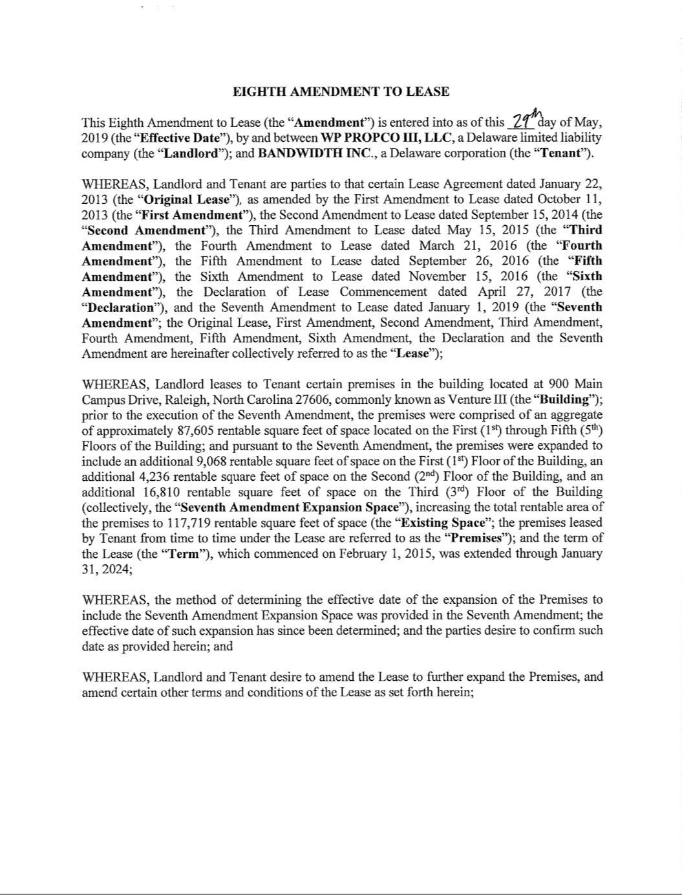

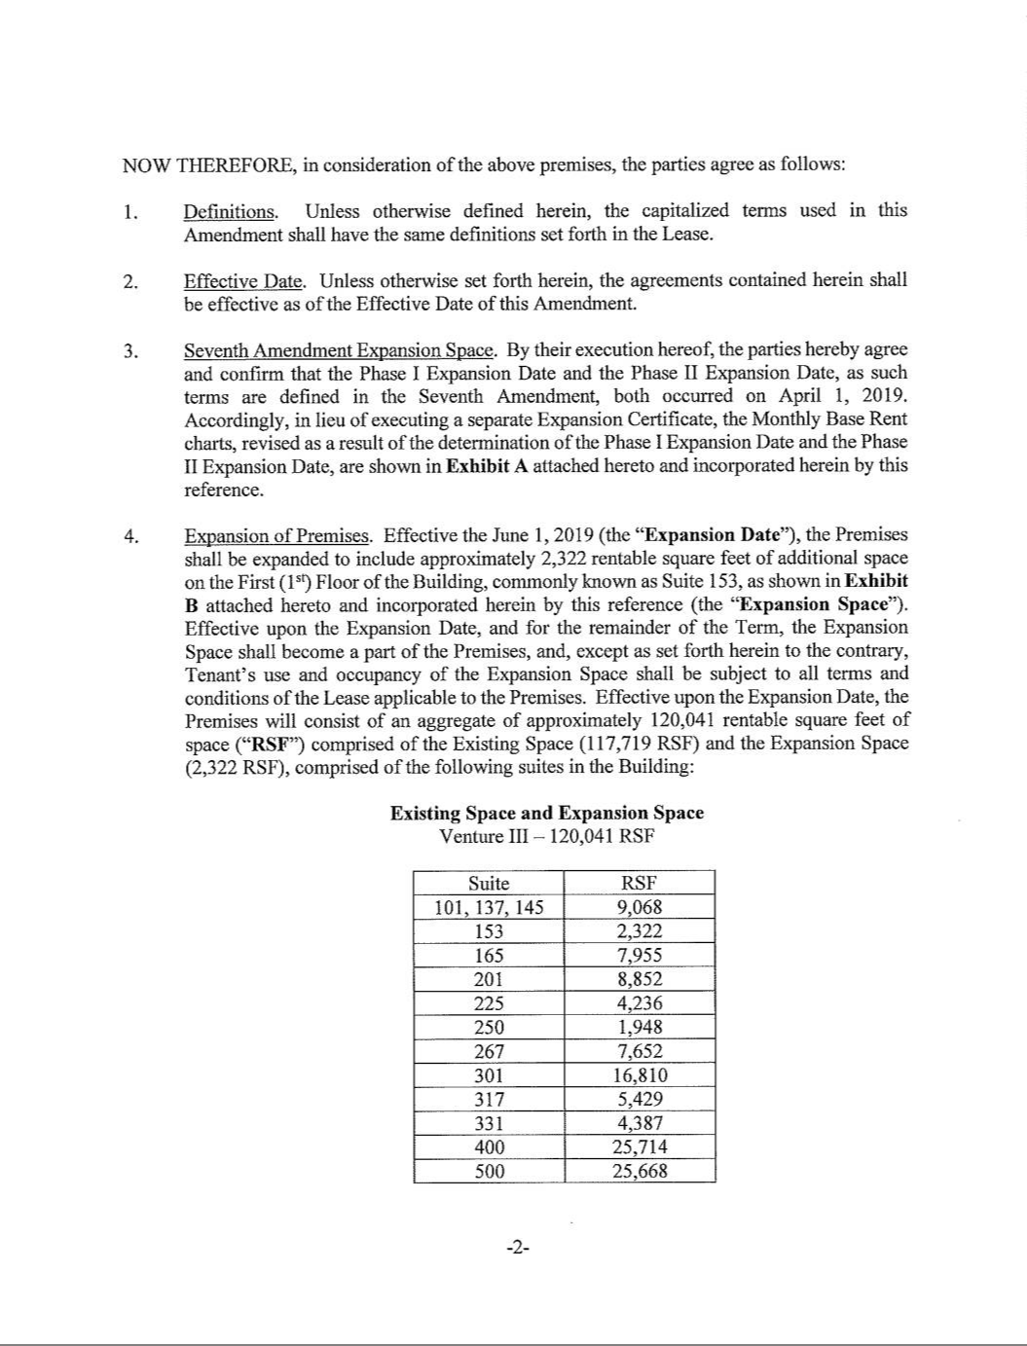

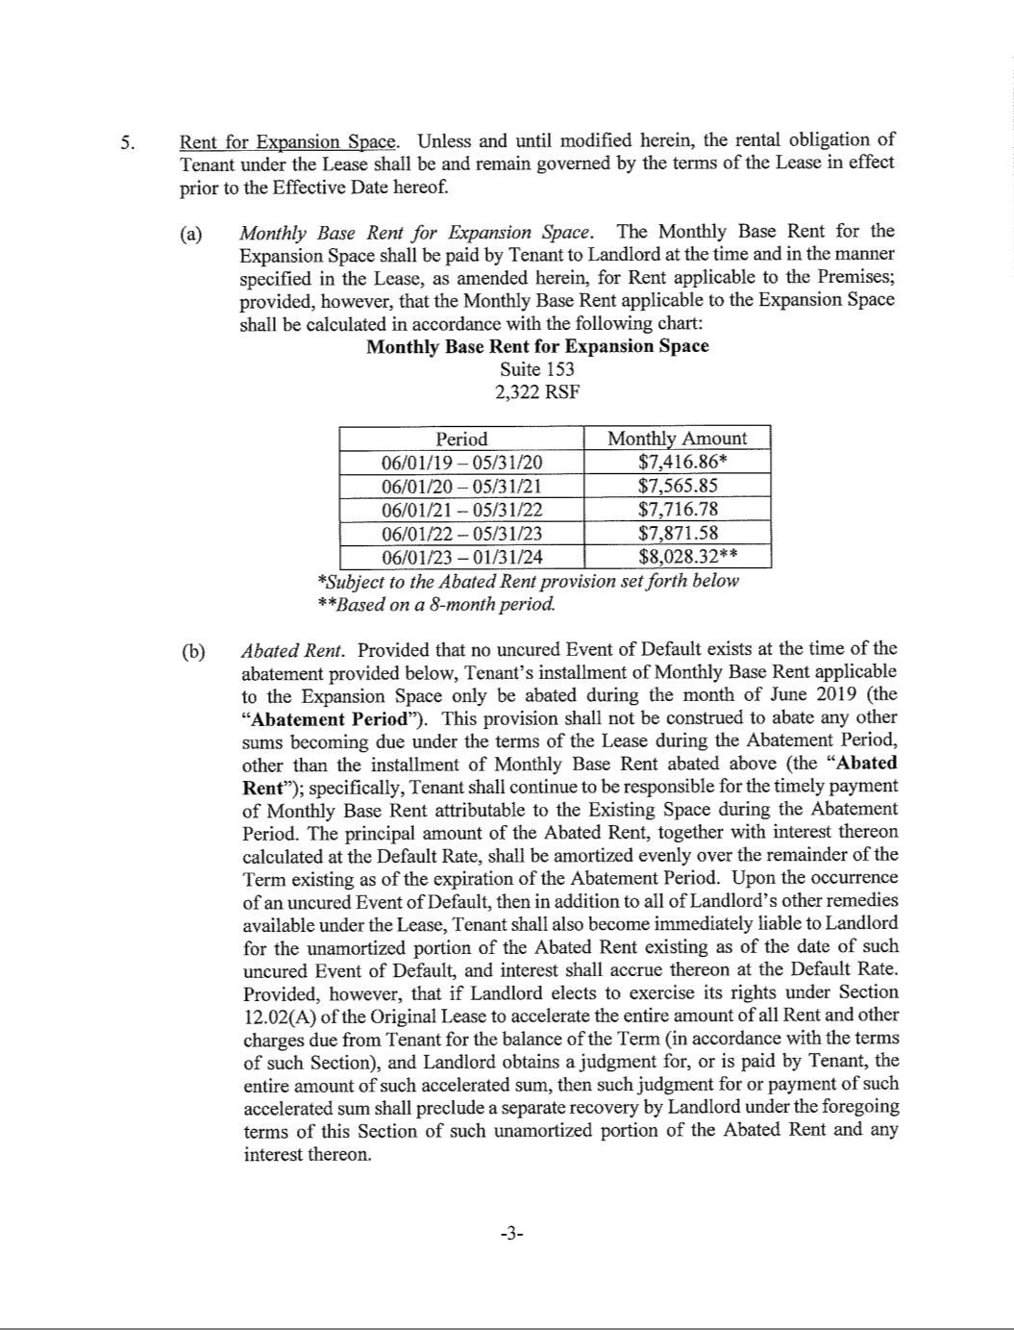

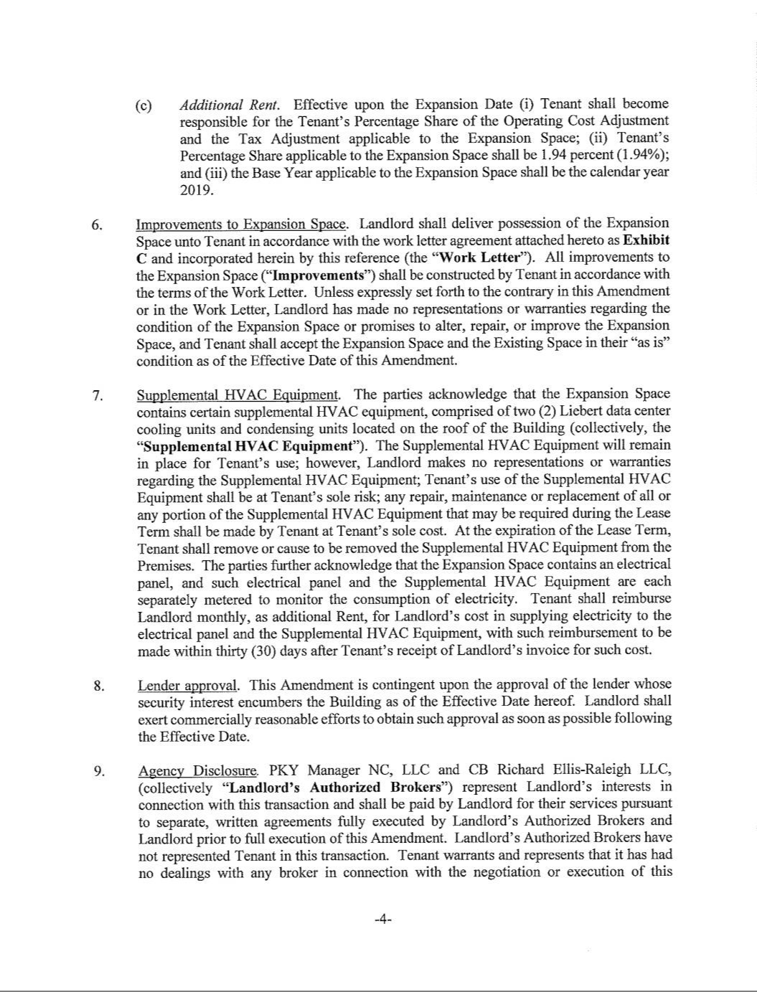

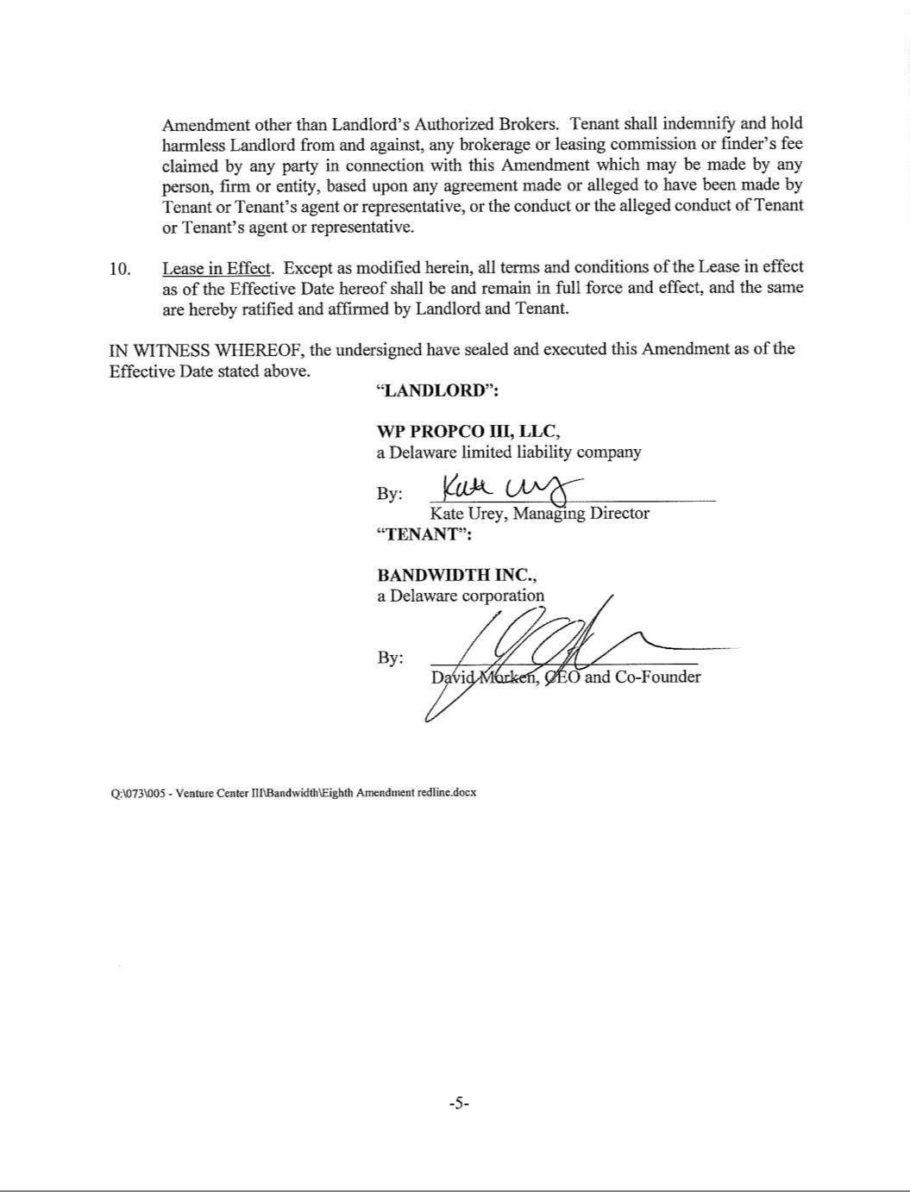

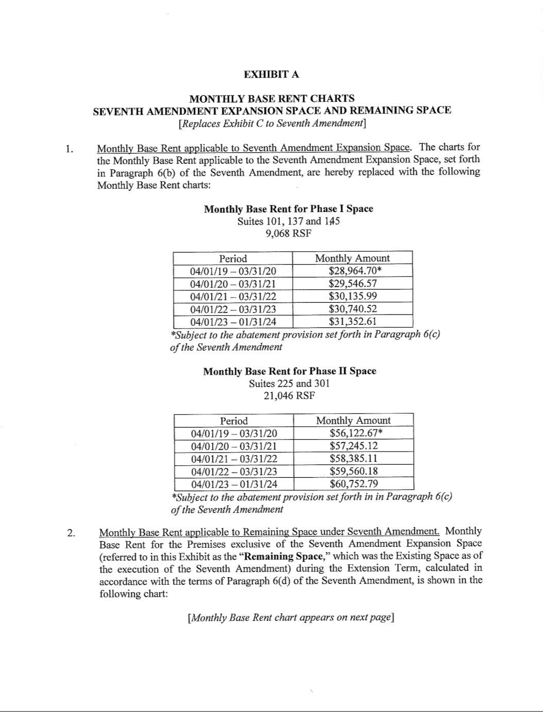



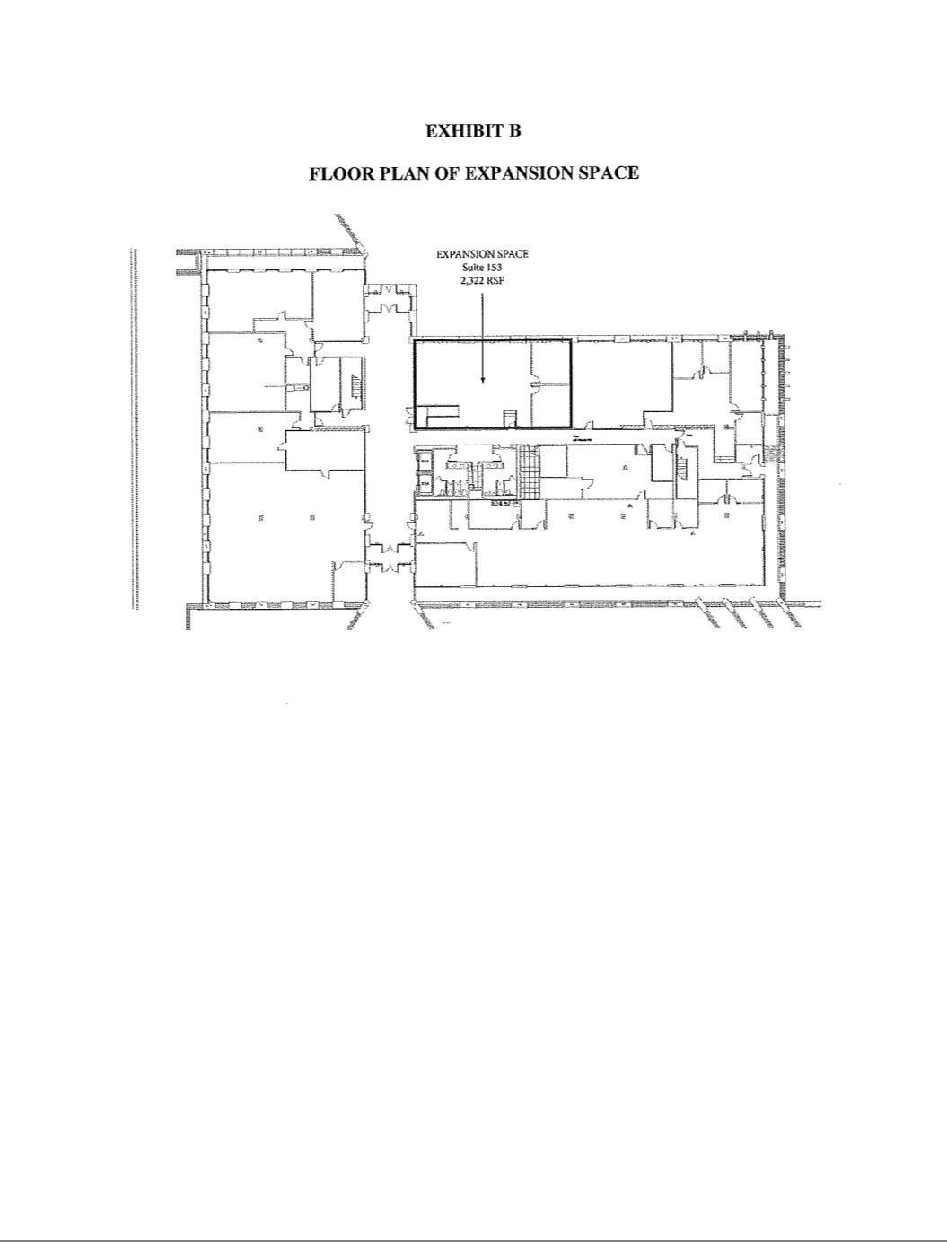

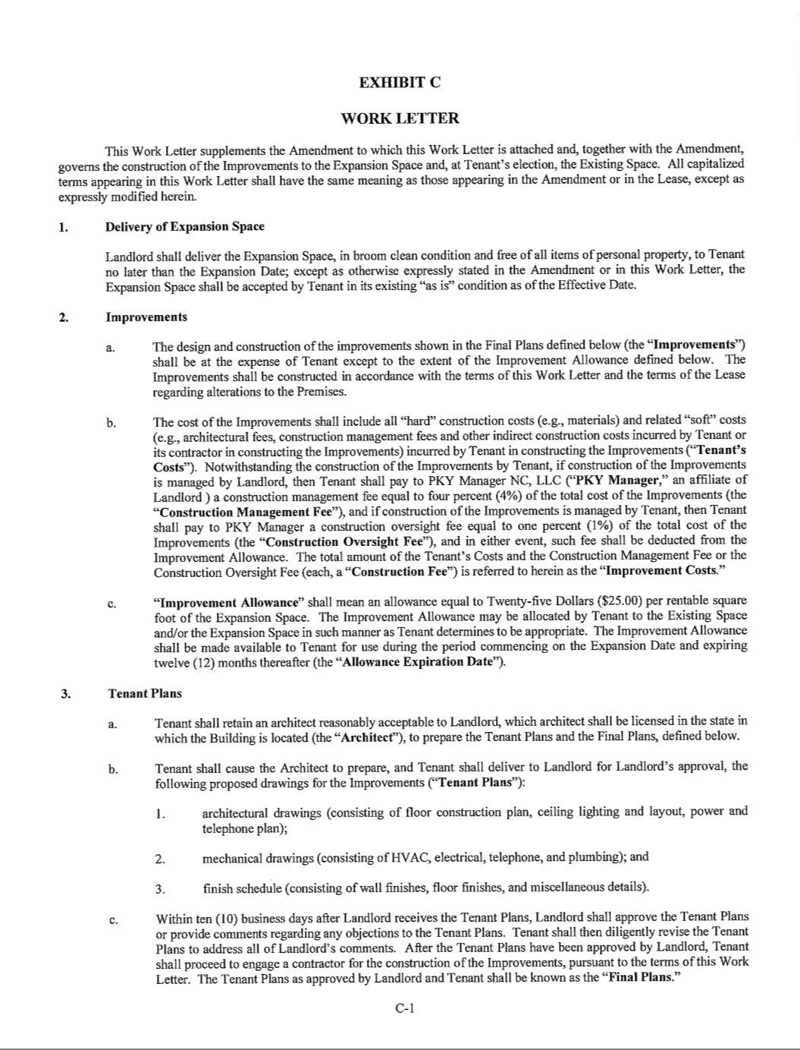

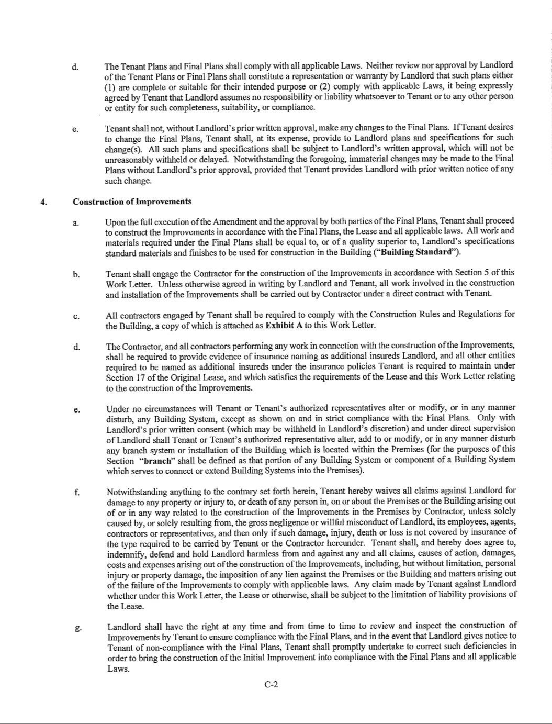

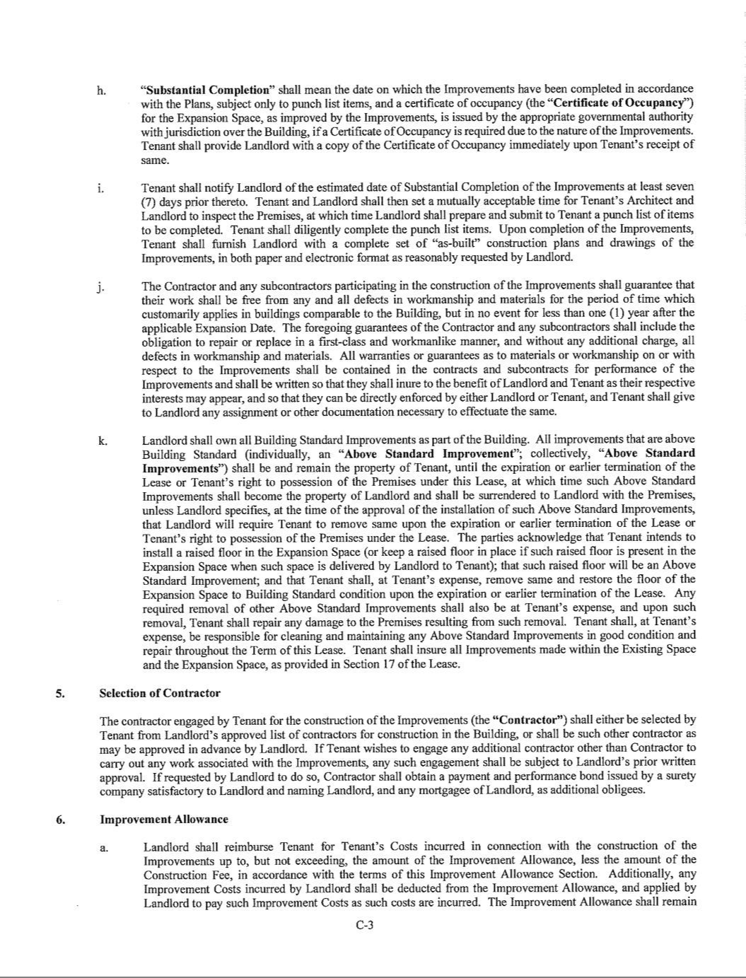

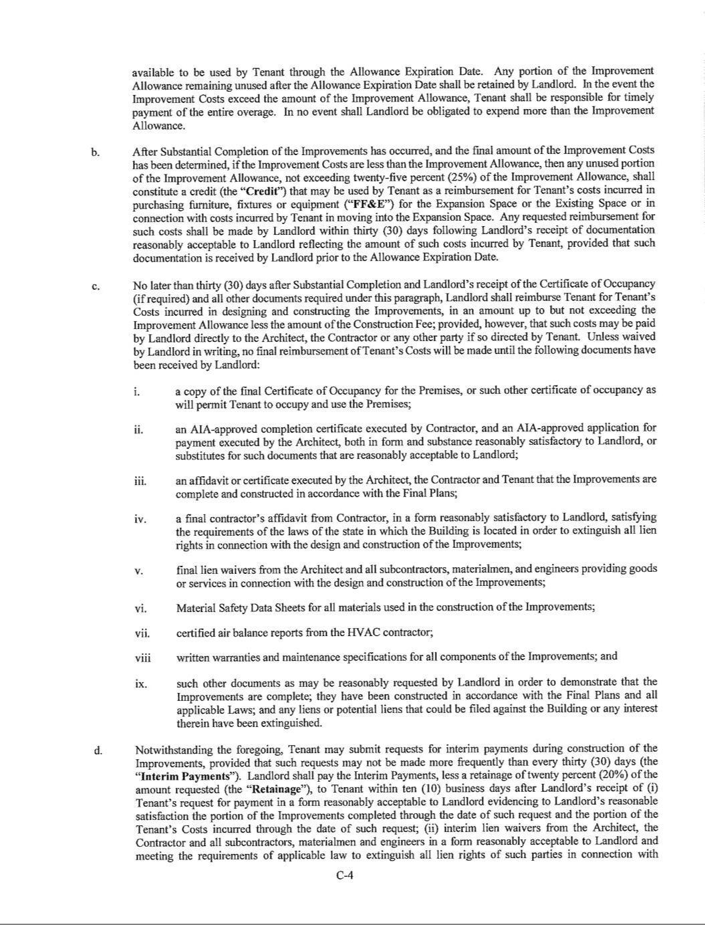

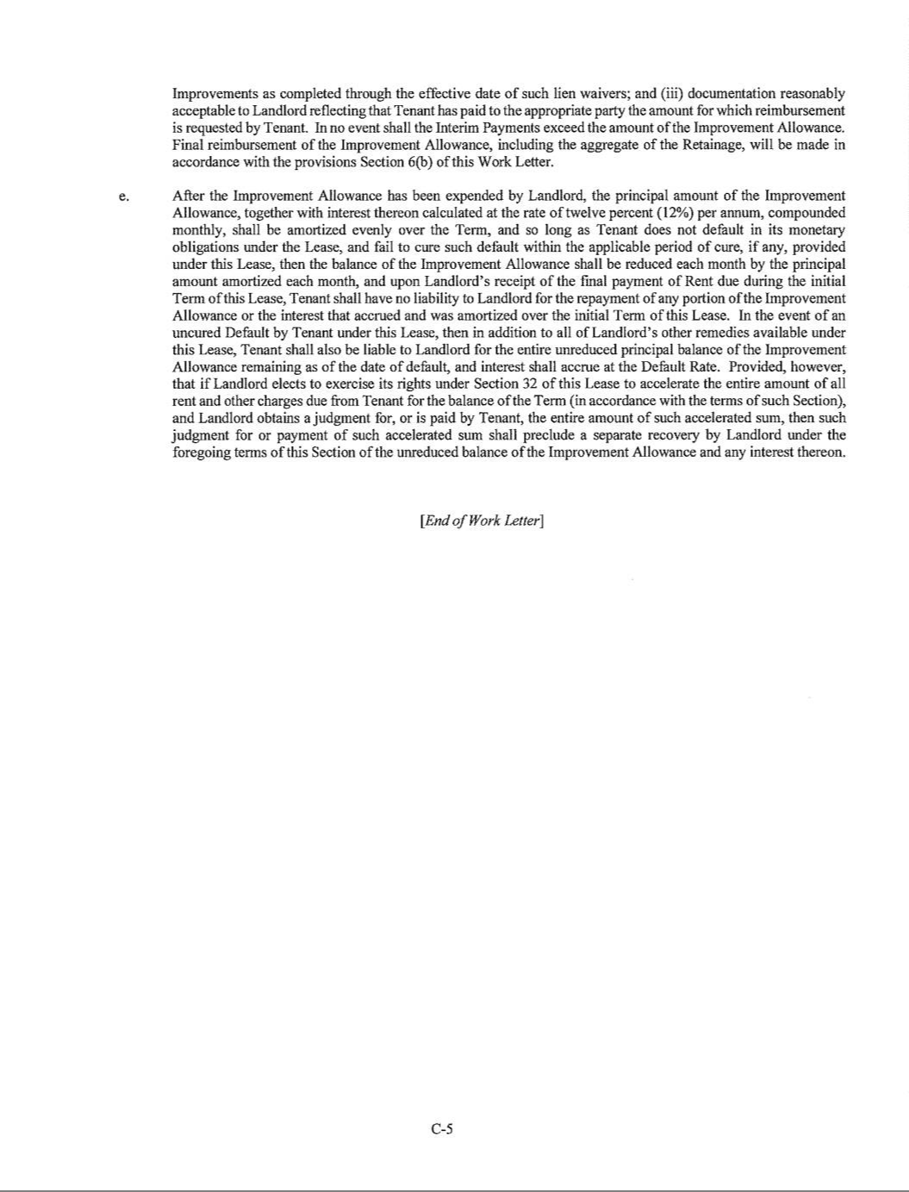

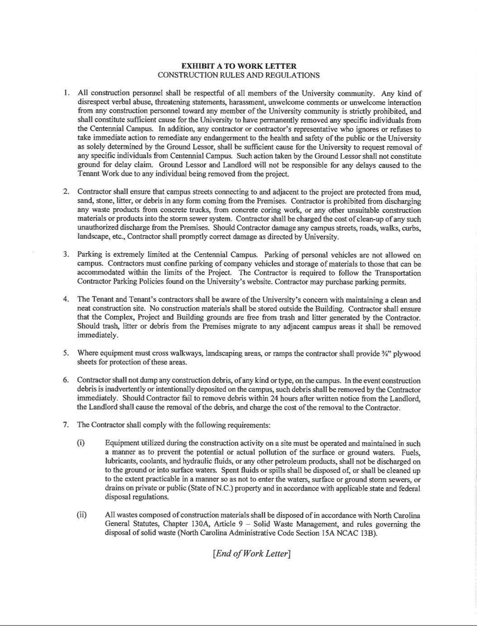

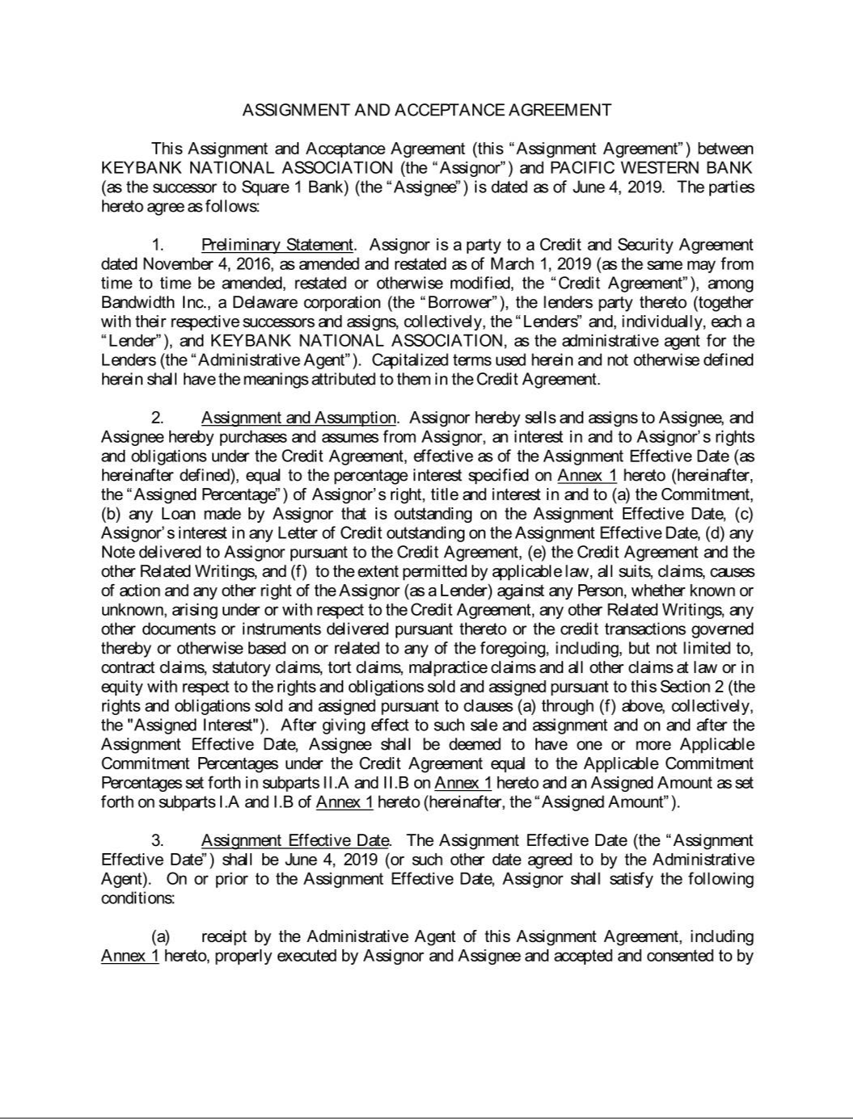

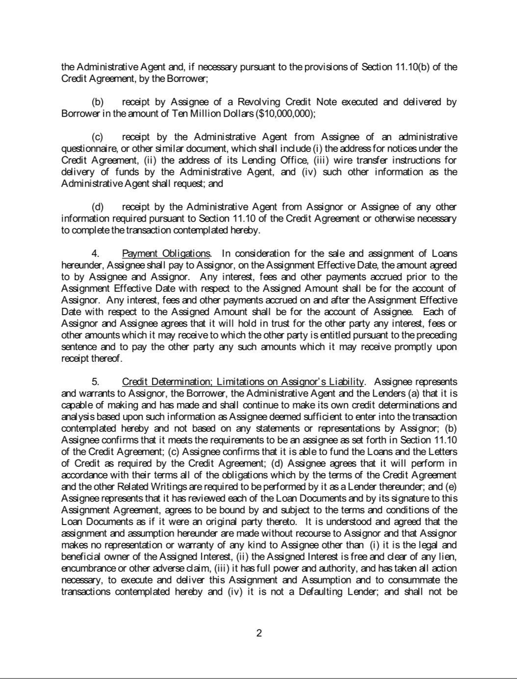





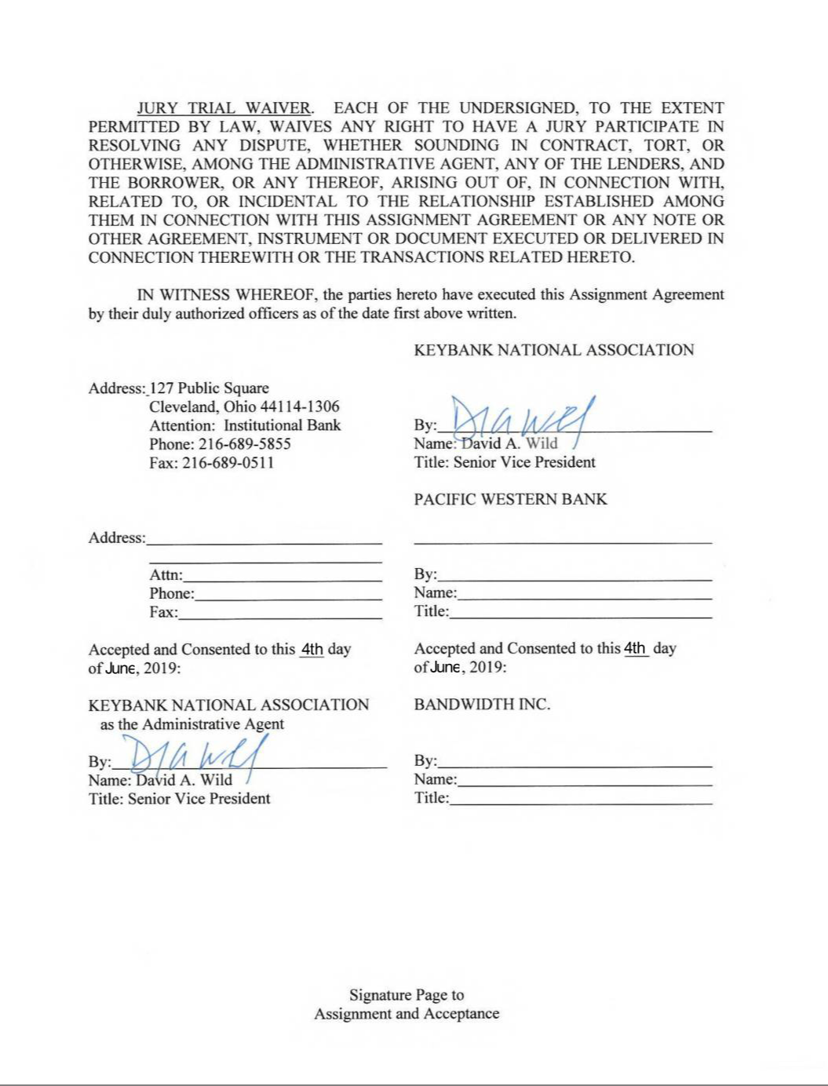

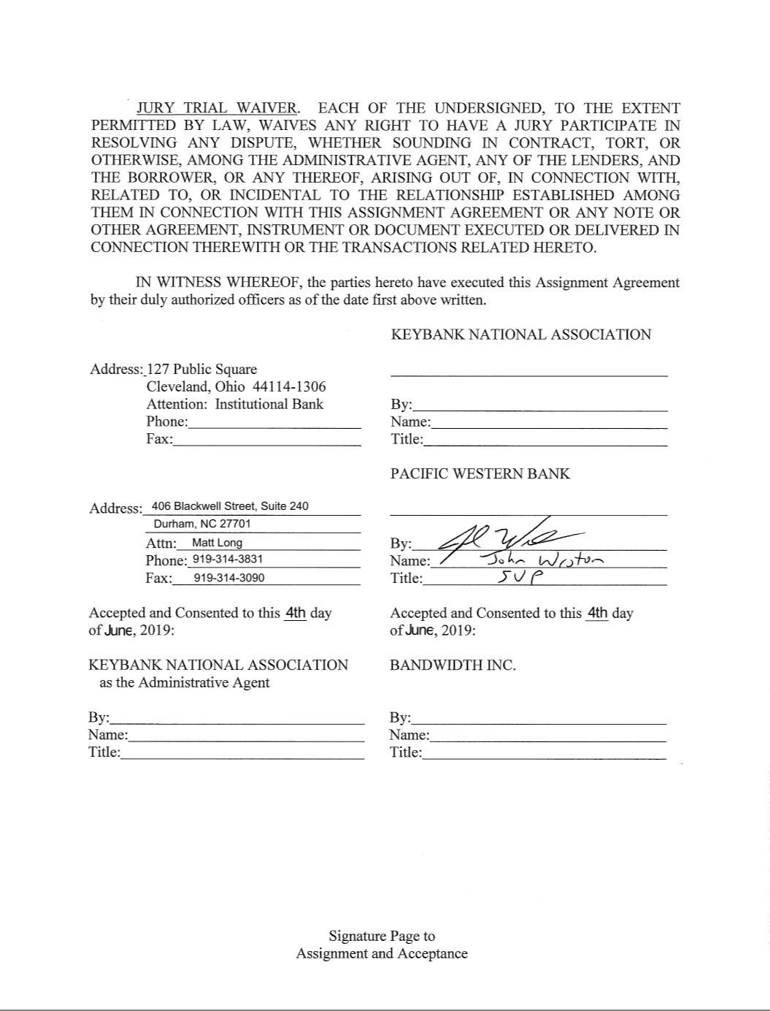

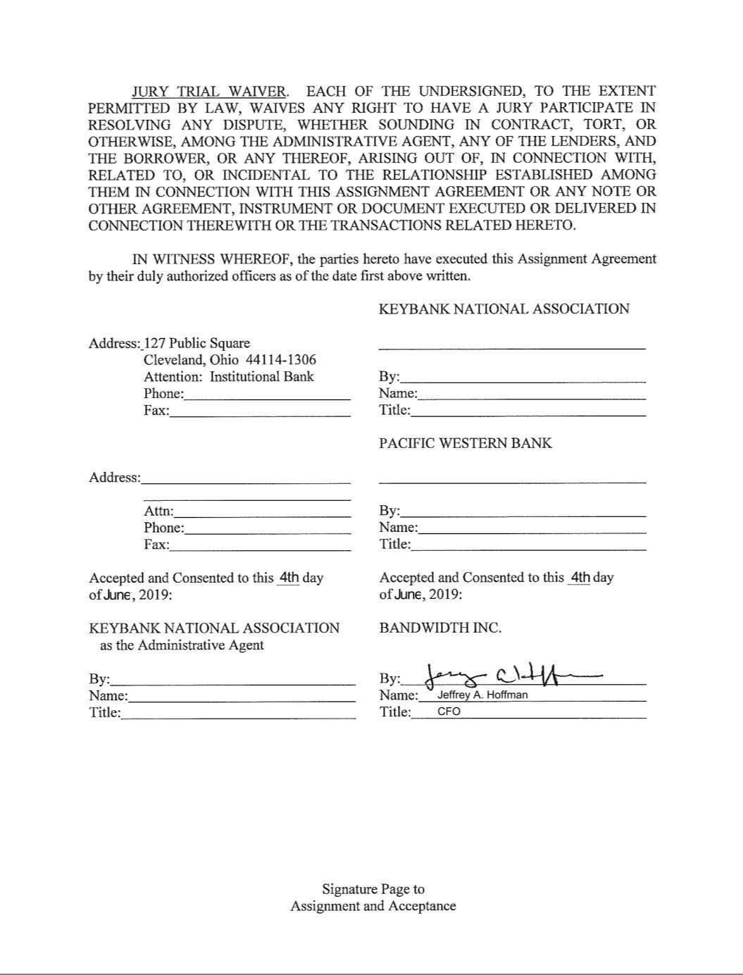

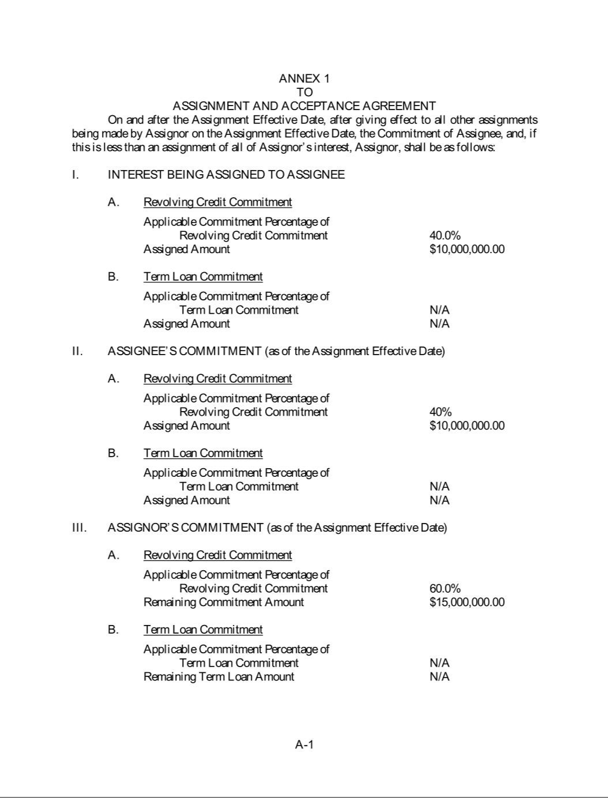

Revenue Commitment Schedule


900 Main Campus Drive, Suite 500

Raleigh, NC 27606


Billing Address

Customer Name: | Republic Wireless, Inc.
Attention To: | Chris Chuang
Address: | 940 Main Campus Drive, Suite 300
City: | Raleigh
State: | NC
Zip Code: | 27606

This Revenue Commitment Schedule (the “Schedule”) supplements the Master Service Agreement (the “MSA”) (including any SOFs, Terms and Conditions, Exhibit(s), Schedule(s), and any other attachments to the MSA, all of which are fully incorporated by reference within this Schedule). This Schedule constitutes an SOF for all purposes related to the MSA. Capitalized terms not elsewhere defined in this Schedule will have the meaning ascribed to them in the MSA.

Date of MSA to which this Revenue Commitment Schedule applies: November 30, 2016
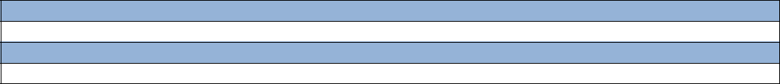

The “Minimum Revenue Commitment” is:

$100,000.00

The “Minimum Revenue Commitment Date” is:

July 1, 2019

“Applicable Charges” means the total invoiced charges for monthly recurring charges, non-recurring charges, and/or per transaction Usage charges included in any applicable invoice(s) for those Services provided or sold to Customer by Bandwidth pursuant to the MSA, except as otherwise expressly provided in any applicable SOF; provided, however, “Applicable Charges” specifically exclude (i) all applicable federal, state or local taxes and all use, sales, commercial, gross receipts, privilege, surcharges, or other similar taxes, license fees, miscellaneous fees, and surcharges, whether charged to or against Bandwidth, which will be payable by Customer, including, without limitation, any cost recovery fee which shall represent an accurate and non-inflated recovery of Bandwidth’s, or any underlying provider’s, miscellaneous tax, surcharge, and fee payments to federal, state or local governmental authorities associated with the provision of Service(s) by Bandwidth to Customer; and (ii) any late payment or similar fees.

If Customer fails to incur Applicable Charges for Services pursuant to the MSA at least equal to the Minimum Revenue Commitment during any monthly billing cycle that begins on or after the Minimum Revenue Commitment Date, Customer will pay to Bandwidth the difference between the actual Applicable Charges for Service(s) incurred and the Minimum Revenue Commitment immediately following such billing cycle.

Schedule Term and Termination: The term of this Schedule shall be for the period commencing on July 1, 2019 and ending on May 31, 2020 (“Schedule Term”) for Services. If the SOF and/or MSA terminates for any reason (other than Default attributable to the acts or omissions of Bandwidth) during the Schedule Term, Customer will immediately pay to Bandwidth an Early Termination Charge equal to one (1) times the Minimum Revenue Commitment amount indicated above, multiplied by the number of months remaining in the Schedule Term.

REPUBLIC WIRELESS, INC.: |  | BANDWIDTH INC:
By: | /s/ Chris Chuang | By: | /s/ Ryan Henley
Printed Name: | Chris Chuang | Printed Name: | Ryan Henley
Title: | CEO | Title: | SVP, Operations
Date: | June 20, 2019 | Date: | June 20, 2019

BANDWIDTH.COM, INC. - Proprietary & Confidential Information

Page 1 of 1

Revenue Commitment Schedule– Updated as of August 2018

Revenue Commitment Schedule

900 Main Campus Drive, Suite 500

Raleigh, NC 27606

BANDWIDTH.COM, INC. - Proprietary & Confidential Information

Page 1 of 1

Revenue Commitment Schedule– Updated as of August 2018

Exhibit 31.1

CERTIFICATION PURSUANT TO RULE 13a-14(a) OR 15d-14(a) OF

THE SECURITIES EXCHANGE ACT OF 1934,
AS ADOPTED PURSUANT TO SECTION 302 OF
THE SARBANES-OXLEY ACT OF 2002

I, David A. Morken, certify that:

- I have reviewed this Quarterly Report on Form 10-Q of Bandwidth Inc.;

- Based on my knowledge, this report does not contain any untrue statement of a material fact or omit to state a material fact necessary to make the statements made, in light of the circumstances under which such statements were made, not misleading with respect to the period covered by this report;

- Based on my knowledge, the financial statements, and other financial information included in this report, fairly present in all material respects the financial condition, results of operations and cash flows of the registrant as of, and for, the periods presented in this report;

- The registrant’s other certifying officer(s) and I are responsible for establishing and maintaining disclosure controls and procedures (as defined in Exchange Act Rules 13a —15(e) and 15d—15(e)) and internal control over financial reporting (as defined in Exchange Act Rules 13a-15(f) and 15d-15(f)) for the registrant and have:
  - Designed such disclosure controls and procedures, or caused such disclosure controls and procedures to be designed under our supervision, to ensure that material information relating to the registrant, including its consolidated subsidiaries, is made known to us by others within those entities, particularly during the period in which this report is being prepared;

  - Designed such internal control over financial reporting, or caused such internal control over financial reporting to be designed under our supervision, to provide reasonable assurance regarding the reliability of financial reporting and the preparation of financial statements for external purposes in accordance with generally accepted accounting principles;

  - Evaluated the effectiveness of the registrant’s disclosure controls and procedures and presented in this report our conclusions about the effectiveness of the disclosure controls and procedures, as of the end of the period covered by this report based on such evaluation; and

  - Disclosed in this report any change in the registrant’s internal control over financial reporting that occurred during the registrant’s most recent fiscal quarter (the registrant’s fourth fiscal quarter in the case of an annual report) that has materially affected, or is reasonably likely to materially affect, the registrant’s internal control over financial reporting; and

- The registrant’s other certifying officer(s) and I have disclosed, based on our most recent evaluation of internal control over financial reporting, to the registrant’s auditors and the audit committee of the registrant’s board of directors (or persons performing the equivalent functions):

  - All significant deficiencies and material weaknesses in the design or operation of internal control over financial reporting which are reasonably likely to adversely affect the registrant’s ability to record, process, summarize and report financial information; and

  - Any fraud, whether or not material, that involves management or other employees who have a significant role in the registrant’s internal control over financial reporting.

Date: August 2, 2019

/s/ David A. Morken

David A. Morken

Chief Executive Officer

(Principal Executive Officer)

Exhibit 31.2

CERTIFICATION PURSUANT TO RULE 13a-14(a) OR 15d-14(a) OF

THE SECURITIES EXCHANGE ACT OF 1934,
AS ADOPTED PURSUANT TO SECTION 302 OF
THE SARBANES-OXLEY ACT OF 2002

I, Jeffrey A. Hoffman certify that:

- I have reviewed this Quarterly Report on Form 10-Q of Bandwidth Inc.;

- Based on my knowledge, this report does not contain any untrue statement of a material fact or omit to state a material fact necessary to make the statements made, in light of the circumstances under which such statements were made, not misleading with respect to the period covered by this report;

- Based on my knowledge, the financial statements, and other financial information included in this report, fairly present in all material respects the financial condition, results of operations and cash flows of the registrant as of, and for, the periods presented in this report;

- The registrant’s other certifying officer(s) and I are responsible for establishing and maintaining disclosure controls and procedures (as defined in Exchange Act Rules 13a —15(e) and 15d—15(e)) and internal control over financial reporting (as defined in Exchange Act Rules 13a-15(f) and 15d-15(f)) for the registrant and have:
  - Designed such disclosure controls and procedures, or caused such disclosure controls and procedures to be designed under our supervision, to ensure that material information relating to the registrant, including its consolidated subsidiaries, is made known to us by others within those entities, particularly during the period in which this report is being prepared;

  - Designed such internal control over financial reporting, or caused such internal control over financial reporting to be designed under our supervision, to provide reasonable assurance regarding the reliability of financial reporting and the preparation of financial statements for external purposes in accordance with generally accepted accounting principles;

  - Evaluated the effectiveness of the registrant’s disclosure controls and procedures and presented in this report our conclusions about the effectiveness of the disclosure controls and procedures, as of the end of the period covered by this report based on such evaluation; and

  - Disclosed in this report any change in the registrant’s internal control over financial reporting that occurred during the registrant’s most recent fiscal quarter (the registrant’s fourth fiscal quarter in the case of an annual report) that has materially affected, or is reasonably likely to materially affect, the registrant’s internal control over financial reporting; and

- The registrant’s other certifying officer(s) and I have disclosed, based on our most recent evaluation of internal control over financial reporting, to the registrant’s auditors and the audit committee of the registrant’s board of directors (or persons performing the equivalent functions):

  - All significant deficiencies and material weaknesses in the design or operation of internal control over financial reporting which are reasonably likely to adversely affect the registrant’s ability to record, process, summarize and report financial information; and

  - Any fraud, whether or not material, that involves management or other employees who have a significant role in the registrant’s internal control over financial reporting.

Date: August 2, 2019

/s/ Jeffrey A. Hoffman

Jeffrey A. Hoffman

Chief Financial Officer

(Principal Accounting and Financial Officer)

Exhibit 32.1

CERTIFICATION OF CHIEF EXECUTIVE OFFICER AND CHIEF FINANCIAL OFFICER

PURSUANT TO
18 U.S.C. SECTION 1350,
AS ADOPTED PURSUANT TO
SECTION 906 OF THE SARBANES-OXLEY ACT OF 2002

Pursuant to the requirement set forth in Rule 13a-14(b) of the Securities Exchange Act of 1934, as amended, (the “Exchange Act”) and Section 1350 of Chapter 63 of Title 18 of the United States Code (18 U.S.C. §1350), David A. Morken, Chief Executive Officer of Bandwidth Inc. (the “Company”), and Jeffrey A. Hoffman, Chief Financial Officer of the Company, each hereby certifies that, to the best of his knowledge:

- The Company’s Quarterly Report on Form 10-Q for the quarterly period ended June 30, 2019, to which this Certification is attached as Exhibit 32.1 (the “Periodic Report”), fully complies with the requirements of Section 13(a) or Section 15(d) of the Exchange Act; and

- The information contained in the Periodic Report fairly presents, in all material respects, the financial condition and results of operations of the Company.

Date: August 2, 2019

/s/ David A. Morken

David A. Morken

Chief Executive Officer

(Principal Executive Officer)

/s/ Jeffrey A. Hoffman

Jeffrey A. Hoffman

Chief Financial Officer

(Principal Accounting and Financial Officer)

