UNITED STATES
SECURITIES AND EXCHANGE COMMISSION
Washington, D.C. 20549
___________________________________________________

FORM 8-K
___________________________________________________
CURRENT REPORT
Pursuant to Section 13 or 15(d)
of the Securities Exchange Act of 1934
Date of Report (Date of earliest event reported) September 15, 2026
___________________________________________________
BANDWIDTH INC.
(Exact name of registrant as specified in its charter)
___________________________________________________
Delaware |  |  |  |  |  | 001-38285 |  |  |  |  |  | 56-2242657
(State or other jurisdiction  of incorporation) |  |  |  |  |  | (Commission  File Number) |  |  |  |  |  | (IRS Employer  Identification No.)
2230 Bandmate Way
Raleigh, NC 27607
(Address of principal executive offices) (Zip Code)
(800) 808-5150
Registrant’s telephone number, including area code
Not Applicable
(Former name or former address, if changed since last report)
___________________________________________________
Check the appropriate box below if the Form 8-K filing is intended to simultaneously satisfy the filing obligation of the registrant under any of the following provisions:
☐ |  |  | Written communications pursuant to Rule 425 under the Securities Act (17 CFR 230.425)
☐ |  |  | Soliciting material pursuant to Rule 14a-12 under the Exchange Act (17 CFR 240.14a-12)
☐ |  |  | Pre-commencement communications pursuant to Rule 14d-2(b) under the Exchange Act (17 CFR 240.14d-2(b))
☐ |  |  | Pre-commencement communications pursuant to Rule 13e-4(c) under the Exchange Act (17 CFR 240.13e-4(c))

Securities registered pursuant to Section 12(b) of the Act:
Title of each class |  |  |  |  |  | Trading Symbol(s) |  |  |  |  |  | Name of each exchange on which registered
Class A Common Stock, par value $0.001 per share |  |  |  |  |  | BAND |  |  |  |  |  | NASDAQ Global Select Market
Indicate by check mark whether the registrant is an emerging growth company as defined in Rule 405 of the Securities Act of 1933 (§230.405 of this chapter) or Rule 12b-2 of the Securities Exchange Act of 1934 (§240.12b-2 of this chapter).
Emerging growth company ☐
If an emerging growth company, indicate by check mark if the registrant has elected not to use the extended transition period for complying with any new or revised financial accounting standards provided pursuant to Section 13(a) of the Exchange Act.
☐

Item 7.01 Regulation FD Disclosure.
Bandwidth Inc. (the “Company”) plans to use certain presentation materials at various investor conferences during the third quarter of 2026. A copy of these materials is furnished with this Current Report on Form 8-K as Exhibit 99.1 and will be available on Bandwidth’s investor relations website at investors.bandwidth.com. The Company is not undertaking to update these materials.
The information furnished with this Item 7.01, including Exhibit 99.1, shall not be deemed “filed” for purposes of Section 18 of the Exchange Act or otherwise subject to the liabilities of that section, nor shall it be deemed incorporated by reference into any filing under the Securities Act, except as expressly set forth by specific reference in such a filing.

Item 9.01 Financial Statements and Exhibits.

(d) Exhibits
Exhibit No. |  |  |  |  |  | Description
99.1 |  |  |  |  |  | Bandwidth Inc. Investor Presentation
104 |  |  |  |  |  | Cover Page Interactive File (the cover page tags are embedded within the Inline XBRL document)

SIGNATURES
Pursuant to the requirements of the Securities Exchange Act of 1934, the registrant has duly caused this report to be signed on its behalf by the undersigned hereunto duly authorized.
 |  |  | BANDWIDTH INC.
Date: September 15, 2026 |  |  | By: |  |  | /s/ Daryl E. Raiford
 |  |  | Name: |  |  | Daryl E. Raiford
 |  |  | Title: |  |  | Chief Financial Officer



Investor Presentation September 2026

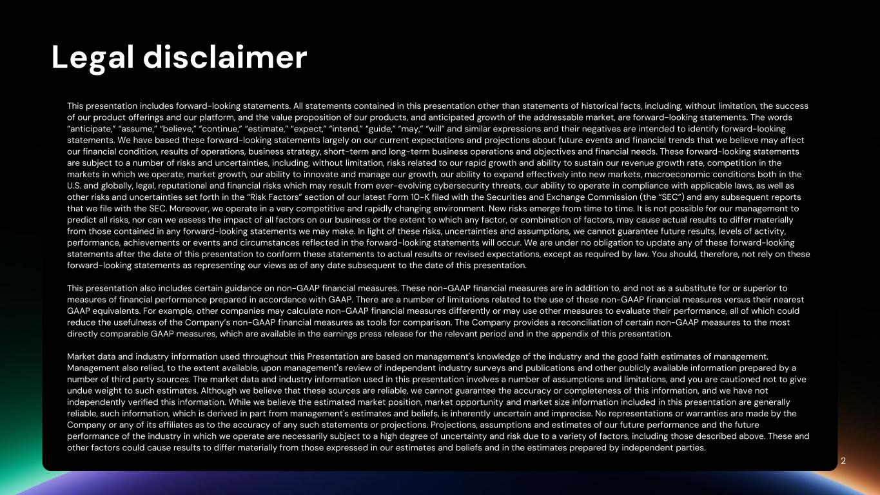
Legal disclaimer This presentation includes forward-looking statements. All statements contained in this presentation other than statements of historical facts, including, without limitation, the success of our product offerings and our platform, and the value proposition of our products, and anticipated growth of the addressable market, are forward-looking statements. The words “anticipate,” “assume,” “believe,” “continue,” “estimate,” “expect,” “intend,” “guide,” “may,” “will” and similar expressions and their negatives are intended to identify forward-looking statements. We have based these forward-looking statements largely on our current expectations and projections about future events and financial trends that we believe may affect our financial condition, results of operations, business strategy, short-term and long-term business operations and objectives and financial needs. These forward-looking statements are subject to a number of risks and uncertainties, including, without limitation, risks related to our rapid growth and ability to sustain our revenue growth rate, competition in the markets in which we operate, market growth, our ability to innovate and manage our growth, our ability to expand effectively into new markets, macroeconomic conditions both in the U.S. and globally, legal, reputational and financial risks which may result from ever-evolving cybersecurity threats, our ability to operate in compliance with applicable laws, as well as other risks and uncertainties set forth in the “Risk Factors” section of our latest Form 10-K filed with the Securities and Exchange Commission (the “SEC”) and any subsequent reports that we file with the SEC. Moreover, we operate in a very competitive and rapidly changing environment. New risks emerge from time to time. It is not possible for our management to predict all risks, nor can we assess the impact of all factors on our business or the extent to which any factor, or combination of factors, may cause actual results to differ materially from those contained in any forward-looking statements we may make. In light of these risks, uncertainties and assumptions, we cannot guarantee future results, levels of activity, performance, achievements or events and circumstances reflected in the forward-looking statements will occur. We are under no obligation to update any of these forward-looking statements after the date of this presentation to conform these statements to actual results or revised expectations, except as required by law. You should, therefore, not rely on these forward-looking statements as representing our views as of any date subsequent to the date of this presentation. This presentation also includes certain guidance on non-GAAP financial measures. These non-GAAP financial measures are in addition to, and not as a substitute for or superior to measures of financial performance prepared in accordance with GAAP. There are a number of limitations related to the use of these non-GAAP financial measures versus their nearest GAAP equivalents. For example, other companies may calculate non-GAAP financial measures differently or may use other measures to evaluate their performance, all of which could reduce the usefulness of the Company’s non-GAAP financial measures as tools for comparison. The Company provides a reconciliation of certain non-GAAP measures to the most directly comparable GAAP measures, which are available in the earnings press release for the relevant period and in the appendix of this presentation. Market data and industry information used throughout this Presentation are based on management's knowledge of the industry and the good faith estimates of management. Management also relied, to the extent available, upon management's review of independent industry surveys and publications and other publicly available information prepared by a number of third party sources. The market data and industry information used in this presentation involves a number of assumptions and limitations, and you are cautioned not to give undue weight to such estimates. Although we believe that these sources are reliable, we cannot guarantee the accuracy or completeness of this information, and we have not independently verified this information. While we believe the estimated market position, market opportunity and market size information included in this presentation are generally reliable, such information, which is derived in part from management's estimates and beliefs, is inherently uncertain and imprecise. No representations or warranties are made by the Company or any of its affiliates as to the accuracy of any such statements or projections. Projections, assumptions and estimates of our future performance and the future performance of the industry in which we operate are necessarily subject to a high degree of uncertainty and risk due to a variety of factors, including those described above. These and other factors could cause results to differ materially from those expressed in our estimates and beliefs and in the estimates prepared by independent parties. 2

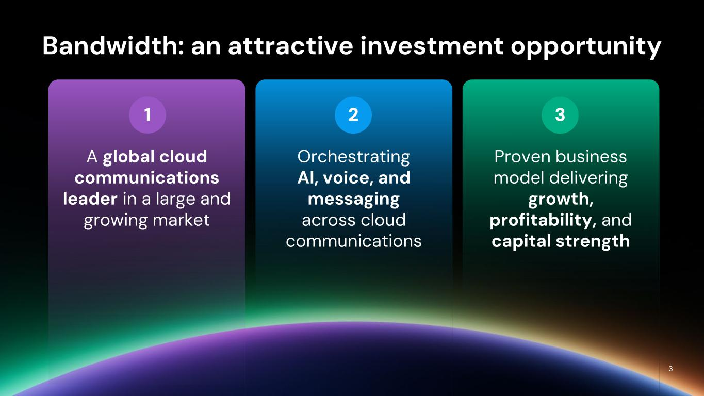
321 Bandwidth: an attractive investment opportunity A global cloud communications leader in a large and growing market Orchestrating AI, voice, and messaging across cloud communications Proven business model delivering growth, profitability, and capital strength 3

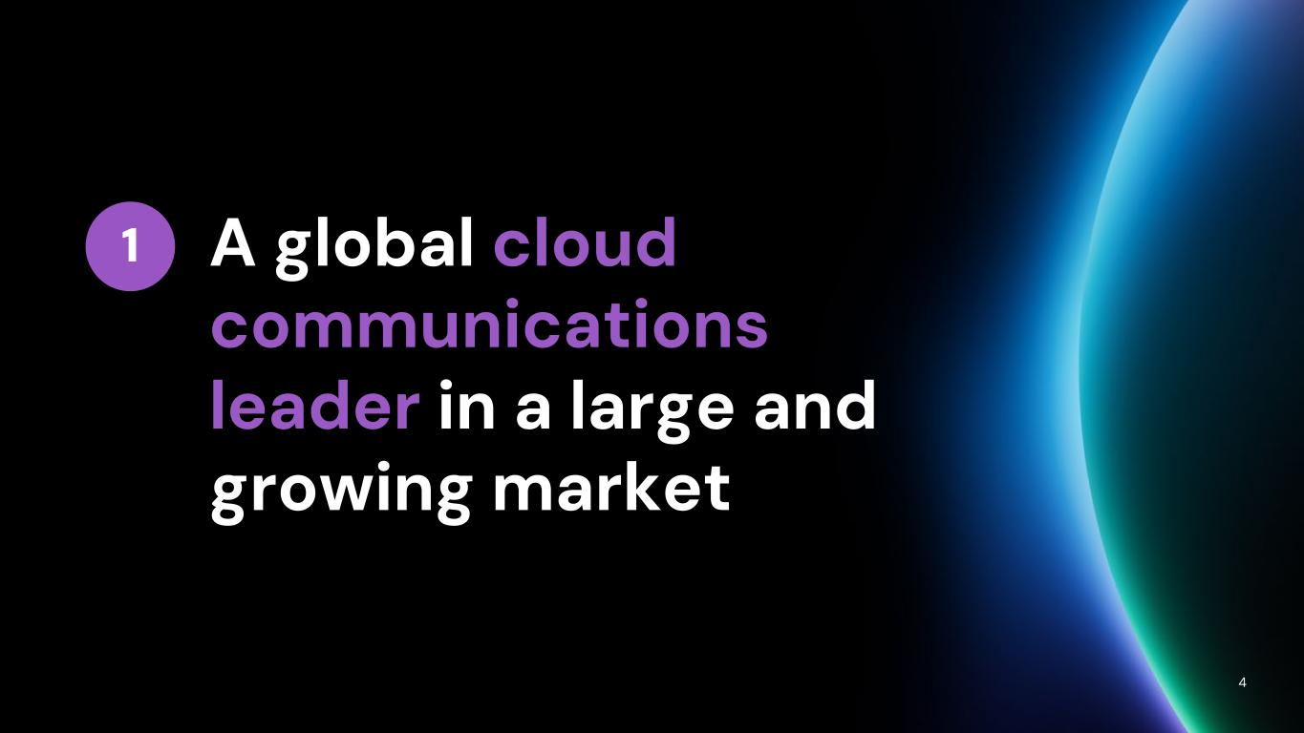
A global cloud communications leader in a large and growing market 4 1

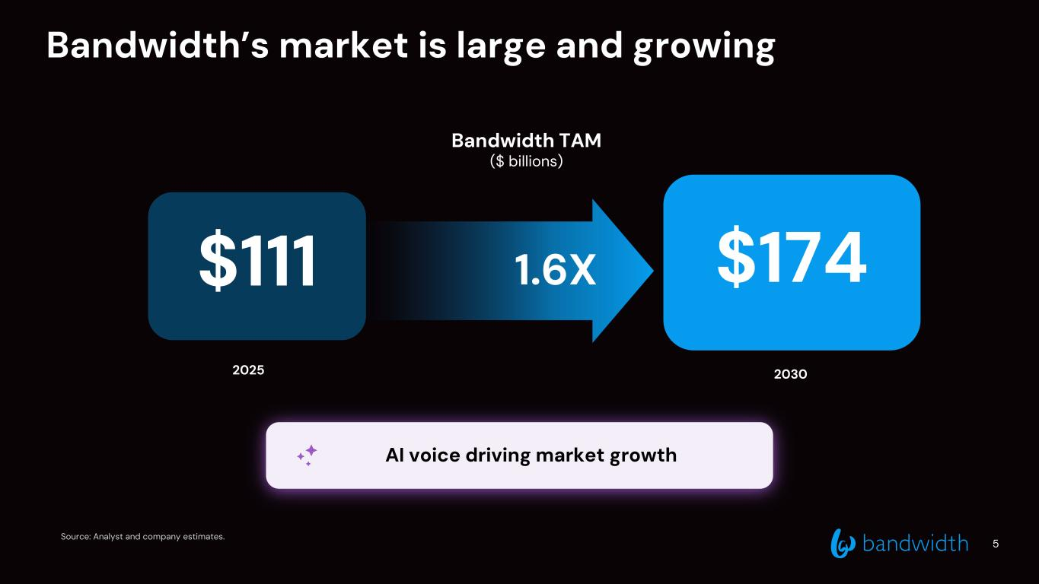
1.6X Bandwidth’s market is large and growing Source: Analyst and company estimates. 5 $111 $174 2025 2030 Bandwidth TAM ($ billions) AI voice driving market growth

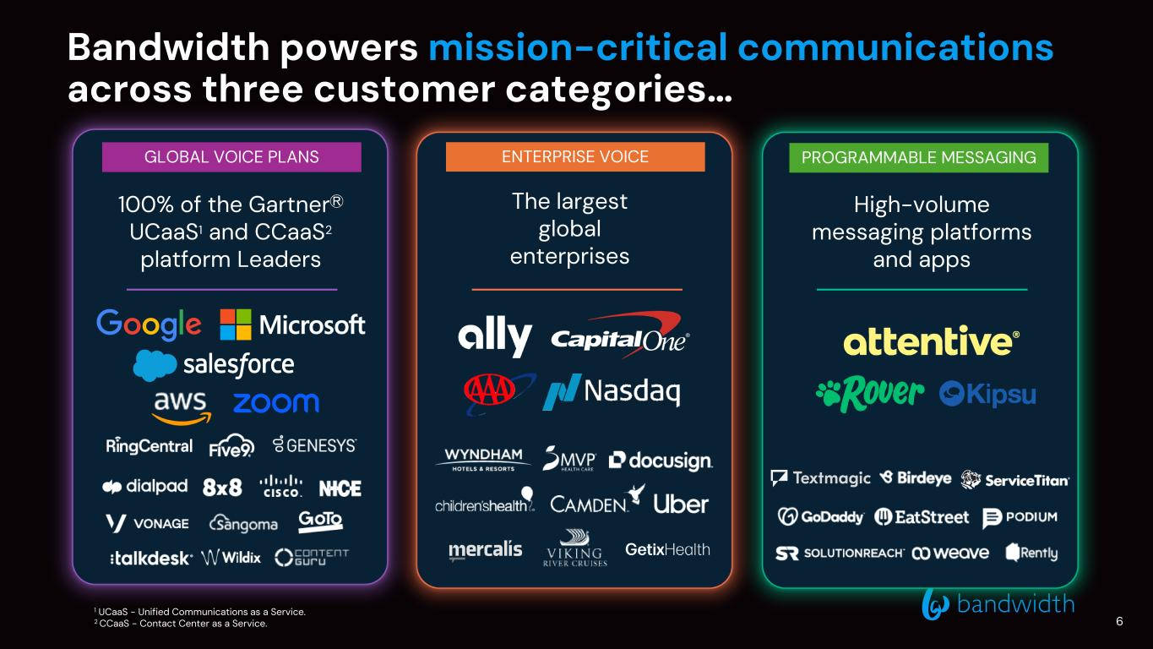
Bandwidth powers mission-critical communications across three customer categories… 100% of the GartnerⓇ UCaaS1 and CCaaS2 platform Leaders The largest global enterprises High-volume messaging platforms and apps 1 UCaaS - Unified Communications as a Service. 2 CCaaS - Contact Center as a Service. GLOBAL VOICE PLANS ENTERPRISE VOICE PROGRAMMABLE MESSAGING 6

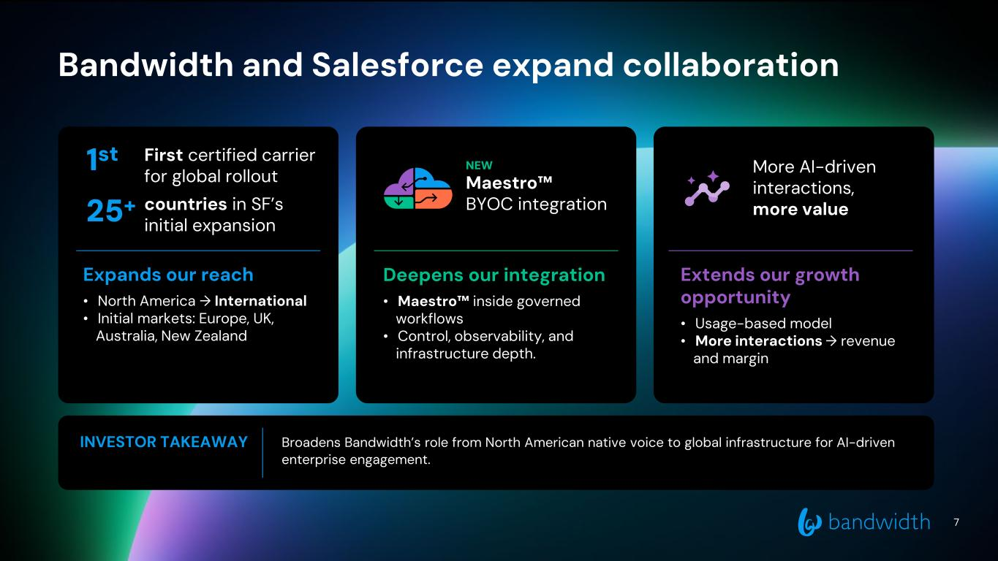
7 Bandwidth and Salesforce expand collaboration First certified carrier for global rollout 25+ countries in SF’s initial expansion NEW Maestro™ BYOC integration Extends our growth opportunity • Usage-based model • More interactions → revenue and margin Expands our reach • North America → International • Initial markets: Europe, UK, Australia, New Zealand Deepens our integration • Maestro™ inside governed workflows • Control, observability, and infrastructure depth. INVESTOR TAKEAWAY Broadens Bandwidth’s role from North American native voice to global infrastructure for AI-driven enterprise engagement. 1st More AI-driven interactions, more value

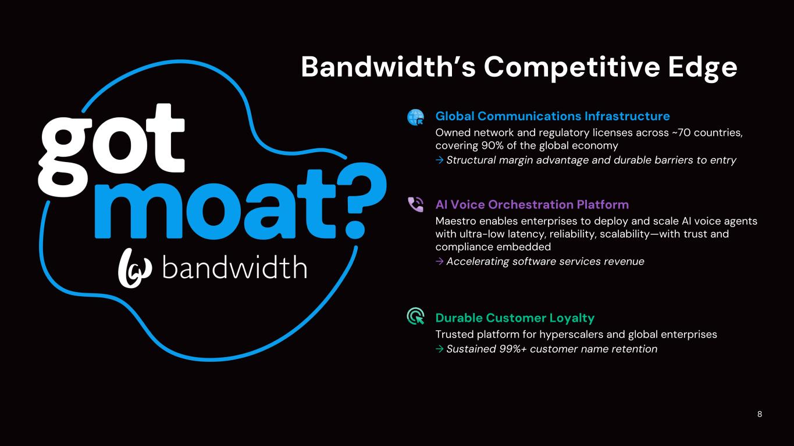
Bandwidth’s Competitive Edge Durable Customer Loyalty Trusted platform for hyperscalers and global enterprises → Sustained 99%+ customer name retention Global Communications Infrastructure Owned network and regulatory licenses across ~70 countries, covering 90% of the global economy → Structural margin advantage and durable barriers to entry AI Voice Orchestration Platform Maestro enables enterprises to deploy and scale AI voice agents with ultra-low latency, reliability, scalability—with trust and compliance embedded → Accelerating software services revenue 8

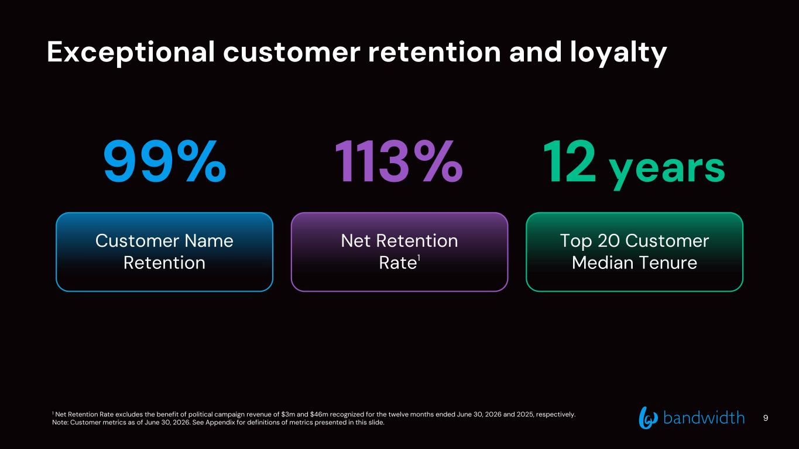
Exceptional customer retention and loyalty 9 99% Customer Name Retention 113% Net Retention Rate1 12 years Top 20 Customer Median Tenure 1 Net Retention Rate excludes the benefit of political campaign revenue of $3m and $46m recognized for the twelve months ended June 30, 2026 and 2025, respectively. Note: Customer metrics as of June 30, 2026. See Appendix for definitions of metrics presented in this slide.

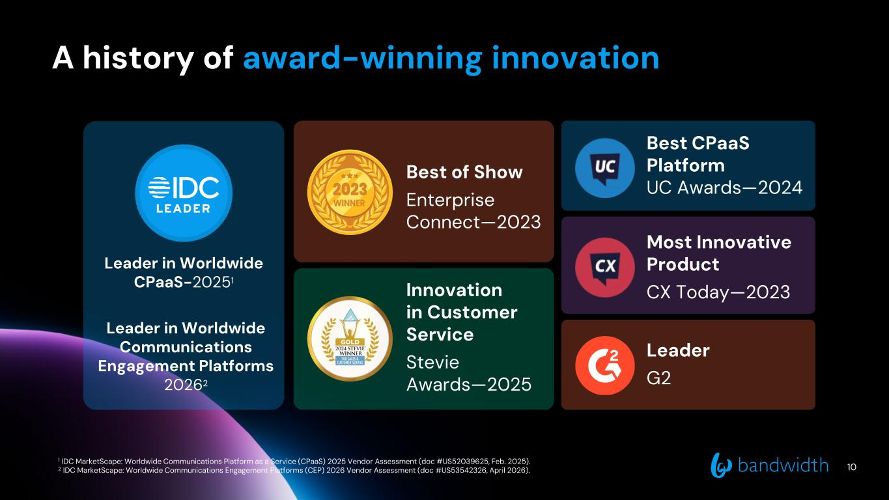
A history of award-winning innovation Best of Show Enterprise Connect—2023 Innovation in Customer Service Stevie Awards—2025 Best CPaaS Platform UC Awards—2024 Most Innovative Product CX Today—2023 Leader G2 10 Leader in Worldwide CPaaS-20251 Leader in Worldwide Communications Engagement Platforms 20262 1 IDC MarketScape: Worldwide Communications Platform as a Service (CPaaS) 2025 Vendor Assessment (doc #US52039625, Feb. 2025). 2 IDC MarketScape: Worldwide Communications Engagement Platforms (CEP) 2026 Vendor Assessment (doc #US53542326, April 2026).

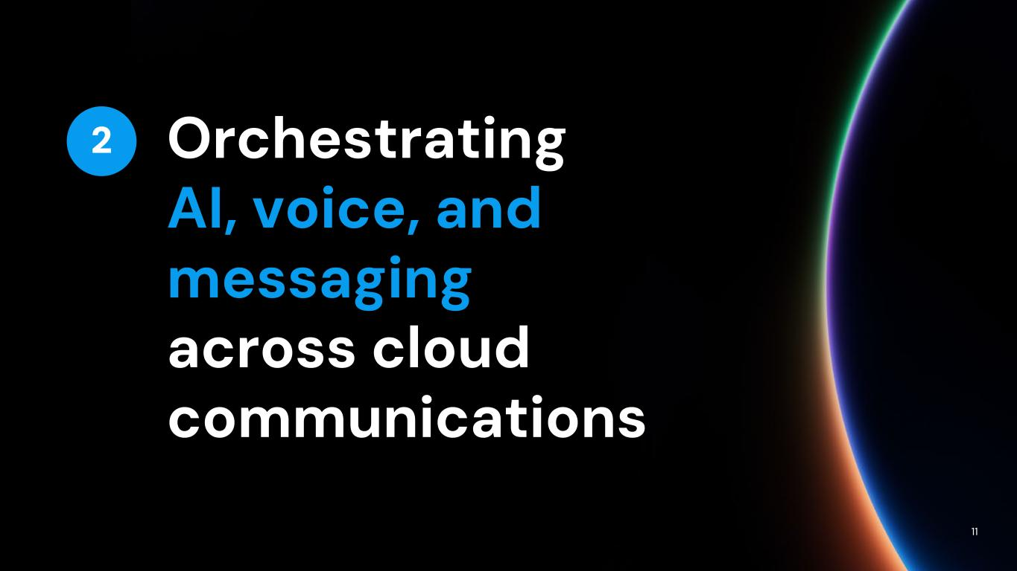
Orchestrating AI, voice, and messaging across cloud communications 11 2

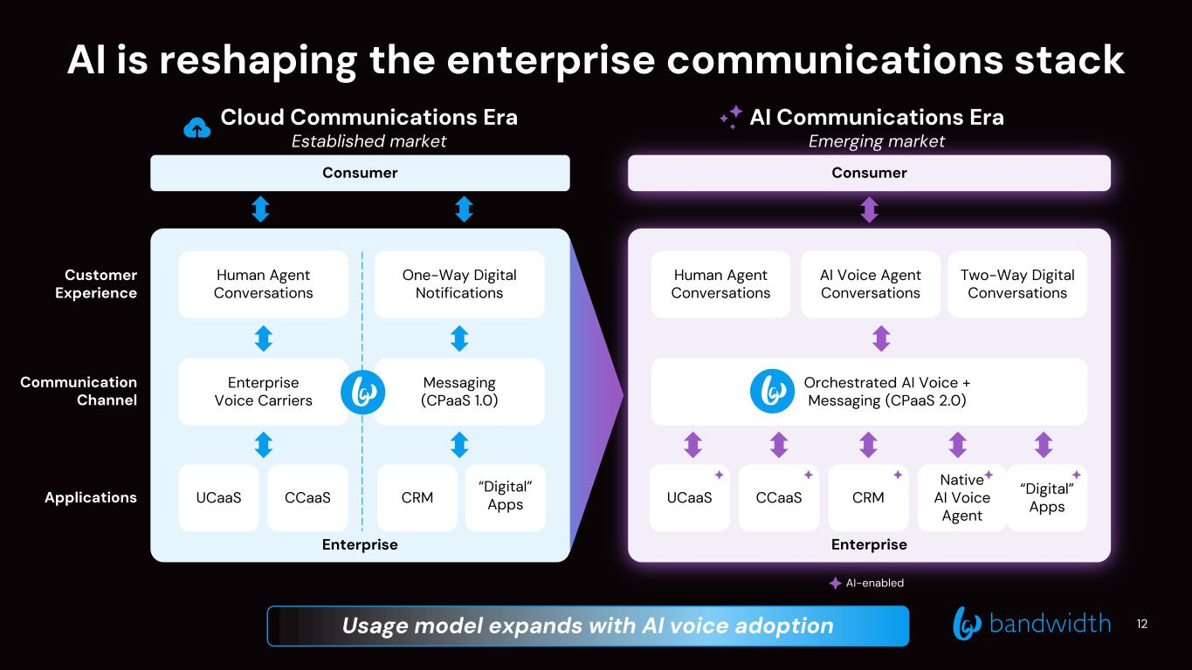
AI-enabled AI Communications Era Emerging market EnterpriseEnterprise AI is reshaping the enterprise communications stack Consumer Consumer CCaaS “Digital” Apps Human Agent Conversations One-Way Digital Notifications Orchestrated AI Voice + Messaging (CPaaS 2.0) Enterprise Voice Carriers CRMUCaaS CCaaS “Digital” AppsCRMUCaaS Native AI Voice Agent Messaging (CPaaS 1.0) Human Agent Conversations Two-Way Digital Conversations AI Voice Agent Conversations Customer Experience Communication Channel Applications Cloud Communications Era Established market 12Usage model expands with AI voice adoption

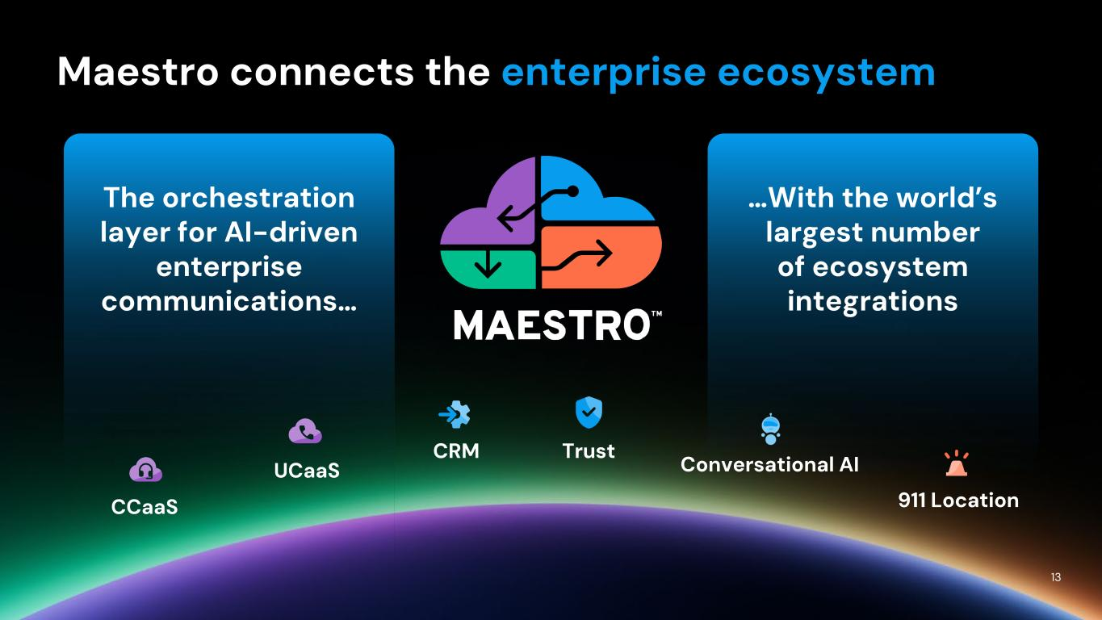
13 The orchestration layer for AI-driven enterprise communications… …With the world’s largest number of ecosystem integrations CCaaS UCaaS CRM Trust Conversational AI 911 Location Maestro connects the enterprise ecosystem

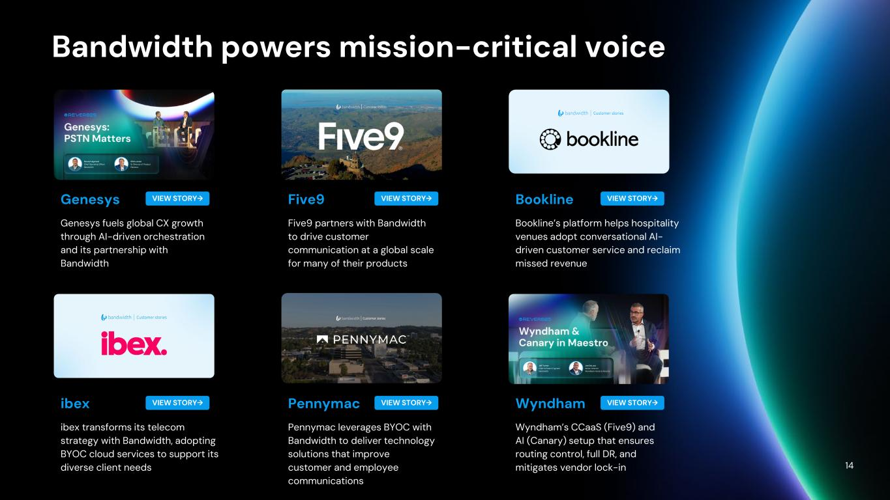
14 Genesys Genesys fuels global CX growth through AI-driven orchestration and its partnership with Bandwidth Five9 Five9 partners with Bandwidth to drive customer communication at a global scale for many of their products Bookline Bookline’s platform helps hospitality venues adopt conversational AI- driven customer service and reclaim missed revenue ibex ibex transforms its telecom strategy with Bandwidth, adopting BYOC cloud services to support its diverse client needs Pennymac Pennymac leverages BYOC with Bandwidth to deliver technology solutions that improve customer and employee communications Wyndham Wyndham’s CCaaS (Five9) and AI (Canary) setup that ensures routing control, full DR, and mitigates vendor lock-in Bandwidth powers mission-critical voice VIEW STORY→ VIEW STORY→ VIEW STORY→ VIEW STORY→ VIEW STORY→ VIEW STORY→

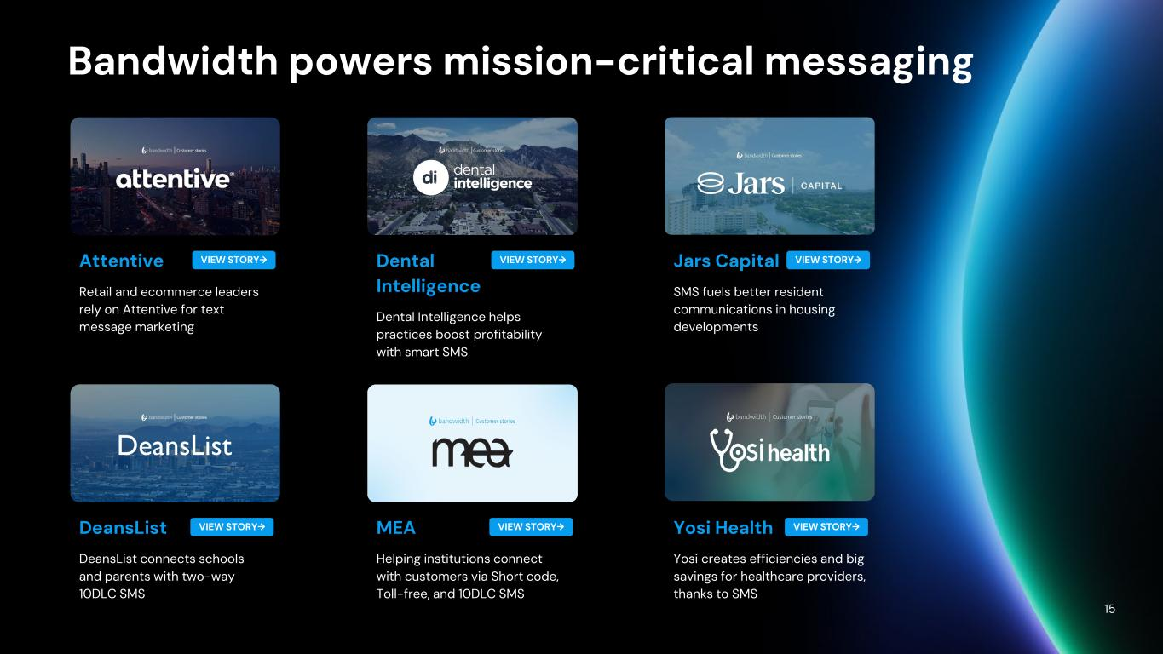
Bandwidth powers mission-critical messaging 15 Attentive Retail and ecommerce leaders rely on Attentive for text message marketing Dental Intelligence Dental Intelligence helps practices boost profitability with smart SMS Jars Capital SMS fuels better resident communications in housing developments DeansList DeansList connects schools and parents with two-way 10DLC SMS MEA Helping institutions connect with customers via Short code, Toll-free, and 10DLC SMS Yosi Health Yosi creates efficiencies and big savings for healthcare providers, thanks to SMS VIEW STORY→ VIEW STORY→ VIEW STORY→ VIEW STORY→ VIEW STORY→ VIEW STORY→

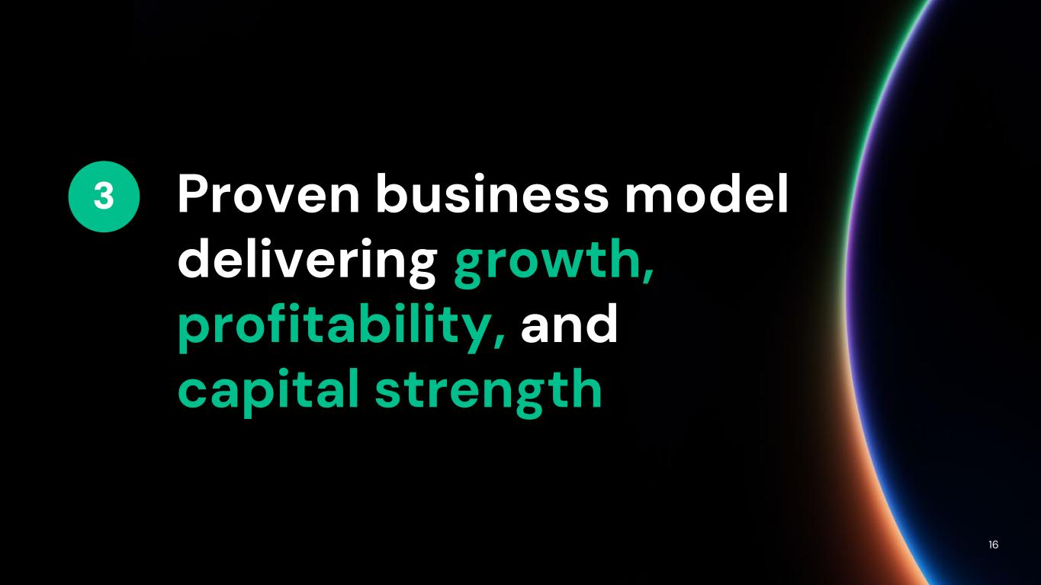
Proven business model delivering growth, profitability, and capital strength 16 3

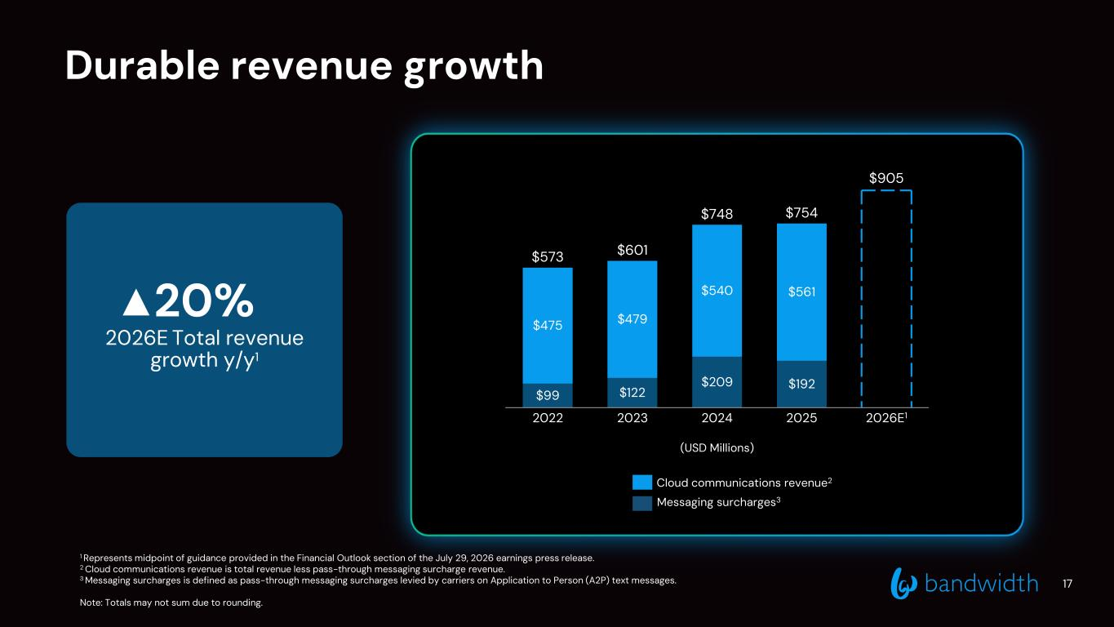
Durable revenue growth (USD Millions) Cloud communications revenue2 Messaging surcharges3 1 Represents midpoint of guidance provided in the Financial Outlook section of the July 29, 2026 earnings press release. 2 Cloud communications revenue is total revenue less pass-through messaging surcharge revenue. 3 Messaging surcharges is defined as pass-through messaging surcharges levied by carriers on Application to Person (A2P) text messages. Note: Totals may not sum due to rounding. 20% 2026E Total revenue growth y/y1 $99 $122 $209 $192 $905 $475 $479 $540 $561 2022 2023 2024 2025 2026E1 Cloud comms surcharges $573 $601 $748 $754 17

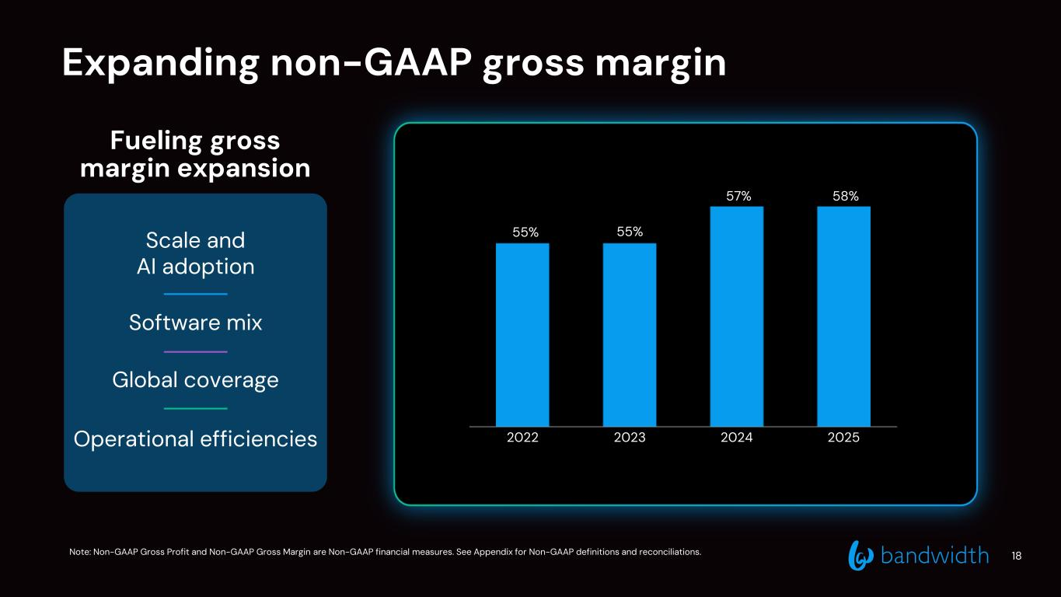
Expanding non-GAAP gross margin Scale and AI adoption Software mix Global coverage Operational efficiencies Fueling gross margin expansion Note: Non-GAAP Gross Profit and Non-GAAP Gross Margin are Non-GAAP financial measures. See Appendix for Non-GAAP definitions and reconciliations. 2022 2023 2024 2025 55% 55% 57% 58% 18

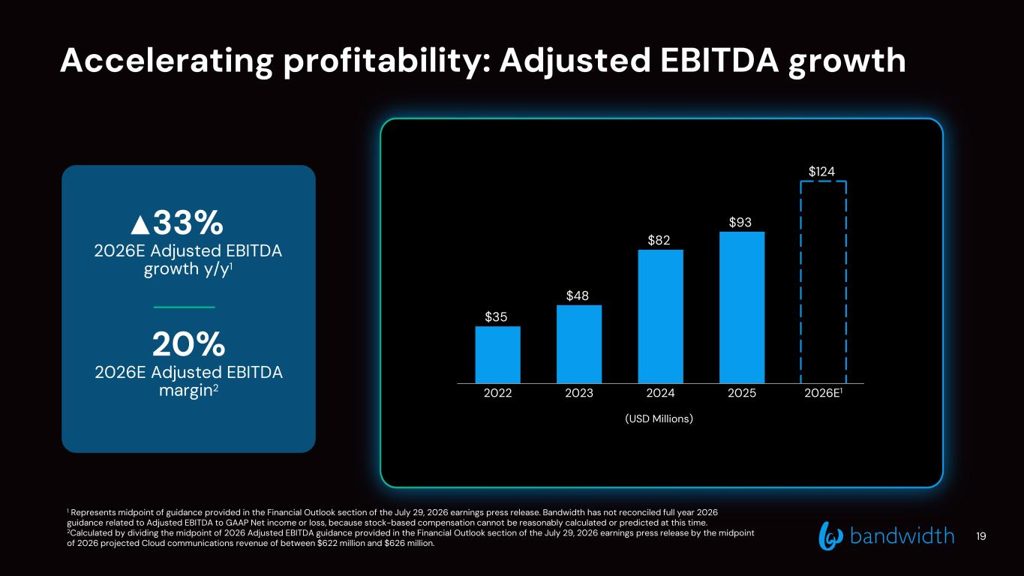
Accelerating profitability: Adjusted EBITDA growth 1 Represents midpoint of guidance provided in the Financial Outlook section of the July 29, 2026 earnings press release. Bandwidth has not reconciled full year 2026 guidance related to Adjusted EBITDA to GAAP Net income or loss, because stock-based compensation cannot be reasonably calculated or predicted at this time. 2Calculated by dividing the midpoint of 2026 Adjusted EBITDA guidance provided in the Financial Outlook section of the July 29, 2026 earnings press release by the midpoint of 2026 projected Cloud communications revenue of between $622 million and $626 million. 19 33% 2026E Adjusted EBITDA growth y/y1 20% 2026E Adjusted EBITDA margin2 (USD Millions) $35 $48 $82 $93 $124 2022 2023 2024 2025 2026E1

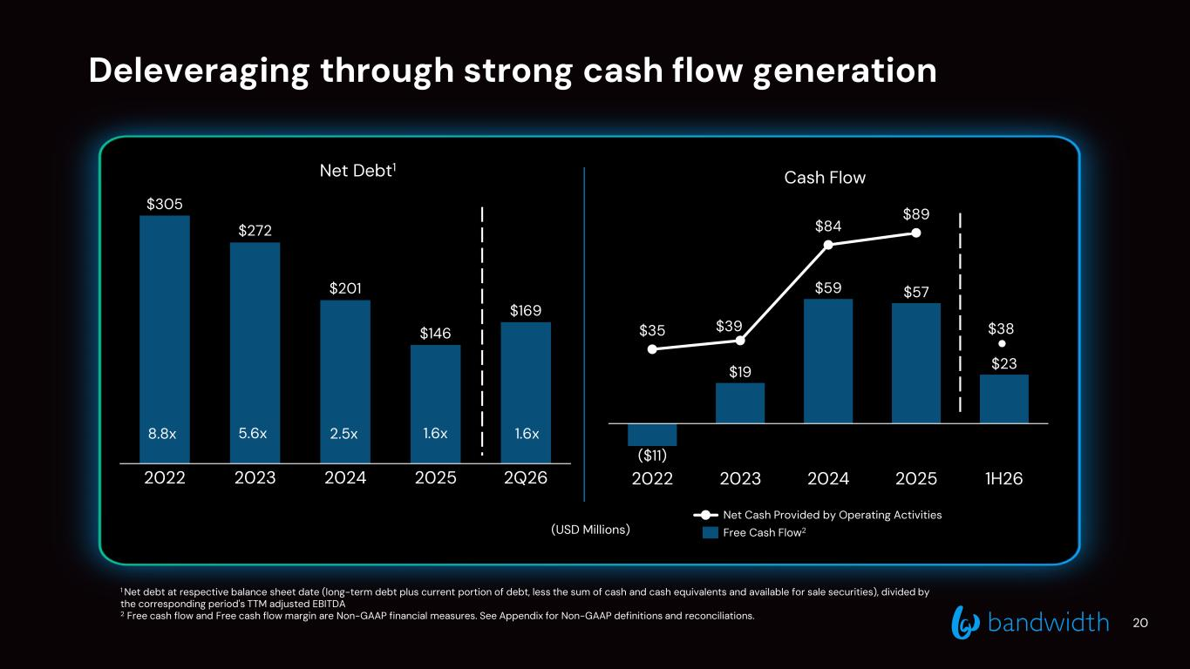
Deleveraging through strong cash flow generation 20 (USD Millions) 2022 2023 2024 2025 2Q26 $305 $272 $201 $146 $169 8.8x 5.6x 2.5x Net Debt1 Cash Flow 1 Net debt at respective balance sheet date (long-term debt plus current portion of debt, less the sum of cash and cash equivalents and available for sale securities), divided by the corresponding period's TTM adjusted EBITDA 2 Free cash flow and Free cash flow margin are Non-GAAP financial measures. See Appendix for Non-GAAP definitions and reconciliations. 1.6x1.6x $19 $59 $57 $23 $35 $39 $84 $89 2022 2023 2024 2025 1H26 ($11) Net Cash Provided by Operating Activities Free Cash Flow2 $38

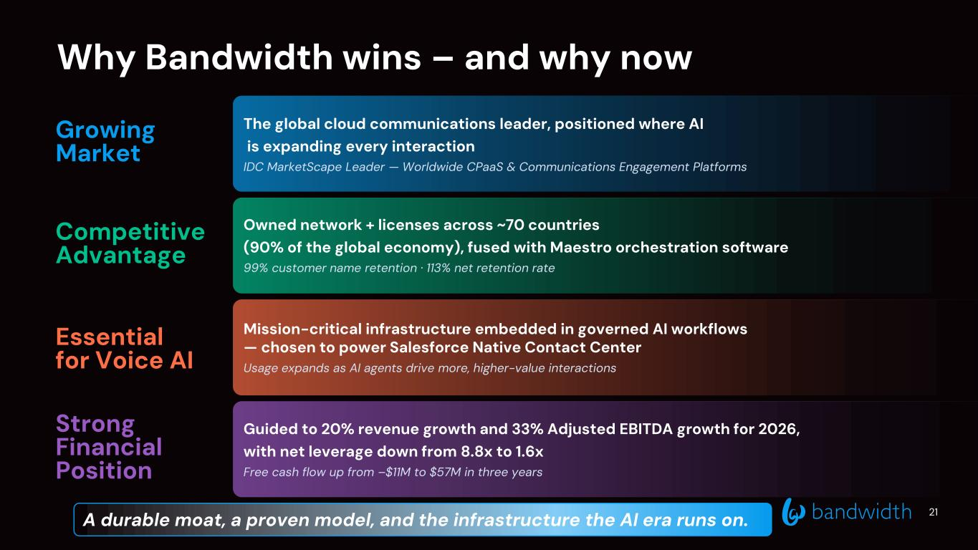
Why Bandwidth wins – and why now The global cloud communications leader, positioned where AI is expanding every interaction IDC MarketScape Leader — Worldwide CPaaS & Communications Engagement Platforms Owned network + licenses across ~70 countries (90% of the global economy), fused with Maestro orchestration software 99% customer name retention · 113% net retention rate Mission-critical infrastructure embedded in governed AI workflows — chosen to power Salesforce Native Contact Center Usage expands as AI agents drive more, higher-value interactions Guided to 20% revenue growth and 33% Adjusted EBITDA growth for 2026, with net leverage down from 8.8x to 1.6x Free cash flow up from –$11M to $57M in three years Growing Market Competitive Advantage Essential for Voice AI Strong Financial Position 21A durable moat, a proven model, and the infrastructure the AI era runs on.

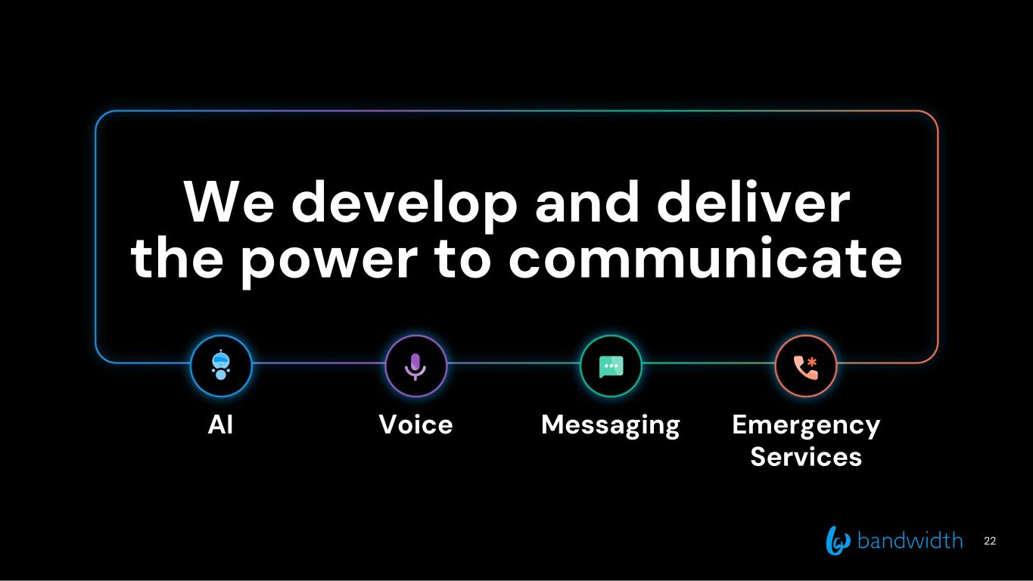
22 We develop and deliver the power to communicate Voice Messaging Emergency Services AI

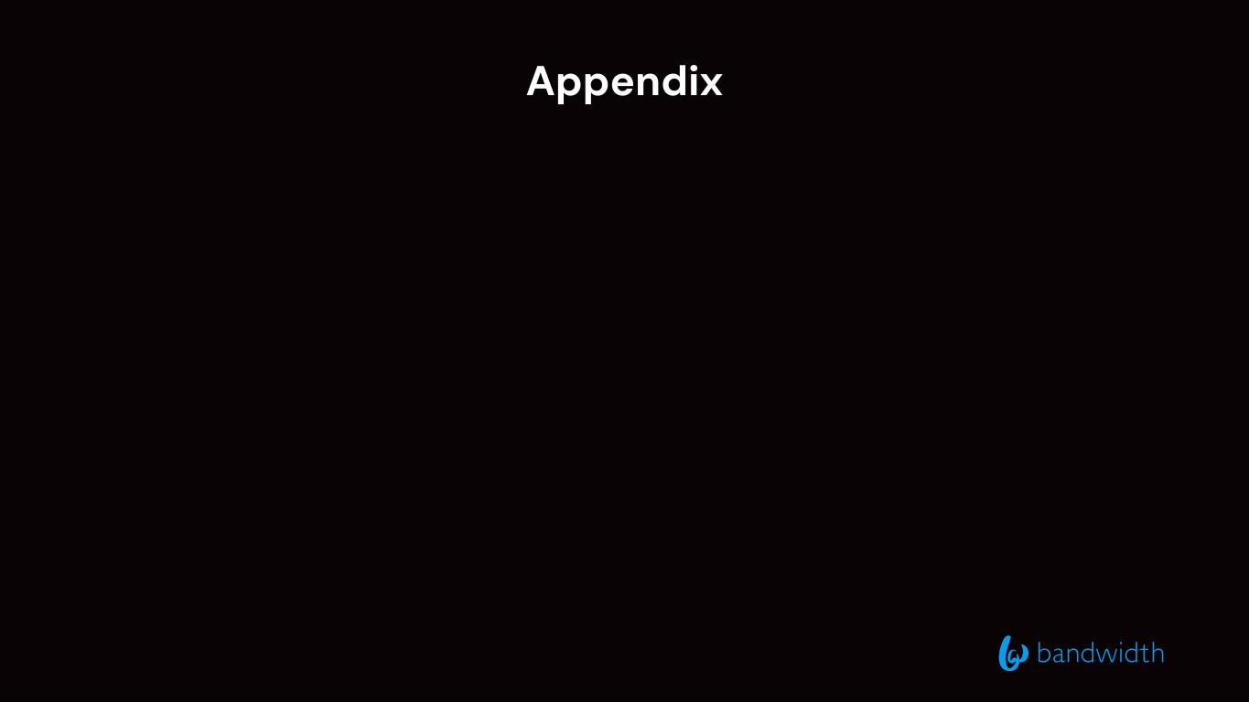
Appendix

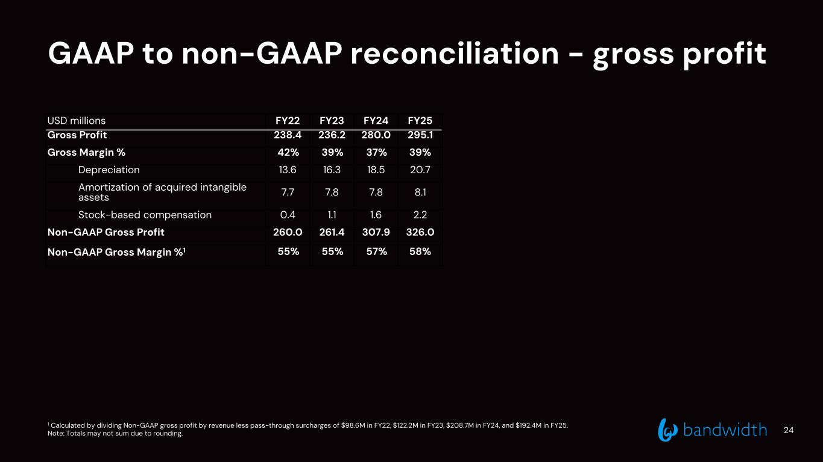
GAAP to non-GAAP reconciliation - gross profit 1 Calculated by dividing Non-GAAP gross profit by revenue less pass-through surcharges of $98.6M in FY22, $122.2M in FY23, $208.7M in FY24, and $192.4M in FY25. Note: Totals may not sum due to rounding. USD millions FY22 FY23 FY24 FY25 Gross Profit 238.4 236.2 280.0 295.1 Gross Margin % 42% 39% 37% 39% Depreciation 13.6 16.3 18.5 20.7 Amortization of acquired intangible assets 7.7 7.8 7.8 8.1 Stock-based compensation 0.4 1.1 1.6 2.2 Non-GAAP Gross Profit 260.0 261.4 307.9 326.0 Non-GAAP Gross Margin %1 55% 55% 57% 58% 24

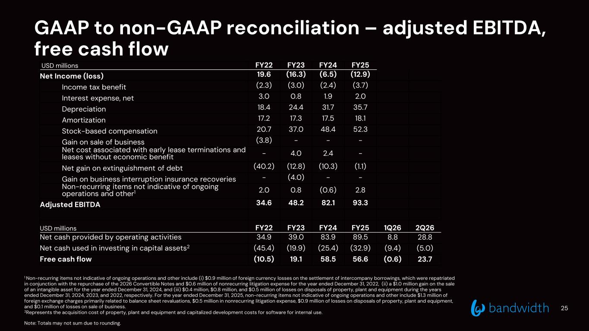
1 Non-recurring items not indicative of ongoing operations and other include (i) $0.9 million of foreign currency losses on the settlement of intercompany borrowings, which were repatriated in conjunction with the repurchase of the 2026 Convertible Notes and $0.6 million of nonrecurring litigation expense for the year ended December 31, 2022, (ii) a $1.0 million gain on the sale of an intangible asset for the year ended December 31, 2024, and (iii) $0.4 million, $0.8 million, and $0.5 million of losses on disposals of property, plant and equipment during the years ended December 31, 2024, 2023, and 2022, respectively. For the year ended December 31, 2025, non-recurring items not indicative of ongoing operations and other include $1.3 million of foreign exchange charges primarily related to balance sheet revaluations, $0.5 million in nonrecurring litigation expense, $0.9 million of losses on disposals of property, plant and equipment, and $0.1 million of losses on sale of business. 2Represents the acquisition cost of property, plant and equipment and capitalized development costs for software for internal use. Note: Totals may not sum due to rounding. GAAP to non-GAAP reconciliation – adjusted EBITDA, free cash flow USD millions FY22 FY23 FY24 FY25 Net Income (loss) 19.6 (16.3) (6.5) (12.9) Income tax benefit (2.3) (3.0) (2.4) (3.7) Interest expense, net 3.0 0.8 1.9 2.0 Depreciation 18.4 24.4 31.7 35.7 Amortization 17.2 17.3 17.5 18.1 Stock-based compensation 20.7 37.0 48.4 52.3 Gain on sale of business (3.8) - - - Net cost associated with early lease terminations and leases without economic benefit - 4.0 2.4 - Net gain on extinguishment of debt (40.2) (12.8) (10.3) (1.1) Gain on business interruption insurance recoveries - (4.0) - - Non-recurring items not indicative of ongoing operations and other1 2.0 0.8 (0.6) 2.8 Adjusted EBITDA 34.6 48.2 82.1 93.3 USD millions FY22 FY23 FY24 FY25 1Q26 2Q26 Net cash provided by operating activities 34.9 39.0 83.9 89.5 8.8 28.8 Net cash used in investing in capital assets2 (45.4) (19.9) (25.4) (32.9) (9.4) (5.0) Free cash flow (10.5) 19.1 58.5 56.6 (0.6) 23.7 25

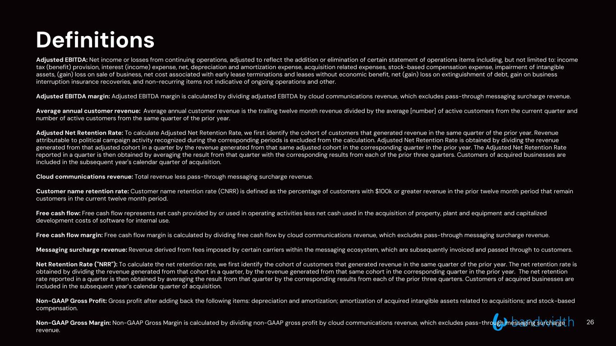
Definitions Adjusted EBITDA: Net income or losses from continuing operations, adjusted to reflect the addition or elimination of certain statement of operations items including, but not limited to: income tax (benefit) provision, interest (income) expense, net, depreciation and amortization expense, acquisition related expenses, stock-based compensation expense, impairment of intangible assets, (gain) loss on sale of business, net cost associated with early lease terminations and leases without economic benefit, net (gain) loss on extinguishment of debt, gain on business interruption insurance recoveries, and non-recurring items not indicative of ongoing operations and other. Adjusted EBITDA margin: Adjusted EBITDA margin is calculated by dividing adjusted EBITDA by cloud communications revenue, which excludes pass-through messaging surcharge revenue. Average annual customer revenue: Average annual customer revenue is the trailing twelve month revenue divided by the average [number] of active customers from the current quarter and number of active customers from the same quarter of the prior year. Adjusted Net Retention Rate: To calculate Adjusted Net Retention Rate, we first identify the cohort of customers that generated revenue in the same quarter of the prior year. Revenue attributable to political campaign activity recognized during the corresponding periods is excluded from the calculation. Adjusted Net Retention Rate is obtained by dividing the revenue generated from that adjusted cohort in a quarter by the revenue generated from that same adjusted cohort in the corresponding quarter in the prior year. The Adjusted Net Retention Rate reported in a quarter is then obtained by averaging the result from that quarter with the corresponding results from each of the prior three quarters. Customers of acquired businesses are included in the subsequent year's calendar quarter of acquisition. Cloud communications revenue: Total revenue less pass-through messaging surcharge revenue. Customer name retention rate: Customer name retention rate (CNRR) is defined as the percentage of customers with $100k or greater revenue in the prior twelve month period that remain customers in the current twelve month period. Free cash flow: Free cash flow represents net cash provided by or used in operating activities less net cash used in the acquisition of property, plant and equipment and capitalized development costs of software for internal use. Free cash flow margin: Free cash flow margin is calculated by dividing free cash flow by cloud communications revenue, which excludes pass-through messaging surcharge revenue. Messaging surcharge revenue: Revenue derived from fees imposed by certain carriers within the messaging ecosystem, which are subsequently invoiced and passed through to customers. Net Retention Rate ("NRR"): To calculate the net retention rate, we first identify the cohort of customers that generated revenue in the same quarter of the prior year. The net retention rate is obtained by dividing the revenue generated from that cohort in a quarter, by the revenue generated from that same cohort in the corresponding quarter in the prior year. The net retention rate reported in a quarter is then obtained by averaging the result from that quarter by the corresponding results from each of the prior three quarters. Customers of acquired businesses are included in the subsequent year’s calendar quarter of acquisition. Non-GAAP Gross Profit: Gross profit after adding back the following items: depreciation and amortization; amortization of acquired intangible assets related to acquisitions; and stock-based compensation. Non-GAAP Gross Margin: Non-GAAP Gross Margin is calculated by dividing non-GAAP gross profit by cloud communications revenue, which excludes pass-through messaging surcharge revenue. 26

